

The development of a support ticketing web application for a tech repair company

**Guy, Jordon Douglas**

**Table of Contents**

**Abstract** **6**

**Glossary** **7**

**1. Introduction** **8**

1.1. Background 8

1.2. Aim and Objectives 8

1.3. Assumptions 8

1.4. Project Methodology and Software Development Life-cycle 9

1.4.1 Introduction 9

1.4.2. Project Management Methodologies 9

1.4.3. Agile 9

1.4.4. PRINCE2 10

1.4.5. PMI/PMBOK 10

1.4.6. System Development Life-Cycles 11

1.4.7. Scrum Agile Framework 11

1.4.8. Kanban Agile Framework 11

1.4.9. Waterfall 12

1.4.10. Chosen Methodologies 12

1.5. Project Ethics review 13

1.5.1. Introduction 13

1.5.2. Ethical Issues 13

1.6. Risk Assessment 13

**2. Requirements** **16**

2.1. Introduction 16

2.2. Client requirements 16

2.3. User requirements 16

2.4. Requirements/Project Deliverable summary 17

**3. Feasibility Study** **17**

3.1. Introduction 17

3.2. Target Market 17

3.2.1. Survey 17

3.3. Similar Applications 19

3.4. Constructive Cost Model 19

**3.5. Tools and Software Available** **20**

3.5.1. Python 20

3.5.2. Django 20

3.5.3. Flask 21

3.5.4. Node.js 21

3.5.5. C# Visual Studio ASP.NET 21

3.5.6. SQLite (Django Default) 21

3.5.7. MongoDB 21

3.6. Tools chosen 22

3.6.1. Python 3.7.2 22

3.6.2. Django 2.1 22

3.6.3. SQLite 3 22

**4. Application Design** **22**

4.1. Overview 22

4.2.Graphical User Interface 23

4.2.1. Layout 23

4.2.3. Theme 23

4.3. Use Cases Diagrams 23

4.4. Database Design 24

4.4.1. Normalisation 24

4.4.2. Entity Relationship Diagram 24

4.4.3. Final Database Design 25

4.5. Pseudo-code 27

4.5.1. View All Posts 27

4.5.2. Add New Post 27

4.5.3. Add Comment to Post 27

4.5.4. Closing a Post 28

4.6. Test Plan Design 28

**5. Sprint 1 - Initial Prototype Development** **28**

5.1. Pre-Sprint Plan 28

5.2. Development Sprint 29

5.2.1. Creating a new Django Project 29

5.2.2. Creating the Django App 29

5.2.3. Creating Models/Database Tables 29

5.2.5. Creating Urls 32

5.2.6. Creating Views 33

5.3. Issues Encountered 34

5.4. Prototype Evaluation 34

5.5. Sprint Evaluation 37

**6. Sprint 2 - Refined Functionality and Visuals** **38**

6.1. Pre-Sprint Plan 38

6.2. Development Sprint 38

6.2.1. Creating Forms 38

6.1.2. Refining HTML Visuals 40

6.1.3. Class-based Views 42

6.1.4. DetailView - Specific Post 42

6.1.5. DetailView - Specific User’s Posts 44

6.2. Issues Encountered 45

6.3. Prototype Evaluation 45

6.4. Sprint Evaluation 47

**7. Extra Development** **48**

7.1. Introduction 48

7.2. Development 48

7.2.1. Adding New Comments 48

7.2.2. Closing Posts 48

**8. Project Deliverable Evaluation** **49**

8.1. Functionality Testing 49

8.2. Usability and Accessibility Evaluation 53

8.2.1. Usability Test group and Survey 53

8.3. Requirements Evaluation 54

8.4. Final Evaluation of Project Deliverable. 54

**9. Further development** **54**

9.1. Finish Functionality 54

9.2. Implementation 55

9.3. Emails/Push Notifications. 55

9.4. Live Chat Feature 55

**10. Conclusion** **55**

**References** **56**

**Bibliography** **58**

**Appendices** **59** 111

# 

# Abstract

The purpose of this project is to create a web application that helps handle Tech CPR’s valued customers technical support needs while costing nothing by utilising open-source tools and software, and the computer infrastructure in place at Tech CPR, this paper contains research into risks and ethical issues for small software projects, the tools and software available, and suitable project methodologies and software development life-cycles. After the research was concluded suitable tools and software were chosen along with a project methodology. The tools and software chosen was Python, SQLite3, and Django as they were all capable of creating this new web application and were all open-source and free to use. The project methodology chosen was Scrum and its principles were followed utilising Sprints to design and develop the new customer support web application while using daily Scrums and burn-down charts to effectively organise the workload towards the clients required features, and to maximise the development teams productivity.

# Glossary

‘Subscribed Clientele’ - Clients of Tech CPR that have work systems or infrastructure built by them or recurring and valued customers.

# 

# 1. Introduction

## 1.1. Background

Tech CPR a tech repair company that deals with both individuals and businesses wants a support ticketing system for their website (https://techcpr.co.uk) that allows their business clientele a place to submit tickets detailing issues they are having with the system(s) that Tech CPR installed so that the support staff will be notified and will be able to respond quickly.

This project has been taken up by a one man team consisting of Jordon Guy a student at Chesterfield College doing a BSc Computer Software Development course, who will be taking up all roles of the project team these roles are: Project Manager, Development Team, and any methodology specific roles such as Scrum master and Product Owner.

## 1.2. Aim and Objectives

The aim of this project is to plan and develop a support ticket web application that can be used by Tech CPR’s ‘subscribed’ clientele to quickly contact the Tech CPR support staff to easily resolve any issues they may be experiencing with the system(s) Tech CPR implemented or maintain for them. The subscribed clientele of Tech CPR will be able to submit posts to the support ticketing system, these posts will be stored within a database; and allow the user to submit text and other media such as images, videos and files allowing them to clearly outline the problem, when the post is submitted the support staff at Tech CPR will be notified encouraging a hasty response. The joint-owners of Tech CPR will be able to manage the web application; administering users, posts and roles with full access to the database within the web applications backend.

Tech CPR already has great presence when dealing with customers over the phone and face to face but the online contact form in place currently is there to help customers initiate business with the company, this project will make sure each customer can communicate effectively and conveniently in the form they choose whether they are talking face to face, over the phone or contacting them online, this will help increase customer satisfaction as they will feel valued whichever way they choose to communicate. (McLean, G. 2017) This new system will incorporate a straight forward graphical user interface (GUI) design, strong accessibility features and help make sure that every customer gets a great experience interacting with the company.

## 1.3. Assumptions

It was identified that Tech CPR repairs many different types of tech including mobile devices, it is assumed that the new support ticketing system wouldn’t function well for these mobile devices as they were mainly personal and the clients would usually bring the device into store to be repaired.

This system is suitable to business clients that rely on infrastructure set-up by Tech CPR as they have in-depth knowledge of the hardware setup and may need to send someone out to the business to resolve the issue, the assumption that this is more suitable comes from the clients requirements as he wants to use this system for his ‘subscribed’ clientele and these are usually recurring customers or business clients that he will choose to create User details for so that they can use the system.

## 1.4. Project Methodology and Software Development Life-cycle

### 1.4.1 Introduction

Using the most suitable project methodology and/or software development life-cycle will help with the success of the project overall, some project methodologies suit different types of projects and project teams better. To ensure that the best project methodology is used each of the available project methodologies will be investigated and reviewed before a final methodology is chosen and justified (Dawson, 2015). During this investigation software development life-cycles have been researched into such as Agile’s proposed principles to help IT projects as well as project management standards such as PRINCE2 and practices used and proposed by the Project Management Institute (PMI)

### 1.4.2. Project Management Methodologies

#### 1.4.3. Agile

Agile is a set of project management principles that suits small ICT projects and small project teams. Its iterative approach to managing software development projects focuses on flexible and continuous development releases through multiple “Sprints” or development cycles to create refined ready for market software within a short time scale. (Fustik, V. 2017).

The Agile project principles focuses on high product quality, higher customer satisfaction, reduced risk, and fast time to market on IT software projects. The end products using Agile have a higher quality as the testing is integrated into each development iteration meaning there are regular checkups to evaluate that the product is working to the clients and customers' needs this also increases their satisfaction as the end product will be refined around their needs.

The reason Agile has reduced risk compared to traditional project methodologies is that a working prototype will be developed after the first sprint meaning no project using agile will completely fail as working software will be developed early on.

This method promotes high performance and is widely used in software development for large companies such as Auto Trader who have teams for both Scrum and Kanban for different projects depending on their requirements ("Autotrader", 2018). The Agile principles are not one size fits all and the different frameworks should be considered to ensure the correct one is being used for the right project.

#### 1.4.4. PRINCE2

PRINCE2 (Projects in Controlled Environments) is a project-based method for effective project management, it is the UK government standard project principles and has been widely adopted worldwide. PRINCE2 provides benefits to project managers and businesses through its controllable use of resources and effective way of identifying and managing risks. It suits large projects being undertaken by a business and allows for the management of a large project team and resources.

It has a consistent approach, with a controlled and organised start, middle and end making it easy to manage milestones and progress. In PRINCE2 the project is fully planned early on and reviewed regularly to ensure the project is on schedule, during these reviews the plan can be altered or a decision can be made to ensure the project meets deadlines, requirements and to increase its chance of success ("PRINCE2 Information & Courses | Project Management Certification | UK", 2019) .

PRINCE2 is stakeholder friendly promoting their involvement and project transparency consistently throughout the projects life, ensuring the project deliverable meets the requirements of the stakeholders and allows them to make informed decisions on what they want from the project.

#### 1.4.5. PMI/PMBOK

The Project Management Institute (PMI) have created a Project Management Book of Knowledge (PMBOK) for rules and standards that should be followed to increase the success of any project. PMI outlines five phases of project management similar to the phases used within the Waterfall model ("PMI PMBOK® Guide Method", n.d.), these phases are:

**Conception & Initiation**, where the projects goals and definition is developed with a feasibility investigation to make sure the project can be done. When these have been developed the project must be presented to the stakeholders for their approval, if the project gets approved the project initiation document (PID) can be created to outline the purpose and requirements of the project. This was done for this project, a project specification was made to outline the purpose and requirements of the project before the project was fully approved by the project observer and client (Tech CPR) (refer to appendix - Project Specification )

**Definition and Planning**, this phase of the project is where the detailed project plan is developed, this project plan identifies important project variables such as Cost, Resources, and a timescale. Within this plan its scope is defined to outline what the project has set out to achieve and to identify when the project will end, it will be a comparison in the final evaluation of the project to calculate the success of the project overall.

**Launch/Execution**, this phase is when the project deliverable is developed and completed, during this phase a lot will happen meaning the status of tasks and resource usage needs to be reported regularly to the project manager to allow them to assess and possibly change the project schedule and plan.

**Performance and Control**, this phase is used to track the project progression and performance to ensure all the tasks work towards the goals of the original project plan. it is the project manager's responsibility to ensure the project stays within schedule, budget, and is working towards the projects objectives so all of these variable need to be monitored carefully throughout the projects life.

**Project Close**, this is final stage of any project this stage is used to the show completion of the project and to evaluate the project overall, all documentation of the project is gathered and stored for future reference. The Project manager will evaluate each of the team members performance to assess their strengths and weaknesses for possible future employment, If the project was done with freelancers the project manager is tasked with terminating their employment, this could instead be a possible offer of further employment with the project manager if any freelancers had notable performances, meaning they could be employed within the in-house team.

### 1.4.6. System Development Life-Cycles

#### 1.4.7. Scrum Agile Framework

Scrum is a framework of Agile (Ruler, B. 2014), it proposes principles and processes to improve software delivery and puts the principles of agile into practice. It uses the “Sprint” development cycle of 2-4 weeks but during these “Sprints” daily scrums are used to optimise development. During each daily scrum the Scrum Master gathers the team together and gets a report from each team member on their progress, what they are doing that day and if anything is hindering their progress. This daily update allows the Scrum master to adjust the Sprint Plan or make possible changes if issues arise, it also helps increase the development teams productivity.

#### 1.4.8. Kanban Agile Framework

Kanban is another framework of Agile ("Kanban - A brief introduction | Atlassian", 2019), that focuses of continuous content delivery without overburdening the development team, Kanban is similar to Scrum as its processes are designed to help teams work together effectively. Unlike Scrum Kanban doesn’t output at set intervals or “Sprints” and instead will always be delivering software/products ("Kanban vs Scrum | Atlassian", 2019).

Kanban uses a Kanban board to help visualise the workload and maximise efficiency, this board is split into three sections that show the state of tasks needed for the project ("The Kanban Board Explained in 5 Simple Steps | Kanbanize", 2019). These are Requested, In Progress, and Done, these are have subsections to help further visualise workflow with sections such as “Development”, “Testing”, and “Deployment” for the “In Progress” for software development to better show the state of the task. As Kanban focuses on continuous delivery the Kanban board can be used to spot potential problems within the workflow, these can be if tasks arrives faster than they leave a pile up of work will slowly be generated over time putting pressure on the development team to keep up with the continuous development and deployment.

Kanban is a very good Agile framework for projects that span over a long time, but for the project given to the project team by Tech CPR is doesn’t work as they want the software to be developed and then for Tech CPR to be responsible for its upkeep. If the project team was formed from workers at Tech CPR or was an embedded part of the company Kanban could be considered to make sure that their website and software products are continually being maintained, updated, and improved upon but it doesn’t suit the situation given to the project team.

#### 1.4.9. Waterfall

The Waterfall model was the first process model and the earliest to use the SDLC (Software Development Lifecycle) (Sharma, 2018) approach for software development as it uses the SDLC phases. It is a sequential approach to software development with a linear line of progression, this software development life-cycle has set cascading phases meaning that they must be done in a set order and only after the previous phase has been completed can the next begin ("What the Waterfall Project Management Methodology Can (and Can’t) Do for You", 2018).

The Waterfall model is good for experienced development teams who can plan everything in-depth , develop software that is refined, and meet the requirements outlined in the project plan,but for this project the team is inexperienced in the software development life-cycle, development tools, and standard development practices so a iterative approach could better suit the team so they can make a refined deliverable while learning the software over multiple iterations.

### 1.4.10. Chosen Methodologies

From the research into industry standard project methodologies and principles, the project team has decided to use the Agile project methodology, with the Scrum framework as they are the best suited to IT projects, small development teams and will help increase the success chance of the project overall.

The project manager has the biggest impact on the project, and as the project team for this project is only one person its impact is the most important element for the success of the project. (Blaskovics, B, 2016) outlines how important the project manager is and that small teams working on IT projects benefit a lot from using the Agile principles as it allows greater freedom on practical work as it is done during a “Sprints” and is great for getting a working prototype in a short time although this can put a lot of stress on the project team which could lead to issues but for this project could be beneficial.

## 1.5. Project Ethics review

### 1.5.1. Introduction

While undertaking this project for Tech CPR risks and ethical issues will be considered while researching, developing and publishing the project deliverable. An issue identified is the recent law changes to the customer information regulation GDPR, as it changes how businesses must handle customer information.

### 1.5.2. Ethical Issues

An ethical issue identified was the security risk of Tech CPR’s information/website, to mitigate this risk the web application will be developed and tested in a secure environment separated from the Tech CPR computer infrastructure removing the risk of clients personal information being leaked or any possible downtime for the website, It is important to all businesses that they handle customers personal data carefully and ethically. The GDPR (General Data Protection Regulation) effects all businesses that handle EU customers data (Gough, O. 2018), and with the recent changes the regulation has an increased territorial scope with extended jurisdiction allowing them to fine any business in breach of the regulation regardless of the company’s location. Because Brexit may still happen and the UK could leave the European Union, Tech CPR could still deal with EU customers meaning they must follow the rules set out by the General Data Protection Regulation or receive a harsh fine.

When selecting tools and software to develop the web application the restrictions and licenses will be followed, this consideration may impact the tools and software used to develop the final deliverable but shouldn’t impact the quality of the final product.

Privacy is a big concern in the modern world of computers and the internet, it is vital to ensure that consumers and there data is protected to ensure that the company doesn’t breach GDPR and to keep the customers trust and business (*Brinkman, B., & Sanders, A. 2013)*. To ensure that the customers data is protected the project deliverable will be developed and tested on a secure and controlled machine, it will also not interact with any data/information from the current Tech CPR website and will function as a separate entity but will be hosted within the Tech CPR server and website.

## 1.6. Risk Assessment

This project undertaken for Tech CPR carries very little risks, but a risk register has been created to help manage the risks that could affect the project (refer to appendix A - Figure 1), this risk register has some general project risks that can occur with any project and some project specific risks that relate to Tech CPR.

The five risk management processes were used for effective risk management (Murphy, 2016); the project team first identified a risk that might affect the project; then they analysed the risk to identify the chance of the risk occurring and its consequences.

After the risk was identified and analysed they were ranked, by determining the risks impacts on the project outcome and the likelihood of the risk occurring.

After the risks have been ranked the project team created a Risk Response plan to assess the highest ranked risks and create a step by step plan to follow to resolve or mitigate the risks possible impact of the project outcome. The final step is to monitor and review each of the risks regularly while they are still a relevant risk to the project, each of these steps need to be revisited throughout the project lifecycle to ensure that all risks can be identified and analysed that may occur. As this project is using the Agile methodology and it is a iterative model, the risks will be revisited before each development cycle to ensure all risks are identified, analysed, evaluated and ranked, treated/mitigated, and monitored and reviewed regularly.

The highest risks for this project are:

Deadlines being missed.

Security Breaches/Weak points.

Going Over budget.

Over burdening the project team.

Poor Communication between client and project team.

Lack of technical knowledge slowing development.

Deadlines being missed, has a high risk rating on the registry because the project team has only one team member and other academic work has been be planned and completed throughout the projects life. This risk has been allocated a probability of 3 and an impact of 3 because of this reason. To help counteract this risk the project plan has had extra time allocated to tasks, and if the deadlines are still missed the project team will not be doing many sprints from the Agile Project methodology this could affect the overall quality of the project deliverable but will ensure it is completed on time.

Another highly rated risk is that the issue this project deliverable is designed to resolve still persists after the project deliverable has been implemented, to prevent this the requirements from the client will be consistently compared against the deliverable when design and creating it. Another reason this risk may occur relates to the deadlines being missed as it could potentially lower the number of Sprints the project team can perform possibly lowering the quality of the final product.

An information breach in modern IT environments is a serious issue that can leave companies with huge fines potentially bankrupting them and a negative customer relationship, due to this protecting customer information should be one of the most important things to a company that handles it (Yang, S. C., & Wen, B. 2017).

Due to recent law changes to GDPR (Eugdpr.org, 2018) it now have authority on a larger scale than before allowing it to apply to companies outside the EU that still handle information from any personal information of individual that reside within EU. this means that even though the UK may still be leaving the EU GDPR will still apply to all customers that may reside within the EU, following GDPR is still a suitable option even though almost all customers will be UK residents as it shows customers the company values the individual's personal data and respects their decision on how the company uses it. And avoiding the huge fine of up to €20 million or 4% of global turnover is a big priority for all businesses.

An issue that will most likely appear during this project is being over budget. the client hasn’t specified a budget, so it is very likely that something that the project requires will cost something that will have to be paid for by the client. This could be for hosting the subdomain unless it can be added to the current servers being provided by UK2.net hosts.

As the project team consists of one person, the project cannot have extra trained staff to help complete the work if a team member is ill/absent. If this does occur the project could run behind schedule and miss deadlines, to counter this risk extra time has been allocated to critical tasks to help keep the project on schedule.

When implementing the system at Tech CPR the new system could crash after sustained up-time, to ensure this doesn’t affect other important functions of the Tech CPR website a backup will be kept regularly updated lowering any possible downtime and protecting Tech CPR’s data. As the new system will be ran on a subdomain it shouldn’t affect other parts of the website and will not interact with other data Tech CPR will handle protecting them and clients personal data.

During the project the risks were constantly being identified and added to the risk register, in the second version additional risks were identified and added to the register (refer to appendix A - figure 2). The two additional risks added were “poor communication with client” and “technical issues”.

Poor communication became apparent as a risk to the project as the project team and client struggled to find a method of communication that was suitable for both parties, the project manager contacted the client over email multiple times with no success due to the client not replying or believing the email was from a troublesome customer with a similar name. This led to the use of non-professional methods of communication with the client such as over the popular gaming platform known as “Battle.net” and through in-game chat. This wasn’t an optimal method of communication and led to the communication between the client and project manager being very limited.

The other risk that was identified was technical issues with the tools and software chosen from the feasibility study as the development team (Jordon) had limited experience with Django and Python but was familiar with them. Because this was a factor affecting development speed additional time was added to tasks involving these tools and software to compensate the development teams limited skills and knowledge.

# 2. Requirements

## 2.1. Introduction

The client requirements for this project have been collected from meetings with Mark Wood at Tech CPR as he is one of the joint owners of business and a major stakeholder in the project, from these initial requirements additional user requirements needed to be collected so a survey has been used to gather them to ensure that the project deliverable has considered and implemented both the clients and users requirements.

## 2.2. Client requirements

The Client Tech CPR wants a new method of communication between their support staff and their clientele that have had infrastructure or work systems implemented by Tech CPR, After a meeting with Mark Wood a joint owner at Tech CPR this is the clients requirements (refer to appendix A - figure 3). This new method of communication must be fast and convenient so that the support staff can respond to issues for any of their clients. The new system must be built into the current Tech CPR website before commercial release allowing customers and support staff to access it through the same portal, Tech CPR wants to give login credentials for ‘subscribed’ clientele and not have them create accounts themselves, this is because they only want the system to be used by ‘subscribed’ or valued recurring customers as this system is a premium service to maintain customer loyalty and satisfaction. The clientele will be able to post on the support forum and it will only be visible to the support staff at Tech CPR to maintain the clients privacy, when the client posts a ticket to the forum an email is to be sent to the support staff prompting them to take the ticket and respond, when they do send a response an email should be sent to the client prompting them to check the support forum.

## 2.3. User requirements

The Users of the support ticketing system will be clientele of Tech CPR that has infrastructure or hardware set-up and/or maintained by Tech CPR, these clientele could be small businesses with multiple computers setup, or loyal recurring customers with expensive personal computers.

Most people in this modern era can really struggle without a functioning computer, this problem has been counteracted by the recent advancements in mobile devices

These developments haven’t removed the problem in businesses though as they could miss out on multiple days' worth of revenue if the computer systems they rely on go down (Campbell, 2019), this means users of this support ticketing system have a need to have their systems repaired very quickly as it could become very costly fast. This new support system will help speed up communication between the support staff and the clientele.

## 2.4. Requirements/Project Deliverable summary

The project deliverable will be a support ticketing system that is built and implemented into the current Tech CPR website, it will provide a method of communication between the support staff at Tech CPR and clients that Tech CPR considers ‘subscribed’ or valued.

The clients will be able to post tickets onto the support system so that the support staff can take a ticket and reply to it quickly. This system will be managed by admins in the backend, these admins will be the joint owners of Tech CPR and will manage the support staff users and the clientele users on the system.

# 3. Feasibility Study

## 3.1. Introduction

The feasibility study section of this report researches and explores available tools and software to develop the application, the capabilities of each and decides on the chosen tools, this section will also discuss surveys undertaken and outline the target audience and what their basic needs are.

.

## 3.2. Target Market

The target market for this support ticketing system is the business clientele of Tech CPR, this covers a large demographic. As Tech CPR functions as a sort of outsourced computing department meaning for some of these businesses the support staff will be dealing with business owners directly, and the age and experience of the owners can vary a lot meaning the new system needs to cater to very inexperienced users.

### 3.2.1. Survey

A survey has been created to help discover the needs and preferences of the potential users of the new support system, it was handed out to students and tutors of the computing so a bias is present as they will be highly experienced with computers and IT. this bias has been identified and taken into account for the result of the survey. With the students and tutors filling in the survey a large age range is present, meaning that a correlation between some questions and the users age can be discovered.

The first question from the survey (refer to appendix A - figure 4) asks the user if they want to talk to a person or not for technical support, 3/4 of the responses want to communicate with another human being for help instead of it being an automated response. This shows that users would benefit from the system proposed as it focuses on using the support staff at Tech CPR to respond to the client/users technical issue.

The second question for the survey has two parts (refer to appendix A - figure 5, 6) and gauges if the user feels they can explain a technical issue over the phone /or over a text only chat (no media, just what the user can explain), 4/5 of the responses said that they could explain a technical issue without the use of other media. The second part of this question asks the user what they believe will be needed to fully explain the issue and one of the recommendations was to use a “report” or “visual representation” of the issue so for the new system will primarily be a text chat posts but should offer the user a chance to upload an image to help explain their technical issue.

The third survey question asks the potential user their average response time from a online support system with 1/3 of the responses receiving replies/support within two hours of submitting the ticket (refer to appendix A - figure 7). As Tech CPR is a small company and do not have outsourced workers to reply to support tickets the current staff at Tech CPR will be used. To ensure the response time is quick, when a new ticket is submitted an email will be sent out to all support staff prompting them to take the ticket and respond. When a response is added to a ticket an email will be sent out to the user that submitted the original post.

The fourth question focuses on if visuals are important to a support system on the users trust of the support received (refer to appendix A - figure 8). From the responses the users feel that they will trust the support given if the visuals of the support system are good. From this the development team will focus of visuals before the systems implementation to ensure the users will trust the support given.

Question five (refer to appendix A - figure 9) is used to see if customers would want an exclusive line of communication to a company supplying a product /or service to them, from the responses 95% said they want a special line of communication. Question six (refer to appendix A - figure 10) expands on this and asks the user if they would feel more valued as a customer, from the responses a large percentage would feel more valued as a customer if they received a special line of communication to the supplier. The new support system proposed gives the clients at Tech CPR a exclusive line of communication to the support staff, this is something the customers clearly want and will be exclusive making them feel more valued.

A feature the development team was planning to implement as a further development was a live-chat feature (Elmorshidy, A. 2018) where the support staff could talk to the customer in real-time, this feature was an additional way to communicate but isn’t an optimal way to give support on difficult issues. A question was added to the survey (refer to appendix A - figure 11) to see if the users wanted this feature was used and from the responses it is a desired feature and will be considered for further development, from the responses it was clear that customers had an interest in a live chat feature.

From the survey we can see that there is a desire for the consumer to talk to another human being for technical support, in *Lord, J. (1999) Putting customer support on the Internet,* It outlines that consumers will prefer convenient customer support, with the access to the internet being in the hands on almost every consumer in the world it is important that every business has a customer support system online to ensure convenience. The new system proposed will help get Tech CPR into online customers support increasing their customer satisfaction while assisting them with any technical issues they may be experiencing.

## 3.3. Similar Applications

A similar application/service to the projects objectives is a company called Salesforce Essentials, it offers a service to companies where they handle customer support for them. They collect and organise all support channels of a business into a single view, similar to how all the customers Posts are going to be displayed on a single web page for the support staff at Tech CPR to see and respond to but on a larger scale by taking all channels of communication and directing them to the Salesforce Platform displaying all customer cases to allow support to reach every customer ("Salesforce Essentials - Customer Support", 2019).

Another similar Customer Support application/service is provided by Zendesk that offers a customer care system to ensure businesses and consumers has a good relationship and support. This service provides a variety of applications to deal with the needs different businesses, one of these applications is a ticketing system that utilises an API to gather tickets from users and directs them to a single webpage where they can be looked at and resolved by the business. This is similar to this projects deliverable as it is a place for customers to post issues they are experiencing so that he support staff can provide customer support and technical support ("Customer Care System | Zendesk", 2019).

From these two similar applications it is clear that there is a demand for a customer support services and that the project deliverable proposed will be an effective and cheap method of handling customer support online for Tech CPR.

## 3.4. Constructive Cost Model

A Constructive Cost Model is important to calculate the overall cost of the development of an application it isn’t vital to this project as it doesn’t have a budget and all work is being done for academic purposes.("Software Engineering | COCOMO Model - GeeksforGeeks", 2019). The development team have estimated to create the new web application, that it will take around 3000 lines of code, around 25% of which will be reused from different methods meaning around 3030 SLOC.

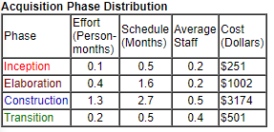

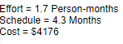

This overall cost of the application if the project wasn’t done for academic purposes would be around $4176 or £3197. Which is a considerable sum for a small company.

## 3.5. Tools and Software Available

There is a wide variety methods to complete this project, this ticketing system could be developed using Python (Django), Javascript (Node + Flask.js), or C# (Visual Studio + ASP.net) but only one language can be used so all of the available Tools and Software need to be evaluated before a final method is chosen.

### 3.5.1. Python

Python is a powerful programming language that is open-source and free to use, making it a suitable candidate for this project. It is easy to read, quick to learn and runs on almost all operating systems. These are positive attributes for the project team as they will be able to quickly learn the language and if there is need for assistance Python is easy to read making it convenient for other developers to pick up where another left off.

### 3.5.2. Django

Django is open-source and free to use full-stack web framework for Python, that comes with many out the box features allowing developers to quickly create web applications without any hassle. The Development team has had experience with Django creating a similar web application, this experience would allow the development team to start developing the deliverable straight away without having to learn a new programming language and development environment. Django helps developers in the creation of web applications by working under a single syntax for creating views, urls, and models unlike other web development tools like Node.js and Flask.js where the user decides on their own syntax.

### 3.5.3. Flask

Flask is a microframework for Python that is free and open source, it provides a lightweight framework with just enough functionality for small web applications. Flask is a good starting point for a web application and gives the developers freedom with what they use to further develop it. One addition to Flask is Node.js which helps integrate Javascript runtime scripts into the web application.

### 3.5.4. Node.js

Node.js is an event driven Javascript runtime tool used to build scalable network applications, it handles requests sent from a web site and can translate them to a backend database. This tool is needed for most web application that take user input but requires the developer to understand Python and Javascript.

### 3.5.5. C# Visual Studio ASP.NET

Visual Studio is a powerful IDE tool for creating web applications ("ASP.NET | Open-source web framework for .NET", 2019), it uses the open-source ASP.NET framework allowing developers to create web apps with pages based on HTML5, CSS, and Javascript with the use of C# for server-side logic. It is a powerful all in one system that helps direct developers creating web applications and services as everything they need is in one place. ASP.NET also allows the developer to host up to ten web applications on Microsoft Azure for free making it a suitable alternative if the Tech CPR hosting server couldn’t be used.

### 3.5.6. SQLite (Django Default)

SQLite3 is the default database for Django, every project created with Django has a default SQLite3 database unless the developer chooses to use something else, it is a file based SQLite database with a self-contained SQL database engine. SQLite come built into all mobile phones and most computers, it also comes bundled inside countless other applications that people use every day.

SQLite3 is a stable cross-platform database, it is suitable for small to medium applications, if the traffic isn’t too heavy. The application being developed isn’t expecting much traffic so SQLite3 will be suitable. If the needs of the project deliverable changed and the traffic increased a MongoDB database would be a suitable change at no extra cost to Tech CPR.

### 3.5.7. MongoDB

Mongodb is the most popular database for modern applications in use today (MongoDB, 2019), it is a free and open-source document-oriented database management system, it supports a variety of programming languages such as Python, Java, C++, C# and JavaScript. It supports high availability, scalability with native sharding, end to end security, with built in management tools that support automation, monitoring, and backups. All the databases are stored in JSON-like documents, meaning that the fields can vary from document to document and the data structure can be changed over time or as the user needs it to.

## 3.6. Tools chosen

The chosen tools for this project are Python 3.7.2 and Django 2.1 with a SQLite 3 Database as all of these tools are open-source and free to use suiting the project requirements as their isn’t a budget, it also suits the development as they have experience in each.

### 3.6.1. Python 3.7.2

The newest version of Python is being used at the time of this project life cycle, Python was chosen as a suitable solution to creating the web application, the project team has experience creating similar web applications meaning they do not have to undertake much research to get the development started.

### 3.6.2. Django 2.1

Django a full-stack framework for Python was chosen because it gave the development team everything they needed to create a fully functional web application without having to plan on additional tools that aren’t provided with a micro-framework such as Flask. Django also works under a single syntax allowing the project team to write the tables for the database and how they will interact with the web pages using the same connotations, lowering the development time needed.

### 3.6.3. SQLite 3

SQLite3 is the default database included with Django, it is an open-source file based database tool that uses a self-contained SQL database engine. SQLite3 suits small to medium project that don’t get a lot of traffic, which makes it ideal for this project. If the needs of the project changed and the traffic to the web application became too much for SQLite3 the database would be changed to MongoDB as it can handle much higher volumes of users and queries, and is still open-source and free meeting the requirements that Tech CPR set for the project.

# 4. Application Design

## 4.1. Overview

The design of the application was created as an initial starting point for what the end product was going to be, but as the project methodology being using is Agile’s Scrum framework these initial designs will be change/improved during and between Sprints as the application prototype will be constantly evaluated and changed. These design documents clearly show how the application should look and function.

## 4.2.Graphical User Interface

### 4.2.1. Layout

The web application being developed for Tech CPR is going to be implemented within the websites current header and footer(refer to appendix B - figure 13, 14), meaning it will be inside the main content area so the application needs to be simple and easy to use as it could make the website appear cluttered with all links and content from the navigation bar and footer. If the layout appears cluttered the user experience with the website will be difficult and possibly confusing, it is important that the website has a clear consistent layout to ensure users have a good experience and high performance with the website. This is very important for a web application as it provides a service to the user and if the user performance on the website is slow the user could have a stressful experience while trying to receive support lowering their satisfaction with the service(Gautham, M., & Ratvinder, G. 2013).

Wireframes (refer to appendix - Wireframes) were created to outline how each of the web pages should look like, each of these wireframes are starting points that could be changed during the development of the application but will consist of each of the functional elements.

### 4.2.3. Theme

The web application will be using the header and footer from the current Tech CPR website meaning the theme of the web application needs to match the Tech CPR website. The colour scheme for will be flat and simple as the parts from the Tech CPR website will be on screen to display the brand and its main colour scheme, a colour palette was created by sampling the colours used on the Tech CPR website, these aren’t all required for the Web application as the main content on other pages of the Tech CPR website are primarily white (refer to appendix - figure 15).

## 4.3. Use Cases Diagrams

A use case was designed and developed to create a visual representation of how different users will use the new support system (refer to appendix - figure 12 ). All users that access the support system will either be a user(clientele), SupportUser(Tech CPR Support Staff) and Administrator(Owners at Tech CPR).

The Users main functions on the support ticketing system are Submitting new tickets (Posts), viewing tickets they posted, and responding to relies on a ticket they submitted. For a user to do these main functions they first must login and view the users section on the web application.

The Support Users are employees at Tech CPR who will be assisting users (Clientele), the main functions of the support users is to view tickets (Posts) submitted by the users, respond to these submitted tickets and then when the users issues have been resolved close the tickets. For the support user to do these functions they first must login to the web application and view the support staff section.

The administrators are the two joint owners of Tech CPR, these two admins will be able to manage all tables in the back end of the web application. They will mainly be creating new users and support users. But will be able to create, edit and delete anything within the database, the administrators will have their own login page and area of the web application to complete these main functions.

## 4.4. Database Design

### 4.4.1. Normalisation

Normalisation was used to help optimise database tables by removing any duplicating data, the development team used Normalisation to ensure that the database size doesn’t increase due to duplicated data and to optimise read times keeping the web applications response times short without moving to a different database tool (refer to appendix - Database Normalisation).

### 4.4.2. Entity Relationship Diagram

A entity relationship diagram was created to show how each of the normalised tables will relate, the diagram simplifies the relationships so that they are easy to read and understand.

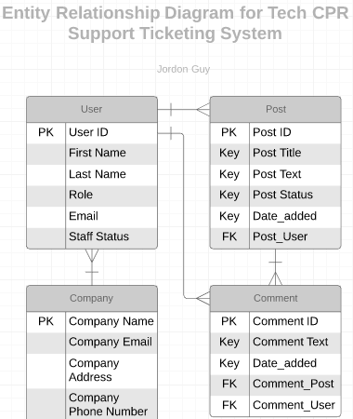

### 4.4.3. Final Database Design

The database chosen is SQLite 3, it is relational and uses a file format that offers cross-platform further promoting the use of Python and Django as they are also have support across a large number of platforms.

The initial database design for the support system was created to show how new tables were going to interact with each other (refer to appendix - figure 16). The database design was changed and improved as the development progressed. The first database design was created before the tools were chosen so it was only a starting point.

The initial database design has three tables (refer to appendix - figure 16); User, Post, and Comment. These three tables make up a basic system where users can add new Posts, and Comments to those Posts.

**User table.**

The user table has four fields, the first is the primary key named “id” which is unique and auto increments for each different user stored in the database. The second field is “username” which is stored as a string and is the username for the user. The third field is “password” which is stored with the data-type varchar as a password can consist of multiple different characters, this is the password for the user. The last field is role and is used to manage different types of users such as “user”, “support staff” and “administrator”.

**Post table.**

The post table has six different fields, the first is the primary key “id” which functions as a unique identifier for each different row in the database. The second field “userid” is a foreign key linking this table to the User table, the relationship between the two tables is a User can belong many posts, but a Post can only belong to one user. The “posttitle” and “postbody” fields in the table function as a title for the post and its main text content, both are stored using the data-type string. “Postmedia” is stored as a string as well but will be string for a directory where an image/other media is stored. The last field in the table is “timestamp” and will display when the post for created.

**Comment table.**

The comment table has six fields, the first is the primary key “id” which functions as a unique identifier for each different row in the database. The second field “postid” is a foreign key linking this table to the Post table, the relationship between the two tables is a Post can have many comments, but a comment can only belong to one post. The table also has a foreign key linking it to the a user, “userid” is used again, meaning a user can belong(create) many comments, but a comment can only belong to one user. The comment table also has other fields similar to the post table, “commentbody”, “commentmedia”, and “timestamp” all function the same as the fields in the post table.

As the development continued opportunities and issues arose that forced the development team to change the database design, a major change to the database happened because of the Python framework Django being used, it has many out the box features including an in-depth Users and Authentication system that took little time to set up, but this feature had its own user table in the database and was tricky to add extra fields to. To resolve this issue a buffer table was used called “ExtendedUserProfile” this table had a one to one relationship with the users table created by Django but was separate meaning Django's inbuilt admin backend still functioned correctly. This buffer linked to two different tables via foreign keys, these two tables were “Role” and “Company”, and were used to link a user to a company and to a specific role within that company so it could be displayed on Posts and Comments the user created/belonged to.

As Django uses a single syntax, it allowed the developers to create a model of a database that Django uses to create a SQLite schema and create the database, the model created for the database uses classes and each of these classes represents a table in the database (refer to appendix - figure 17).

## 4.5. Pseudo-code

This pseudo-code will help with the development of the actual code that will be used to make the main functions, it will follow the rules Django has to ensure that it is useful to the development team. Django passes variables to a View (HTML page), within the HTML “{% %}” tags are used to run statements such as conditionals like “If & Else”, within these pages “{{ }}” tags are also used, these tags pull information from variables passed to the View this is how information from the database will be displayed on the page.

### 4.5.1. View All Posts

***Get all objects in Post database where Post_Status equal true and order by date_added from newest to oldest.***

This will collect all objects in the Post database that are active and orders them from newest to oldest to be passed to the View

***For each object in Post Create a widget that contains PostTitle, Date_added, Post Body, User Name(PostOwner), User Role(PostOwner), User Company(PostOwner).***

This creates a separate widget for each individual post in the database from newest to oldest on a HTML page.

### 4.5.2. Add New Post

This pseudo code is for a form that will be used to submit a new post to the Post database. Django has a very interesting feature with forms that allows the developer to create a new form from a database model that was used to create the database tables.

***From Post Model create form using the fields Post Title and Post Body***

This creates a new form but only wants the information for the two fields PostTitle and PostBody, this form is then passed to the View, and to use this form on a HTML page all that is needed is “{{ form }}” and it will generate a HTML form that will be rendered.

***When form is submitted check if the form is valid, else display error. If form is valid create a Post to save to the database, pull information such as current user and add to the new Post, then commit the new Post to the database and load the ViewPosts View/Webpage.***

As the form doesn’t have all the information needed to make a new valid row in the Post table, the information that the is required but the user cannot input needs to be gathered and added to the new Post before it is committed to the database.

### 4.5.3. Add Comment to Post

***From Comment Model create form using the field Comment Body***

This creates a new form but only wants the information for the field Comment Body, this form is then passed to the View, and to use this form on a HTML all that is needed is “{{ form }}” and it will generate a HTML form.

***When form is submitted check if the form is valid, else display error. If form is valid create a Comment to save to the database, pull information such as current user and Post, and add to the new Comment, then commit the new Comment to the database.***

As the form doesn’t have all the information needed to make a new valid row in the Comment table, the information that the is required but the user cannot input needs to be gathered and added to the new Comment before it is committed to the database.

### 4.5.4. Closing a Post

This will be another form but only using a button without the user having to input any information.

***If close post button is pressed commit changes to database setting current Post table field PostStatus to false.***

This function will only be available to Support Staff Users and the original Poster to signal that the issue is resolved or no longer relevant.

## 4.6. Test Plan Design

Functionality test plans were created as a tool to evaluate the functionality of the web application created, these test plans use conditions to ensure that each function of the application works correctly under different circumstances (Refer to appendix H - Functionality Test Plans).

# 5. Sprint 1 - Initial Prototype Development

## 5.1. Pre-Sprint Plan

The pre-sprint plan is where all the tasks are created and assigned to a sprint, eight tasks were originally created relating to the creation of the prototype application. Some tasks were completed before the first day of the sprint, these were tasks such as installing all software and tools needed to begin development, create basic HTML templates for each of the web application pages, and start a new django project creating all of the Django default files (refer to appendix C - figure 18).

Sprint 1 started officially on the 9th of March 2019 and lasted for 1 week, finishing on the 16th. During this time the development team worked through the tasks created in the pre-sprint plan closing them off as they were completed. This is shown in the sprint documentation (refer to appendix C - figure 18) as a burndown chart visualising the number of tasks that aren’t closed over time.

## 5.2. Development Sprint

The first day of Sprint 1 was the 9th of March 2019, some prerequisites were completed before this date such as installing all of the necessary tools for development, this included Python 3.7.2 and Django 2.1.7.

### 5.2.1. Creating a new Django Project

On the first day after the initial Scrum meeting Jordon created a new Django project generating all of the of default files, To create a new project using Django the command “django-admin startproject TechCPRSupportSystem” was ran within an CMD console while within a folder that was created on the main development computer.

Django populated the workspace will many folders and files (appendix C - figure 19, 20), as seen in figure 19 Django has created a python file called manage.py, the manage.py file is used to run Django specific commands such as runserver, createsuperuser, makemigration and migrate.

After the project files were generated the database tables needed to be committed, to do this the command “python manage.py migrate” was ran in the command prompt while the project directory containing manage.py, this generated the database called db.sqlite3 with all of the Django default tables (appendix C - figure 20).

### 5.2.2. Creating the Django App

Django allows the user to create a project and break it up into smaller manageable parts, this web application only has two main functions, these are to login/logout of a user account and to post tickets and comments, Django allows the developer to split these functions into apps so they function as individual modules, to create the two different apps the commands “python manage.py startapp supportsystem” and “python manage.py startapp account”(appendix C - figure 21) was ran, this created a folder within TechCPRSupportSystem named “supportsystem” and “account” these folders contains multiple files used to create apps (appendix C - figure 22), the model.py file is used to create models that will become database tables in the SQLite3 database from figure 20, the views.py file is used to tell the application what directories it has for the users to visit, the directories stated within views.py are passed to a file named urls.py this file actually sends the user to the different pages and allows the developers to give them a common name that can be referenced within HTML and python code.

### 5.2.3. Creating Models/Database Tables

To use the SQLite3 database that was created when the Django project was created, Models needed to be outlined in the Models.py file (appendix C - figure 22). After these models were outlined documents could be generated that tell the database how to create those models as tables in the database. These are the models outlined so that when the “makemigrations” command was used it would generate a document/database schema with instructions on how to make the tables in the SQLite database. These needed to be formatted into a order that made sense to the database as it read from the top line down so any Foreign Key references needed to the stated before it was used.

**Company Model**

This model outlines the Company table in the database, this table is used to store a list of companies so that it could be added onto the user without writing the company name each time a new user was created.

***class Company(models.Model):***

***company = models.CharField(max_length=50)***

***def __str__(self):***

***return '{}'.format(self.company)***

**Role Model**

This model outlines the Role table in the database, this table is used to store a list of roles so that it could be added onto the user without writing the users role each time a new user was created. It will store roles such as “User”, “Support Staff”, and “Admin”.

***class Role(models.Model):***

***role = models.CharField(max_length=20)***

***def __str__(self):***

***return '{}'.format(self.role)***

**ExtendedUserProfile Model**

This model outlines the ExtendedUserProfile table in the database, this table was used because of complications with the Django auto generated user table as adding extra fields created issues with the out of the box backend features. The ExtendedUserProfile allowed the development team to add extra fields to a user via a OneToOneField without changing the user table itself.

***class ExtendedUserProfile(models.Model):***

***user = models.OneToOneField(User, on_delete=models.CASCADE)***

***role = models.ForeignKey(Role, on_delete=models.CASCADE)***

***company = models.ForeignKey(Company, on_delete=models.CASCADE)***

***def __str__(self):***

***return '{} at {} as {}'.format(self.user.username, self.company, self.role)***

**Post Model**

This is model that was used to generate the Post table in the SQLite database, it has a foreign key to a user as each post must belong to a single user that originally Posted it, each post also has a title (posttitle), main body of text (postbody), a status displaying if it is active (poststatus), and a date added (date_added).

Poststatus by default will be True, this variable will be set to False by a support staff user when the users issue(s) have been resolved, because it is True by default the users post will be seen until this variable is changed, then the post will not be loaded onto the webpage as it will no longer needed as the users issues should have been resolved. But the post will still exist within the database allowing it to be reactivate or left to be archived.

Date_added also has a default state, when a new post is added to the database the Date_added field will default to the current date and time of the commit. This means that the posts date_added is accurate and doesn’t need to be inputted by the user themselves.

**class Post(models.Model):**

**user = models.ForeignKey(User, on_delete=models.CASCADE)**

**posttitle = models.CharField(max_length=50)**

**postbody = models.TextField()**

**#postmedia = models.ImageField(upload_to = 'uploadedimages/', default = 'uploadedimages/None/no.img.jpg')**

**poststatus = models.BooleanField(default=True)**

**date_added = models.DateTimeField(default=timezone.now)**

**def __str__(self):**

**return '<PostID:{}, Posttitle:{}, Status:{}>'.format(self.id, self.posttitle, self.poststatus)**

**Comment Model**

This model was used to generate the Comment table in the SQLite database, it has a foreign key to a user as each Comment must belong to a single user that originally made it, each Comment must also belong to a single Post so another foreign key has been used to create that relationship in the database. The Comment table also has a main body of text (commentbody), and a date added (date_added).

The two foreign keys make sure that each Comment belongs to a single post and to a single user, but a User and a Post can still belong multiple Comments

***class Comment(models.Model):***

***user = models.ForeignKey(User, on_delete=models.CASCADE)***

***post = models.ForeignKey(Post, on_delete=models.CASCADE, related_name="comments", related_query_name="comment")***

***commentbody = models.TextField()***

***#commentmedia = models.ImageField(upload_to = 'uploadedimages/', default = 'uploadedimages/None/no.img.jpg')***

***date_added = models.DateTimeField(default=timezone.now)***

***def __str__(self):***

***return '<CommentID:{}, Post:{}>'.format(self.id, self.post)***

### 5.2.5. Creating Urls

For this web application there is three areas that different users will use, these are “admin/”, “supportsystem/”, and “account/”, each of the separate parts of the web application have been created as separate modules containing their own views and models.

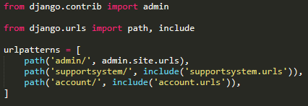

The admins of the web application such as Mark and the other joint owner of Tech CPR will use the “admin/” url path to view the back end of the web application where they will be able to create, edit, and delete users, and all other tables in the database. The views for “admin/” are all out of the box features of Django and didn’t need to be created by the developers.

Both the support staff users and clientele users will use the “account/” urls to log in and log out of the web application, this is the “account/” urls only function but was needed to separate the login feature and ensure the code was re-usable. The “auth_views.LoginView.as_view()” and “auth_views.LogoutView.as_view()” lines of code are used to send login and logout requests, the login request is sent via a form on the HTML page, these are default functions of Django and work out of the box allowing a easy to setup login system.

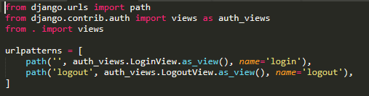

The “supportsystem/” is used by all users and is where they will view posts and comments, add new posts, and make comments.

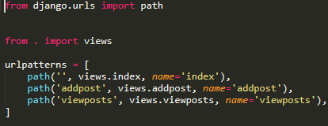

### 5.2.6. Creating Views

Views are used to send variables to a HTML page and handle POST requests from HTML forms, the developers used the views to pass objects from the database to HTML pages and handle the POST requests to the database when adding new Posts or Comments via the HTML forms.

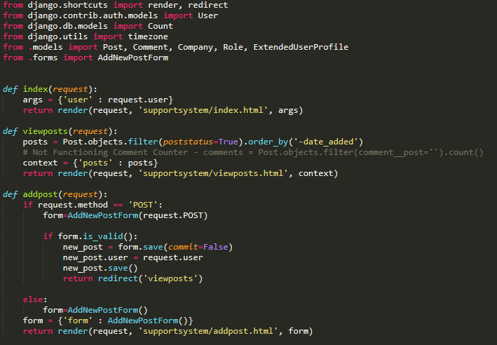

## 5.3. Issues Encountered

During the development of the web application the project team ran into issues involving some of the out of the box features of Django, the project team originally intended to create its own user table in the database but after seeing the ease of use of the Django inbuilt features decided to use them. This resulted in the Django user table being related to the other tables Post and Comment, but an issue arose as it was difficult to add extra fields to the Django User table with breaking the inbuilt backend features. To resolve this issue the project team had to research into OneToOneFields that created a one to one relationship in the database, The project team created a table in the database called “ExtendedUserProfile” thatspurpose was to hold extra fields that would relate to a specific user such as “Role” and “Company”.

## 5.4. Prototype Evaluation

At the end of sprint 1 a basic working prototype of the support ticketing system was created, it allowed the admins to create, edit, and delete User, Posts, Comments, and Companies. It also displayed all posts on a web page but didn’t allow them to post new Posts to the database due to development issues.

**Django Admin**

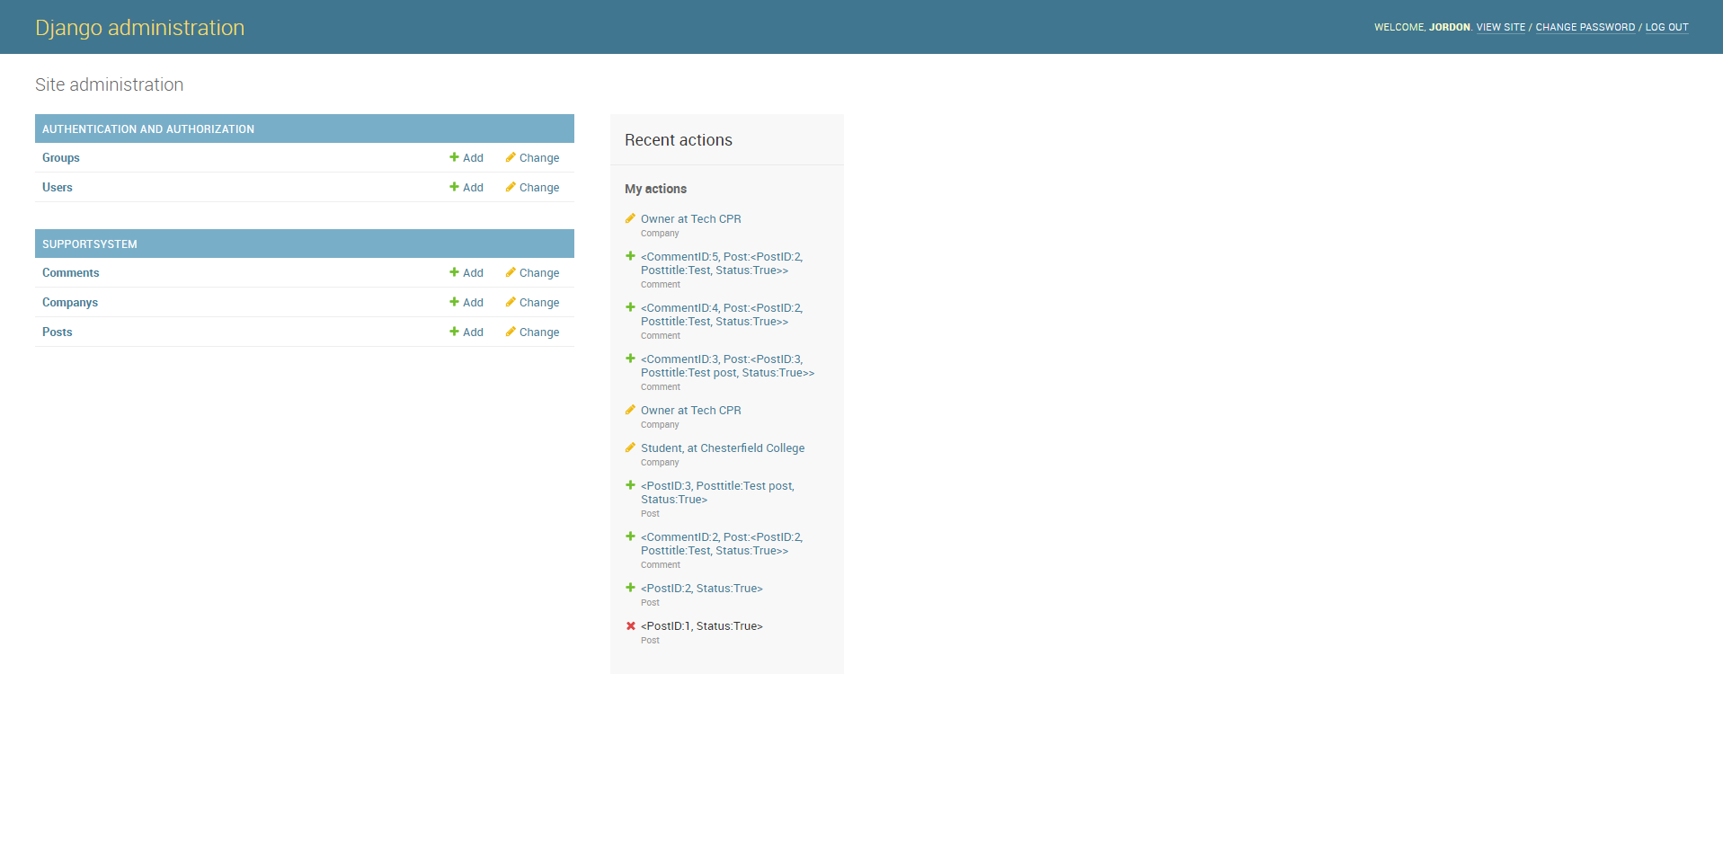

This is the Django Admin Backend allowing the admins to create, edit and delete entries in each of the tables within the SQLite database, it works correctly and will function for the admins needs.

**Index Page**

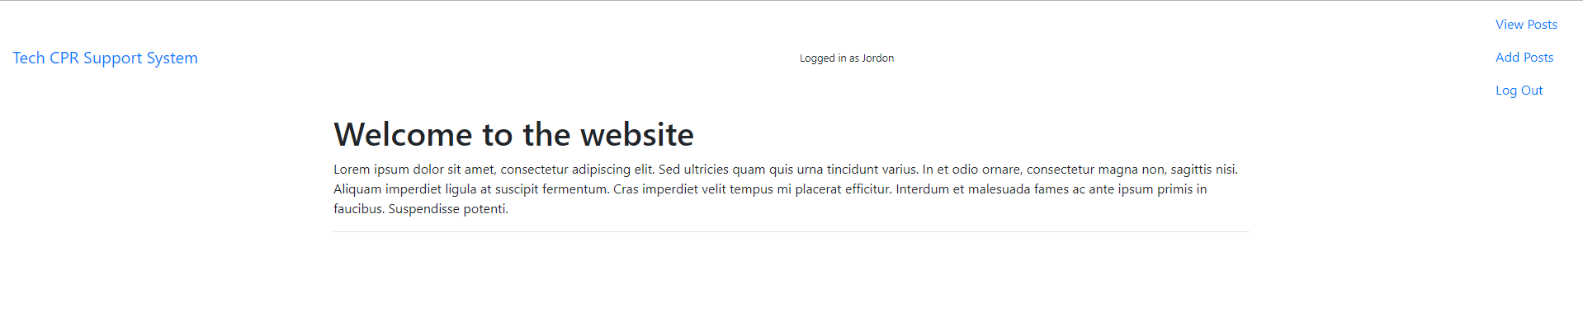

This is the default index page for the web application, it served as a homepage and main navigation point for the support staff and users, this page is what the users will first see, this is a logged in view for the User “Jordon” and will allow that user to goto the “viewposts.html”, “addpost.html”, and “logout.html” pages.

**Login Page**

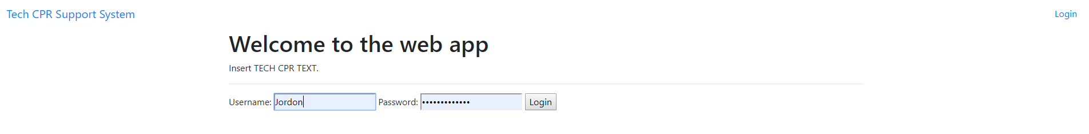

The web application allows users to login and logout using the auth_user table generated by Django, this feature fully works with this prototype. A form to create new users wasn’t required as the client wanted to create login credentials for each of his clientele himself, this can be done by an admin using the Django backend.

**Logged out view Page**

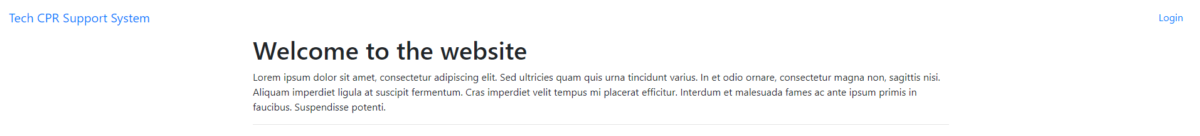

When the user first comes to the page and isn’t logged in they see a different homepage not allowing them to view the navigation links to “viewposts.html”, “addpost.html” and “logout.html” when the user logs out they are redirected to this page.

**Add Post Page**

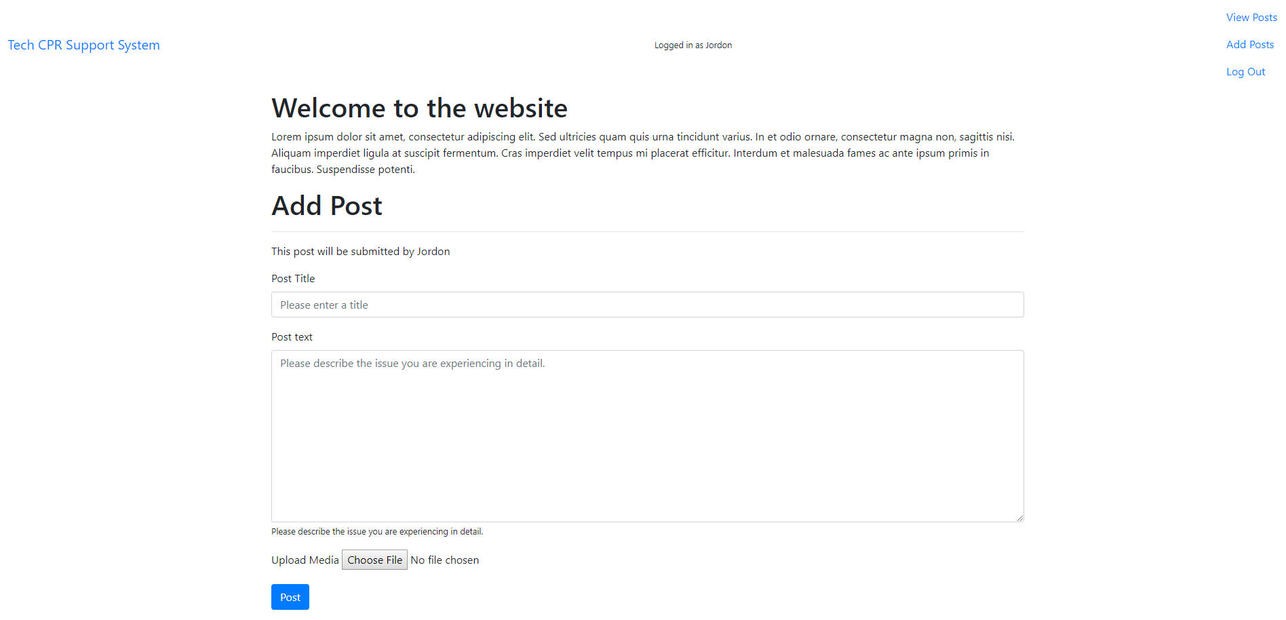

This is where the users can add posts to the database, currently it can be accessed without being logged in which needs to be addressed before publication.

The Add Post form doesn’t validate correctly so the prototype wouldn’t allow the users to submit new posts to the database, this was a problem that was addressed in the second sprint as the development team struggled to get this working without further time to build skills using Django..

**View Posts Page**

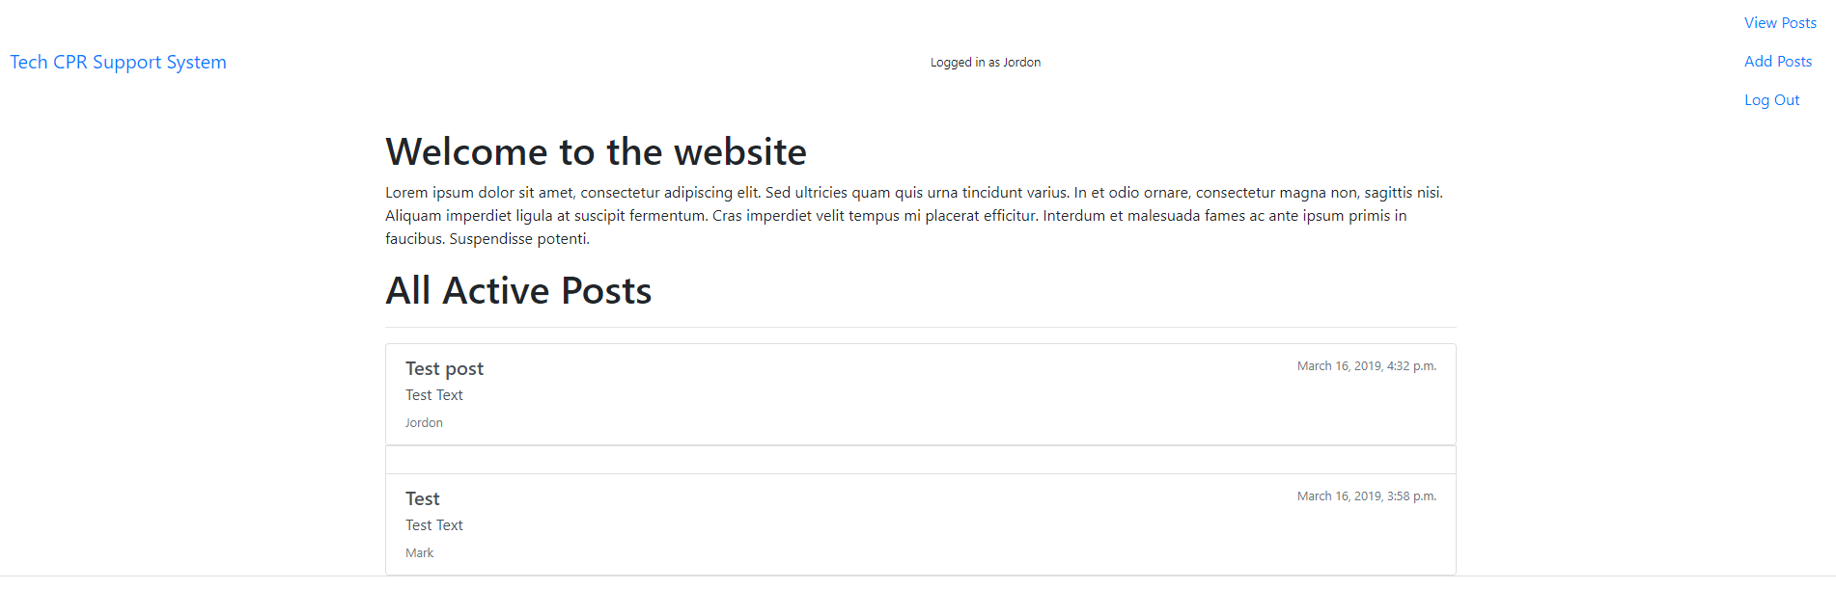

This is the view posts page, in this build it displays all posts regardless of if the user logged in which was needed to be addressed, but wasn’t an issue as this was an early prototype build.

Each of the posts are displayed, but was missing a few bits of information from the company table, the development team couldn’t resolve this issue without further research. It needed to pull information from a foreign key for each of the posts but didn’t function correctly.

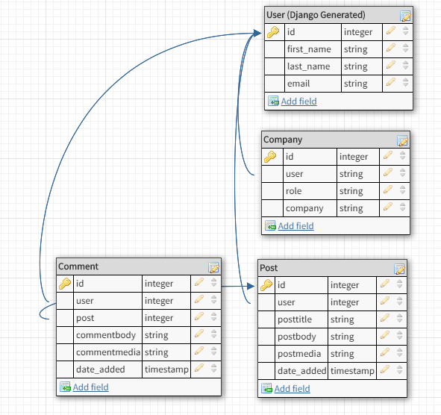

This is the database model at the end of Sprint 1, it contained four different tables relating to each other. It was developed further and changed from the database designs created before the first sprint due to Django’s default user system having its own database table and development issues (refer to appendix - Sprint 1 Documentation).

## 5.5. Sprint Evaluation

Sprint 1 was full of personal and technical issues leading to delays and shortcomings in prototype development and functionality.

Day one and two went smoothly with the development team completing and closing tasks on schedule, installing prerequisites, creating a Django project and starting work on the SQLite database models.

Day three had issues as the development team was absent due to personal reasons, forcing more tasks to be completed in less time, some work on the Django models was started that day but no tasks were closed. On Day five the database models were finished, migrated and tested.

On day six technical issues arose slowing the development of the prototype, the relationships between the models/database tables needed to be changed as Django had its own inbuilt user system and to utilise this system the models needed to be changed. This issue arose because the development team didn’t have any prior knowledge to this user system and they had to make fast adjustments to attempt to keep on schedule with the sprint. The last day of the sprint progressed the prototype a lot allowing the users to login and logout of the web application. But many of the tasks that was allocated to the sprint were left unclosed and more time was needed for them to be completed. This led to the project manager shifting tasks from Sprint one to Sprint two (refer to appendix C - Sprint 1 Documentation).

Sprint one wasn’t a good start to the development of the deliverable and the outcome was a crude prototype that had limited functionality that served as a base for Sprint two. A note for the future would be to allocate more time for the project team to learn the software and tools they are going to be using, and to account for personal reasons that may lead development team members being absent/busy such as birthdays and illness.

# 6. Sprint 2 - Refined Functionality and Visuals

## 6.1. Pre-Sprint Plan

Sprint one wasn’t a good start to the development of the web application as the development team ran into many issues causing many tasks to partially completed, these tasks were handed over to Sprint 2 and the expectations of Sprint 2 were lowered to compensate.

## 6.2. Development Sprint

### 6.2.1. Creating Forms

Django has a very interesting feature with forms that allows the developer to create a new form from a database model they used to create the database tables. So the model that used to create the Post table in the database was also used to create the Form that the user will use to submit new posts to the database.

As the only information that the user will able to supply for a new post is the title and main body of text, the new form has only been passed the fields “posttitle” and “postbody” all other fields in the database will be gathered before the new post is committed to the database.

class AddNewPostForm(forms.ModelForm):

class Meta:

model = Post

fields = ['posttitle', 'postbody']

widgets = {

'posttitle' : forms.TextInput(attrs={'class' : 'form-control', 'placeholder' : 'Please enter a title'}),

'postbody' : forms.Textarea(attrs={'class' : 'form-control', 'placeholder' : 'Please describe the issue you are experiencing in detail.'})

}

This form was implemented onto a HTML document called “AddNewPost.html”, Django uses a document called Views.py to pass variable to a HTML page, this new form was passed to the view “addpost” that allowed it to be called within the HTML page.

def addpost(request):

if request.method == 'POST':

form=AddNewPostForm(request.POST)

if form.is_valid():

new_post = form.save(commit=False)

new_post.user = request.user

new_post.save()

return redirect('viewposts')

else:

form=AddNewPostForm()

**form = {'form' : AddNewPostForm()}**

**return render(request, 'supportsystem/addpost.html', form)**

Django uses a single syntax, where “{{ }}” tags appear indicates to Django that code is present and needs to be ran but only within these curly brackets. The form was called to the HTML page on load using the “{{ form._____ }}” tags, after form._____ each field within the was call individually, a “csrf_token” is also present to help ensure that the information being submitted to the database comes from this webpage meaning it needed to be validated first.

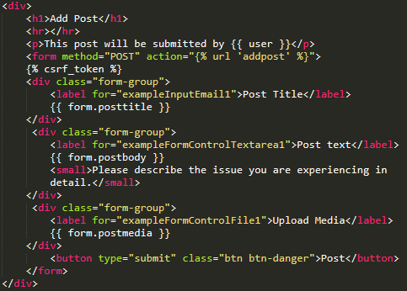

When a POST request comes from the web form, it is ran through an If statement checking if it is valid, if the form isn’t valid it displays an error. If the form is valid a new object is created to commit to the database, but before it can be more information is gathered such as the current user logged in, after this information is gathered the new Post is committed to the database and the user is returned to the ViewPost.html page.

def addpost(request):

**if request.method == 'POST':**

**form=AddNewPostForm(request.POST)**

**if form.is_valid():**

**new_post = form.save(commit=False)**

**new_post.user = request.user**

**new_post.save()**

**return redirect('viewposts')**

**else:**

**form=AddNewPostForm()a a**

form = {'form' : AddNewPostForm()}

return render(request, 'supportsystem/addpost.html', form)

### 6.1.2. Refining HTML Visuals

The styling for the HTML pages were done using Bootstrap (Otto, 2019) via a content delivery network, Bootstrap is a very useful tool for styling HTML pages and suited the needs of the project as the web application needed to be developed quickly. Bootstrap delivers style sheets to a HTML page that can utilise them without the developers having to write their own CSS.

The favicon from the Tech CPR website was added to the web application to match, after these changes to the web application it is ready to be implemented into the main content section of the Tech CPR website.

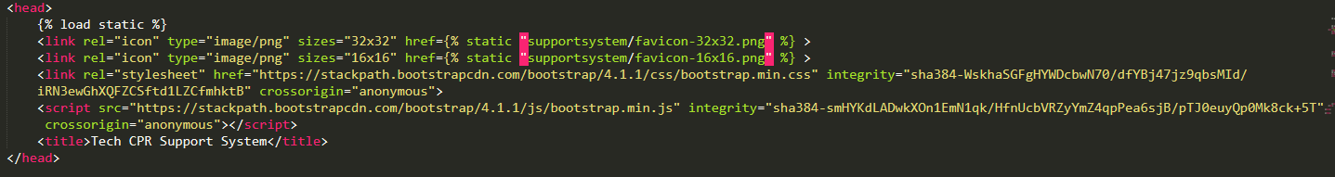

This is the head tags of each of the webpages in the Support System, it contains links to the Favicon for sizes 32x32 and 16x16. Within these tags there is a link to the Bootstrap style sheets via a content delivery network meaning the CSS files do not have to be present within web application static resources folder.

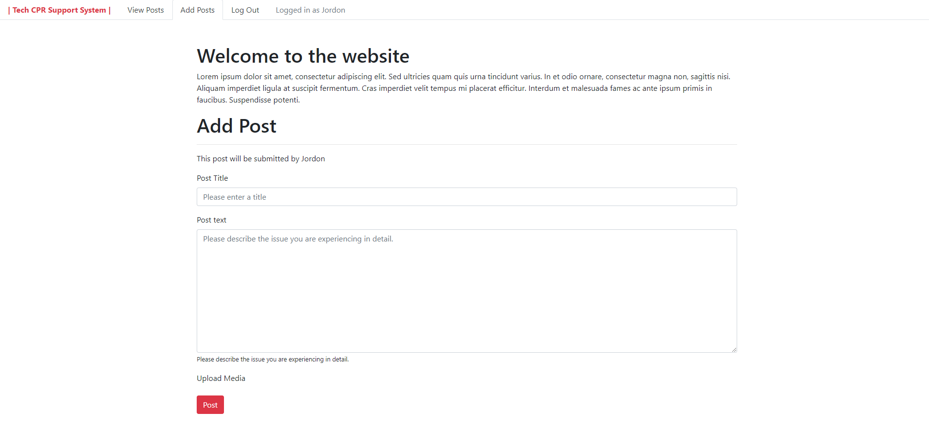

The web application is styled to look simple as it needed to show within the Header and Footer of the Tech CPR website,

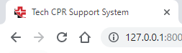

The Favicon is identical to the one used on the Tech CPR website and is display across all web pages of the web application..

### 6.1.3. Class-based Views

Some functions that web application needed were to; view a single post with all comments associated with it; and to view all posts from a single user. The development team didn’t have any experience with this problem and had to research into Django’s documentation to find a solution. The solution found was a class based view called a Detail View ("Built-in class-based generic views", 2019). A class based view allows developers to create a class of abstract view development patterns to allow them to re-use the class across multiple views effectively lowering the amount of lines of code needed. A useful feature of Class-based views is creating a single View that handles multiple different requests, this allowed the development team to create a Detail View that allows the user to view a specific “Post” that can be reused across all “Post”s.

### 6.1.4. DetailView - Specific Post

When the user selects a Post from the list it redirects them to a Detail View displaying all information about that specific Post and all comments that belong to it.

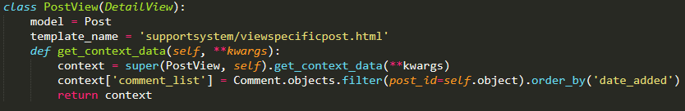

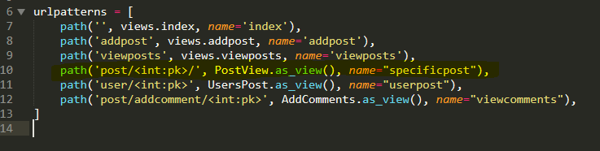This Class-based view is used when a URL is called with “supportsystem/post/<int:pk>” this means that it is only used when it matches with the primary key of a post in the database. When it matches it calls all information about that Post as an object and also all Comments that belong to it in a Object_list called “comment_list”. It uses the template ‘supportsystem/viewspecificpost.html’ where code is implemented within “{{ }}” curly brackets to display the information.

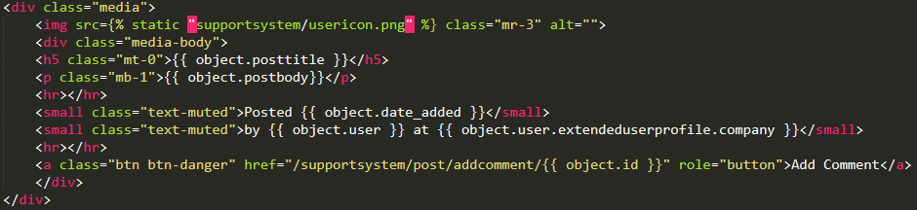

This section of HTML displays the information about the specific post that was called, it is passed to the HTML page as “Object”. Each attribute of the object was called into the HTML elements for styling purposes.

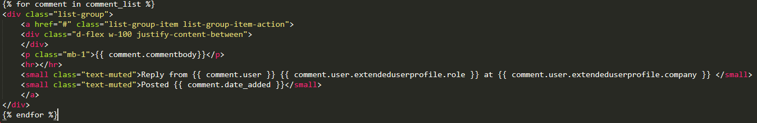

This section of HTML displays every Comment that belongs to the posts being displayed on the web page, there is a “For” loop surrounding the HTML elements and for each of the comments that belongs to the Post being displayed, an individual comment is displayed separately. When the Comment_list was created it was sorted by newest first so older comments will be displayed at the top creating a chat history list as the user scrolls down.

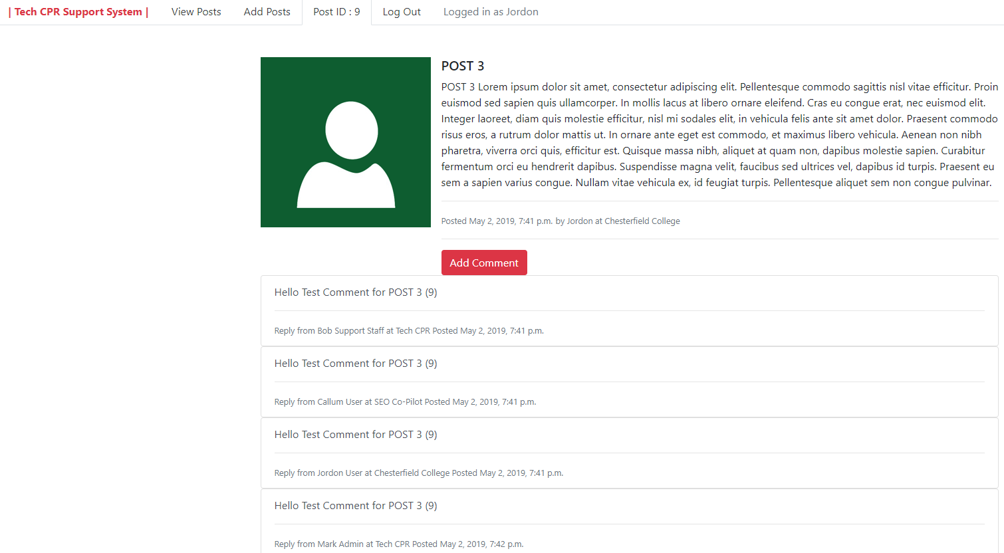

This is the HTML page being rendered showing the Post with the primary key of 9. It displays all information about that post and shows all comments that belong to. It also has a button that takes the user to a webpage where they can add a new comment to the post.

### 6.1.5. DetailView - Specific User’s Posts

When the user visits their User page all Posts they have submitted that are still active are displayed so they can view them and any comments/replies that have been left by the support staff.

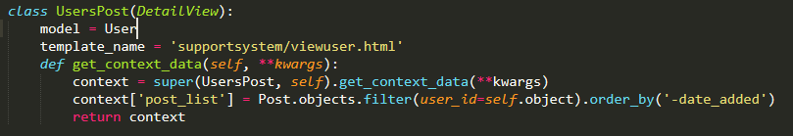

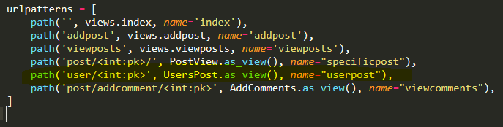

This Class-based view is used when a URL is called with “supportsystem/post/<int:pk>” this means that it is only used when it matches with the primary key of a User in the database. When it matches it calls all information about that User as an object and also all Posts that belong to it in a Object_list called “post_list”. It uses the template ‘supportsystem/viewuser.html’ where code is implemented within “{{ }}” curly brackets to display the information.

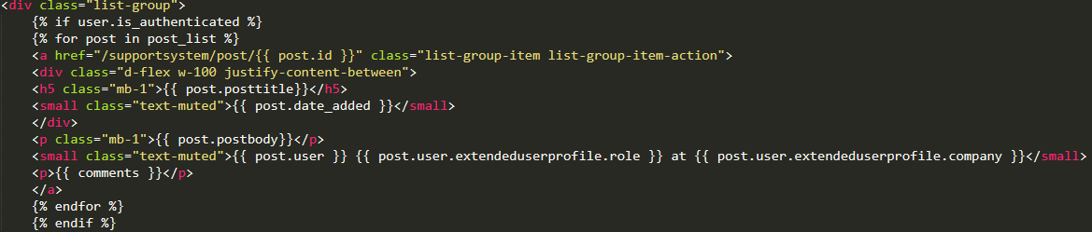

This section of HTML displays each POST that belongs to a specific User using a For loop. This For loop surrounds HTML elements meaning that they are repeated for each of the Posts that are obtained using the filter looking for Post ID to match the user.

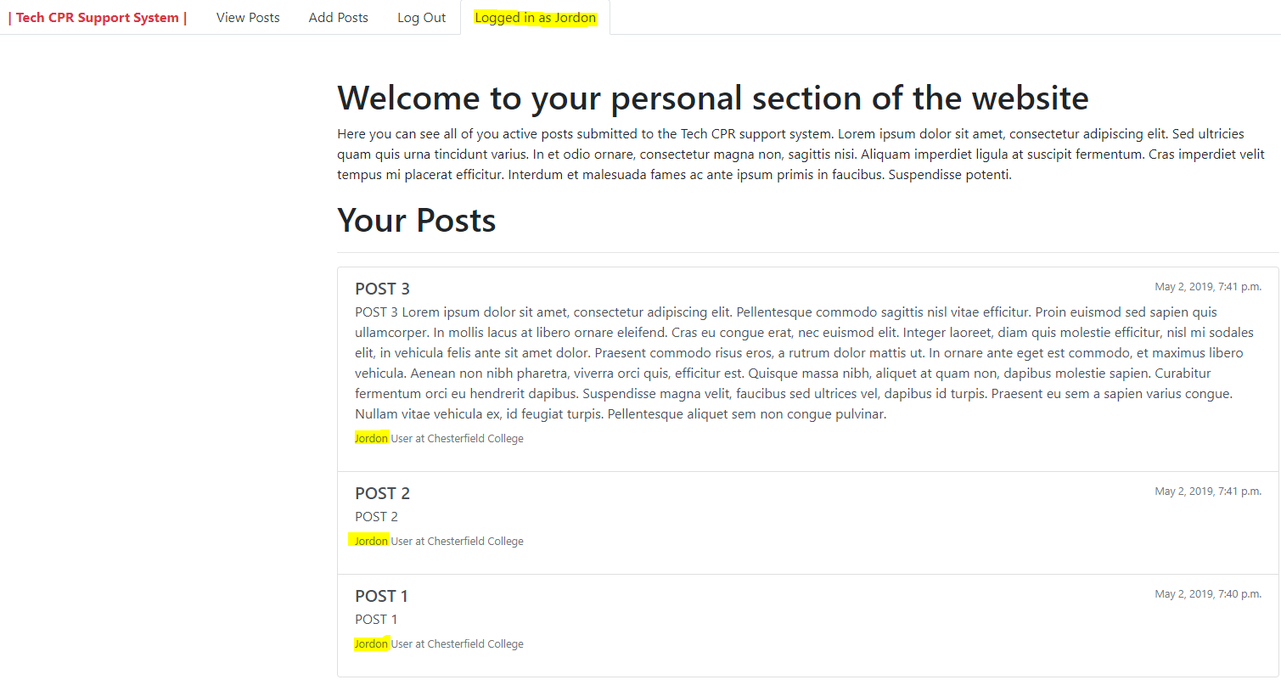

This is the render for the User with the Id of 1, it displays all the posts they have submitted to the web application, in reverse date added or newest first. The user will be able to select a individual Post to view more details and any comments that belong to that post.

## 6.2. Issues Encountered

The development team needed a method a handling individual objects from the database as their wasn’t a way to see an specific Post and Comments or all a User's Post on the web app, to resolve this issue the development team researched into Class Based views, Generic Views and Detail Views. The solution came with its own issues but allowed for the creation of templates that could handle requests related to objects in the database (refer to appendix D).

An issue encountered from using Class Based views was creating views for each specific Post, with all Comments and the ‘Add Comment Form’ as Class Based views aren’t able to take a Model, extra objects with a form at the same time so a new method of submitting comments needed to be created. This led to issues as the development team didn’t know how to resolve the issue without making the Comment Submission messy/unprofessional (refer to appendix D).

## 6.3. Prototype Evaluation

**Specific User View**

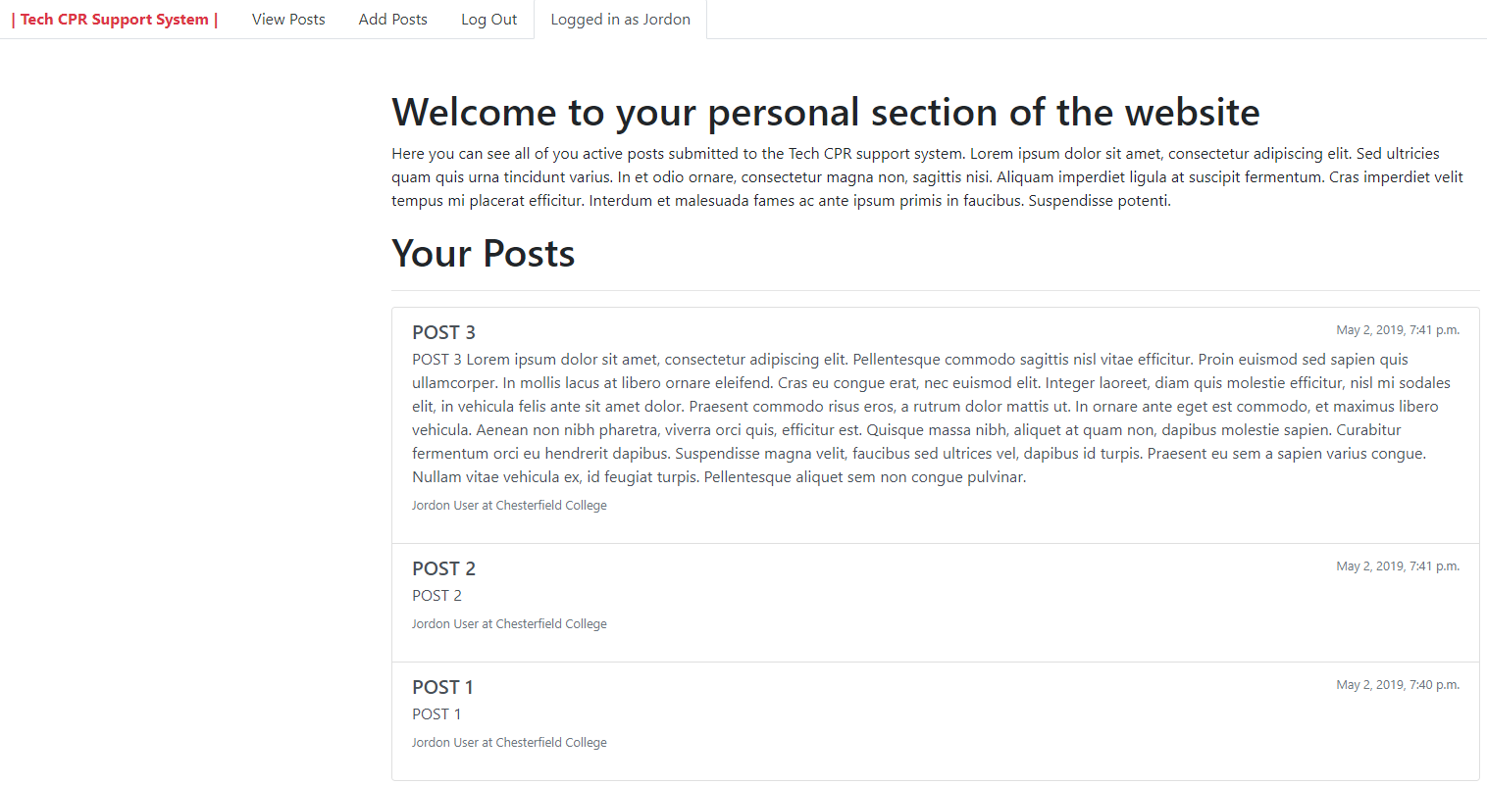

**Specific Post View**

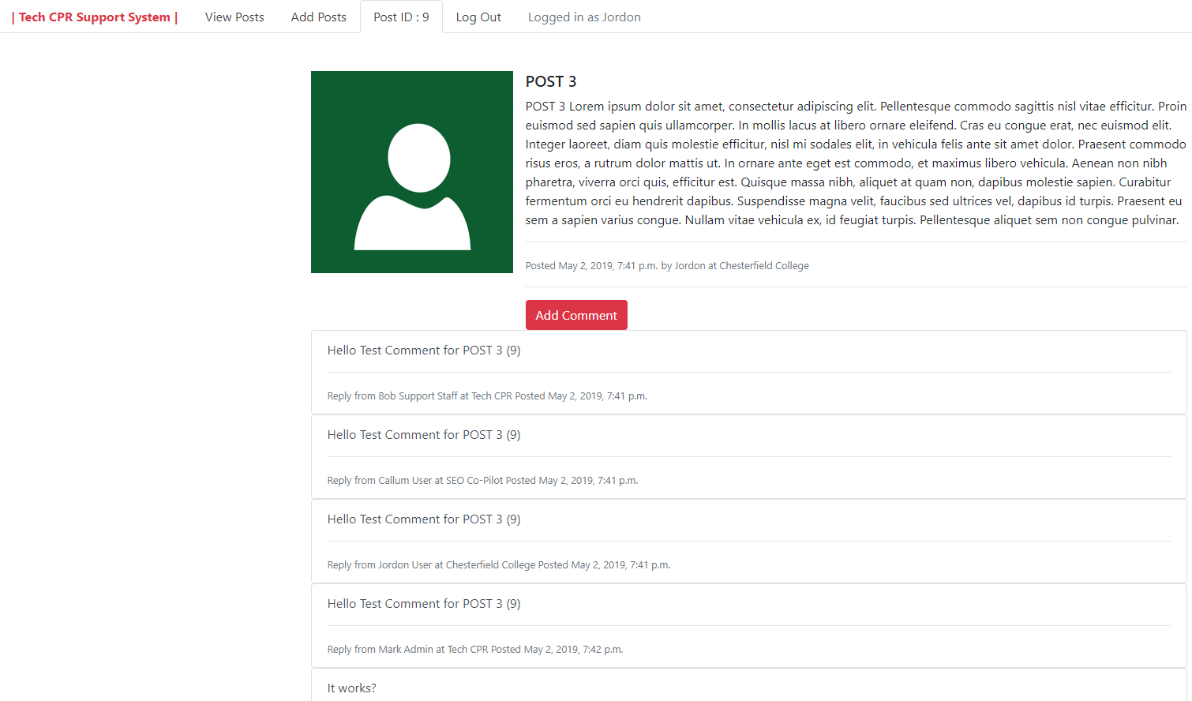

This view matches the designs created, it displays an individual post and only comments that belong to that post. As this is the prototype styling is slightly poor but all functionality is present and works.

The “Add Comment” button has a href that changes depending on the post so it can redirect the user to the add comment form that adds a new comment to the post they were on.



It uses the same integrated logic where it calls the object which is the individual post and adds it to the hrefs URL sending the user to a unique web page that handles POST requests for new comment for that individual post.

**Add Comment View**

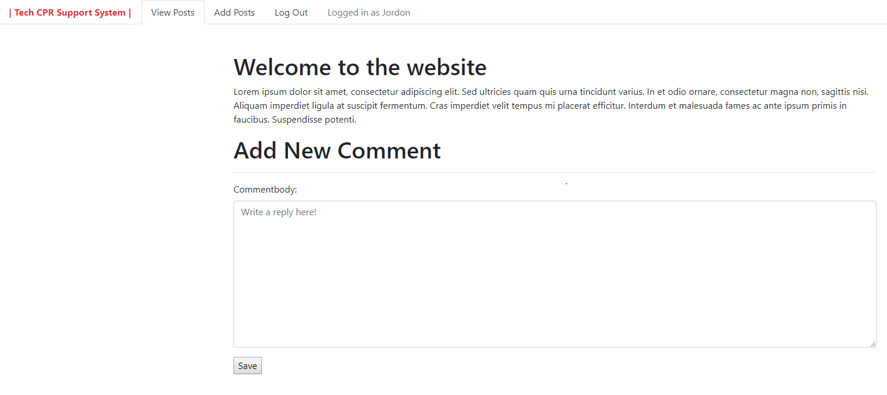

The add comment view works from the Post model(database table). If the url requested has a id that matches an entry in the database it will load, if not it will load a 404. Currently issues with the submission means that users aren’t able to post new comments to the database, This view doesn’t function as the requirements stated and needs extra development time.

## 6.4. Sprint Evaluation

Sprint 2 was overall a success as it got new functionality to the prototype and refined the visuals to match the needs and requirements from Tech CPR. Class based views (Detail Views) were created to view a specific Post and all comments belonging to it and a view for seeing all posts that belong to a specific user. As Well as refining the visuals to better suit the Tech CPR website so that the web application can be integrated.

There were still issues during Sprint 2 as a new method of handling individual post views needed to be found, the solution to this was a class based view, this works really well for creating the pages around each unique object in the Post database but led to issue when creating a method of posting new comments to the database. Due to this issue the vital functionality of adding a new comment doesn’t work making this prototype unsuitable for release. A extra Sprint is needed to finish the prototype off but due to time constraints will have be a done outside of a Sprint in extra development.

# 7. Extra Development

## 7.1. Introduction

Some development for the project deliverable was done outside of the allocated Sprints, this was needed as issues arose during the Sprints and additional development was needed to ensure the prototype development was suitable for the needs of Tech CPR (refer to appendix E - Figure 24).

## 7.2. Development

### 7.2.1. Adding New Comments

The function of adding new Comments surfaced issues around the use of Class Based Views as each class based view could only serve a single function such as “Detail View”, “CreateView”, “UpdateView” etc. because of this single functionality each function needed to be split up into different views. A non-class based view was used to combat this issue but another problem halted development when adding new comments, it was getting the Comment the user wanted to add a comment to when submitting a new entry in the database.

After other solutions failed to resolve the issue the class based view was revisited and a makeshift solution was created to allow users to add new comments to different posts. This solution allows the user to select the Post they want to add a comment to, it uses a drop down list that contains all Posts that has a poststatus that equals True (refer to appendix E - Figure 25) and a text area for the main text of the comment (refer to appendix E - Figure 29). This isn’t professional and is a makeshift solution to the problem.

### 7.2.2. Closing Posts

The function of closing a post when the issue is resolved is needed to indicate that the post doesn’t require any more attention, this function doesn’t need to delete the post so that if the post needed to be reopened an admin could use the admin panel to restore its visibility to the support staff and user.

A class based view was used called an “UpdateView” where it takes the primary key of a Post in the Url, this is so the Form understands what Post is to be targeted and updated (refer to appendix E - Figure 27). A new form was created that only targeted “poststatus” so that when the request is “POST”, only the “poststatus” field of the object is changed. on the HTML it only appears as a tick box representing “True” and “False” for active and not active. (refer to appendix E - Figure 30).

# 8. Project Deliverable Evaluation

## 8.1. Functionality Testing

**Login system**

|  |  |  |  |  |
| --- | --- | --- | --- | --- |
| **Conditions** | **Rule 1** | **Rule 2** | **Rule 3** | **Rule 4** |
| Username (A/B) | B | B | A | A |
| Password (A/B) | B | A | B | A |
| Output (C/D) | C | C | C | D |

*Legend:*

*A - Correct Username/Password*

*B - Incorrect Username/Password*

*C - Validation Error Displays*

*D - User is Logged In*

**Viewing All Active Posts**

|  |  |  |
| --- | --- | --- |
| **Conditions** | **Rule 1** | **Rule 2** |
| User (A/B) | A | B |
| Output (C/D) | C | D |

*Legend:*

*A - User is logged in*

*B - No User is logged in*

*C - All Active Posts are displayed.*

*D - Nothing is displayed and the navigation bar only shows the login button.*

This functionality of only showing information if a user is logged in is present across all pages of the web application to ensure that information is hidden to anonymous users. This helps protect customer information and any possible vulnerabilities to their computer infrastructure as it would be unethical to leave it unprotected (*Brinkman, B., & Sanders, A. 2013)*.

**Database Testing (Using Back-end Admin Section)**

**Creating a new User**

|  |  |  |  |  |
| --- | --- | --- | --- | --- |
| **Conditions** | **Rule 1** | **Rule 2** | **Rule 3** | **Rule 4** |
| Username (A/B) | A | A | B | B |
| Password + Password Confirmation (C/D) | C | D | C | D |
| Output (E/F) | F | F | F | E |

*Legend:*

*A - Username Null*

*B - Username Not Null*

*C - Password meets the conditions but doesn’t match*

*D - Password meets the conditions but does match*

*E - A new user is created*

*F - Errors display*

**Removing a User*.***

|  |  |  |
| --- | --- | --- |
| **Conditions** | **Rule 1** | **Rule 2** |
| User (A/B) | A | B |
| Output (C/D) | C | D |

*Legend:*

*A - User has Posts*

*B - Posts has Comments*

*C - User + Posts are deleted*

*D - User + Post + Comments are deleted*

**Removing a post**

|  |  |  |
| --- | --- | --- |
| **Conditions** | **Rule 1** | **Rule 2** |
| Post (A/B) | A | B |
| Output (C/D) | C | D |

*Legend:*

*A - Post has no Comments*

*B - Post has related Comments*

*C - Post is deleted from the database*

*D - Post is deleted along with all related Comments*

**Removing a Comment*.***

|  |  |  |
| --- | --- | --- |
| **Conditions** | **Rule 1** | **Rule 2** |
| User (A) | A | A |
| Output (C/D) | C | C |

*Legend:*

*A - Comment belongs to a Post*

*C - Comment is removed*

*D - Comment + Post is removed*

All the admin backend works correctly to the project requirements, Posts, Comments can be created, deleted and updated via the admin section of the website allowing the Admins at Tech CPR to easily manage the web application. The backend of the web application also allows the admins to create new users but they will also have to create the buffer table called “ExtendedUserProfile” for the user to be able to post Comments and Posts.

**Adding Posts**

|  |  |  |  |  |
| --- | --- | --- | --- | --- |
| **Conditions** | **Rule 1** | **Rule 2** | **Rule 3** | **Rule 4** |
| Post Title (A/B) | A | A | B | B |
| Post Text (A/B) | A | B | A | B |
| Output (C/D) | C | C | C | D |

*Legend:*

*A - Post Title/Body Null*

*B - Post Title/Body Not Null*

*C - Validation Errors Are Displayed*

*D - New Post is submitted to the database*

This function works as intended and fits the project requirements of allowing users to add new posts to the web application for the Support Staff.

**Adding Comments**

|  |  |  |  |  |
| --- | --- | --- | --- | --- |
| **Conditions** | **Rule 1** | **Rule 2** | **Rule 3** | **Rule 4** |
| Comment body (A/B) | A | A | B | B |
| User (C/D | C | D | C | D |
| Output (E/F/G) | E | G | F | G |

*Legend:*

*A - Comment body Null*

*B - Comment body Not Null*

*C - Logged in*

*D - Not logged in*

*E - Validation Errors Are Displayed*

*F - New Post is submitted to the database*

*G - Form isn’t displayed*

The add comment has limited functionality without further development but the fundamentals of adding a new comment are present on the prototype.

## 8.2. Usability and Accessibility Evaluation

Usability is an important part of any application that aims to assist users, if the usability of the application is low it won’t be a pleasant experience for user or the support staff to navigate and use. This evaluation will determine user performance on the web application (Gautham, M., & Ratvinder, G. 2013) and if the visuals are appealing to users as it was clear they collate websites visuals to how much they trust/value the support received (refer to appendix A - figure 8).

### 8.2.1. Usability Test group and Survey

A small group of users were allowed to test the application under the supervision of the development team to evaluate if the users could use the support system easily and without instruction. Generic login details to given to the user and they were watched for a short time. After the users had tested the application they filled out a short survey to help gather the results.

**Usability Survey Results**

From the survey 60% of test subjects believed the web application to be easy to navigate, this result shows that the application is user friendly and its layout is easy to understand (Refer to appendix I - Usability Survey Results - Q1). The test subjects believed the application wasn’t to a high professional standard but didn’t believe it looked messy or amateur (Refer to appendix I- Usability Survey Results - Q2).

As the functionality test shows the users can login, view all active posts, view a specific post and create their own new posts, but the users were unable to submit new comments correctly as that function needs further development time for its issues to be resolved.

The last question of the survey tested a privacy system where the web application will not render any information if there isn’t a user logged in. all test subjects responded that they couldn’t see anything other than the login navigation button if they were not logged in meaning the privacy system worked correctly.

**Supervisor Comments**

As the test subjects were using the web application a member of the development team supervised them to take notes and assist the subject if they had any questions. The supervisors said that all test subjects could navigate the web application quickly and efficiently completing the tasks given to them. Each test subject logged in successfully, views all the active posts, created their own post and attempted to add a new comment before issues arose. From this we can see that the web application created is user friendly and user performance is high making it a suitable design.

## 8.3. Requirements Evaluation

The final product fits many of the clients requirements, the application offers another convenient method of communication between the customers of Tech CPR and the Support Staff. Customers that the client chooses can have login credentials created for them by an admin such as Mark or the other joint owner of Tech CPR, with these login credentials the customer will be able to login to the web application, view their posts and any related comments, create new posts and add comments to them. The web application maintains the clients privacy hiding their information from anonymous users.

One requirement that hasn’t been met from the clients requirements is a method of notifying the users and support staff when a post is created and when a new comments has been added to a post. This notification system is a vital part of the system and would help ensure that the support system runs smoothly and quickly. This requirement has become a further development of project and could be addressed if the client wanted the prototype to become a viable new system.

## 8.4. Final Evaluation of Project Deliverable.

The project deliverable meets most of the clients requirements, the web application created is a place that allows the customers of Tech CPR to submit support tickets, and allows the support staff to respond to those tickets. The product itself needs more time to become viable as the submission of new comments doesn’t function correctly. After the product has been refined and completed, it will ready to be implemented onto the Tech CPR website and server. As there isn’t any more time to develop the application these extra bits have been made into further development if the client decides that they want to continue.

# 9. Further development

## 9.1. Finish Functionality

As mentioned in the Sprint 2 evaluation and extra development the functionality of submitting new comments to the database from the web application doesn’t work as intended, this means time for an extra sprint needs to be arranged to resolve the problem before the deliverable will be suitable for commercial release. If this issue isn’t resolved the deliverable won’t be useful for the Users as their requirements stated in the project document is that they need to be able to reply/comment on their own posts to respond to the Support staff who may have left advice or solutions.

## 9.2. Implementation

A further development of this web application is to implement it onto the Tech CPR website/hosting server, to do this a template of the Tech CPR website needs to retrieved from the hosting server, after that the development team need to implement the web application into the Tech CPR HTML page within the main content section.

With the integrated web application a suitable server that can run Python and Django needs to be found, although the currently hosting servers at Tech CPR may already be compatible.

## 9.3. Emails/Push Notifications.

A method of notifying the support staff when a new post is submitted to the database is vital to making the support system quick and effective to the users issues. If this isn’t added to the project deliverable the support staff may rarely check for new tickets so issues from users may go unanswered lowering their relationship with Tech CPR. This notification system could be via emails or push notifications to the support staffs mobile devices.

This notification system also needs to be in place to notify users when a post they submitted receives a new comment/reply, this system most likely will be through an automated email with a link that can send them straight to the post that has been commented on. With this in place the user will not have to keep checking the Support System to see if they have received any replies.

## 9.4. Live Chat Feature

As one of the aims of this project is to give the customers of Tech CPR convenience when seeking technical support a live chat feature was considered as an addition to the web application. A live chat feature would allow the clients of Tech CPR to talk to the support staff in real time over a text only chat on the web application to help them resolve trivial or priority issues the clients may be experiencing. This live chat feature would be implemented as a widget onto the support systems web pages as an alternative to submitting a post.

# 10. Conclusion

**Having an effective way of offering customer support is a vital need for any business in this modern era**, if a business is providing a product/service it is expected that they have customer support in place to assist consumers and maintain a good business relationship. Because customer support is important having convenient ways offering it to customers is always a positive, customer support usually existed in the form of person to person or over the phone interactions, but with the massive use of the internet and computers it is vital to offer online customer support. Some companies specialise in making all customer support flow through an online web application ("Salesforce Essentials - Customer Support", 2019) showing there is a demand for Customer Support and outsourcing it is an option.

The product created for the client Tech CPR was a cheap and effective new method of delivering customer support, This product offers Tech CPR’s customer a new way of communicating with the support staff at Tech CPR. It has strong backend functionality allowing the admins and support staff of Tech CPR to manage the web application, all users, posts, and comments. The front-end user side of the web application has all major functions that they need to submit new posts for the support staff to view and allows them to view responses and add their own replies. This web application fits almost all of the projects requirements, the main feature missing that is important to the success of this application is the notification system discussed in further developments.

Overall the project deliverable is a success, and with a little more development time could be implemented onto the Tech CPR website with the other features discussed in the further developments section such as the notification system and a live chat. The system is suitable for Tech CPR’s needs and didn’t cost them anything as all the tools and software used were open-source and the development team consisted of Students doing the project for academic purposes.

# References

**ASP.NET | Open-source web framework for .NET. (2019). Retrieved from** [**https://dotnet.microsoft.com/apps/aspnet**](https://dotnet.microsoft.com/apps/aspnet)

***Autotrader. (2018). Retrieved from*** [***https://resources.collab.net/case-study/autotrader***](https://resources.collab.net/case-study/autotrader)

***Blaskovics, B. (2016). The Impact of Project Manager on Project Success – The Case of ICT Sector. Society And Economy, 38(2), 261-281.***

***Brinkman, B., & Sanders, A. (2013). Ethics in a computing culture. Boston, Mass: Course Technology Cengage Learning.***

**Built-in class-based generic views | Django documentation | Django. (2019). Retrieved from** [**https://docs.djangoproject.com/en/2.2/topics/class-based-views/generic-display/**](https://docs.djangoproject.com/en/2.2/topics/class-based-views/generic-display/)

**Campbell, S. (2019). Unplanned downtime continues to be a huge vulnerability with today's applications. Retrieved from** [**https://www.itweb.co.za/content/JKjlyrvwdx17k6am**](https://www.itweb.co.za/content/JKjlyrvwdx17k6am)

**Customer Care System | Zendesk. (2019). Retrieved from** [**https://www.zendesk.co.uk/support/features/customer-care-system/**](https://www.zendesk.co.uk/support/features/customer-care-system/)

***Dawson, C. (2015). Projects in Computing and Information Systems 3rd edn (3rd ed.). Pearson Education Limited.***

**Elmorshidy, A. (2018). Applying The Technology Acceptance And Service Quality Models To Live Customer Support Chat For E-Commerce Websites. *Journal Of Applied Business Research*, *29*(2), 589-595.**

***Eugdpr.org. (2018). Key Changes with the General Data Protection Regulation – EUGDPR. [online] Available at: https://eugdpr.org/the-regulation/ [Accessed 5 Feb. 2019].***

***Fustik, V. vfustic@feit. ukim. edu. m. (2017). The Advantages of Agile Methodologies Applied in the Ict Development Projects. International Journal on Information Technologies & Security, 9(4), 51–62. Retrieved from*** [***http://search.ebscohost.com/login.aspx?direct=true&db=aci&AN=126562224&site=eds-live***](http://search.ebscohost.com/login.aspx?direct=true&db=aci&AN=126562224&site=eds-live)

**Gautham, M., & Ratvinder, G. (2013). The Transformation of Web Pages towards a Consistent Layout to Gauge the Change in User Performance. In *Proceedings of the International Conference on Modeling, Simulation and Visualization Methods (MSV)*. Las Vegas, USA.: CSREA Press.**

***Gill, J., Clark, M., & Johnson, P. (2010). Research methods for managers. Los Angeles: SAGE.***

***Gough, O. (2018). GDPR 2018: What is GDPR? What does GDPR stand for?. Express (Online). Retrieved from*** [***https://www.express.co.uk/news/uk/964786/GDPR-2018-what-is-GDPR-what-does-it-stand-for-EU-General-Data-Protection-Regulation***](https://www.express.co.uk/news/uk/964786/GDPR-2018-what-is-GDPR-what-does-it-stand-for-EU-General-Data-Protection-Regulation)

***Kanban - A brief introduction | Atlassian. (2019). Retrieved from*** [***https://www.atlassian.com/agile/kanban***](https://www.atlassian.com/agile/kanban)

***Lord, J. (1999). Putting customer support on the Internet. Today; Boston, 21(1), 35 - 38.***

***McLean, G. (2017). Investigating the online customer experience – a B2B perspective. Marketing Intelligence & Planning, 35(5), 657-672. doi: 10.1108/mip-12-2016-0222***

***Murphy, J. (2016). 5 steps of risk assessment. [online] Hsdirect.co.uk. Available at: https://www.hsdirect.co.uk/free-info/the-five-steps-to-a-risk-assessment.html [Accessed 26 Feb. 2019].***

**Otto, M. (2019). Bootstrap. Retrieved from** [**https://getbootstrap.com/**](https://getbootstrap.com/)

***PMI PMBOK® Guide Method. Retrieved from*** [***https://www.smartsheet.com/pmi-pmbok-method***](https://www.smartsheet.com/pmi-pmbok-method)

***PRINCE2 Information & Courses | Project Management Certification | UK. (2019). Retrieved from*** [***https://www.prince2.com/uk***](https://www.prince2.com/uk)

***Ruler, B. (2014). Reflective Communication Scrum - Recipe for Accountability. : Eleven International Publishing. Retrieved from*** [***http://search.ebscohost.com/login.aspx?direct=true&db=nlebk&AN=926040&site=eds-live***](http://search.ebscohost.com/login.aspx?direct=true&db=nlebk&AN=926040&site=eds-live)

**Salesforce Essentials - Customer Support. (2019). Retrieved from** [**https://www.salesforce.com/solutions/essentials-enter-email/?d=7010M000000j0laQAA**](https://www.salesforce.com/solutions/essentials-enter-email/?d=7010M000000j0laQAA)

***Sharma, L. (2018). WaterFall Model in Software Developement Life Cycle | SDLC. Retrieved from*** [***https://www.toolsqa.com/software-testing/waterfall-model/***](https://www.toolsqa.com/software-testing/waterfall-model/)

**Software Engineering | COCOMO Model - GeeksforGeeks. (2019). Retrieved from** [**https://www.geeksforgeeks.org/software-engineering-cocomo-model/**](https://www.geeksforgeeks.org/software-engineering-cocomo-model/)

***The Kanban Board Explained in 5 Simple Steps | Kanbanize. (2018). Retrieved from*** [***https://kanbanize.com/kanban-resources/getting-started/what-is-kanban-board/***](https://kanbanize.com/kanban-resources/getting-started/what-is-kanban-board/)

***The Web framework for perfectionists with deadlines | Django. (2019). Retrieved from*** [***https://www.djangoproject.com/***](https://www.djangoproject.com/)

***Welcome to Python.org. (2019). Retrieved from*** [***https://www.python.org/about/***](https://www.python.org/about/)

***What the Waterfall Project Management Methodology Can (and Can’t) Do for You. (2018). Retrieved from*** [***https://www.lucidchart.com/blog/waterfall-project-management-methodology***](https://www.lucidchart.com/blog/waterfall-project-management-methodology)

***Yang, S. C., & Wen, B. (2017). Toward a cybersecurity curriculum model for undergraduate business schools: A survey of AACSB-accredited institutions in the United States. Journal of Education for Business, 92(1), 1. Retrieved from*** [***http://search.ebscohost.com/login.aspx?direct=true&db=edb&AN=121039519&site=eds-live***](http://search.ebscohost.com/login.aspx?direct=true&db=edb&AN=121039519&site=eds-live)

# Bibliography

**Ahmadpour, S., & Khaleghi, A. (2018). *ICIME 2017* (pp. 91-95). ICPS.**

**Bendoraitis, A. (2014). *Web Development with Django Cookbook* [Ebook]. Packt Publishing. Retrieved from** [**http://eds.b.ebscohost.com/eds/detail/detail?vid=0&sid=37ca3113-ea31-44c6-af9a-02dcbc6ccbe8%40sessionmgr101&bdata=JnNpdGU9ZWRzLWxpdmU%3d#db=nlebk&AN=870961**](http://eds.b.ebscohost.com/eds/detail/detail?vid=0&sid=37ca3113-ea31-44c6-af9a-02dcbc6ccbe8%40sessionmgr101&bdata=JnNpdGU9ZWRzLWxpdmU%3d#db=nlebk&AN=870961)

***Bollou, F., Balogun, E., & Usang, I. (2012). Eradicating Complexity In Software Interface For Increased Productivity: Increasing Effectiveness of Enterprise Systems. In Proceedings of the International Conference on Software Engineering Research and Practice (SERP). United States, Athens: The Steering Committee of The World Congress in Computer Science, Computer Engineering and Applied Computing (WorldComp).***

***Class-based views | Django documentation | Django. (2019). Retrieved from*** [***https://docs.djangoproject.com/en/2.2/topics/class-based-views/***](https://docs.djangoproject.com/en/2.2/topics/class-based-views/)

***Cottrell, S. (2014). Dissertations and project reports. Basingstoke, Hampshire: Palgrave Macmillan.***

**Elmorshidy, A. (2018). Applying The Technology Acceptance And Service Quality Models To Live Customer Support Chat For E-Commerce Websites. *Journal Of Applied Business Research*, *29*(2), 589-595.**

**Grehan, R. (2011). Pillars of Python: Six Python Web frameworks compared. Retrieved from** [**https://www.infoworld.com/article/2622836/application-development/pillars-of-python--six-python-web-frameworks-compared.html**](https://www.infoworld.com/article/2622836/application-development/pillars-of-python--six-python-web-frameworks-compared.html)

***ISO. (2019). ISO/IEC 27001 Information security management. [online] Available at: https://www.iso.org/isoiec-27001-information-security.html [Accessed 29 Jan. 2019].***

**McLean, G. (2017). Investigating the online customer experience – a B2B perspective. *Marketing Intelligence & Planning*, *35*(5), 657-672. doi: 10.1108/mip-12-2016-0222**

***Robertson, T. (2006). Ethical issues in interaction design. Ethics And Information Technology, 8(2), 49-59. doi: 10.1007/s10676-005-8308-3***

***Sharma, L. (2018). What is Software Development Life Cycle in Software Testing. Retrieved from*** [***https://www.toolsqa.com/software-testing/software-development-life-cycle/***](https://www.toolsqa.com/software-testing/software-development-life-cycle/)

***Soegaard, M., & Dam, R. (2013). The Encyclopedia of Human-Computer Interaction(2nd ed.). The Interaction Design Foundation.***

***TechCPR, 2018. Retrieved from*** [***https://techcpr.co.uk/***](https://techcpr.co.uk/)

# Appendices

## Appendix A - Research and Risks

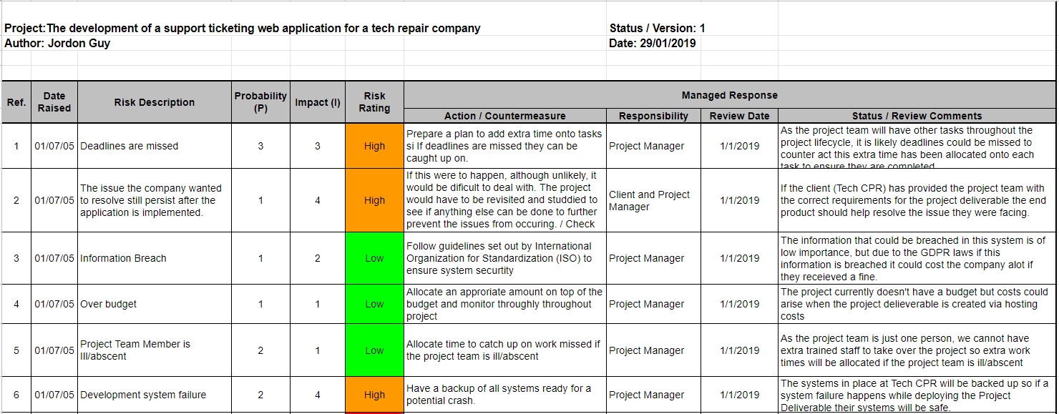

Figure 1 - **Risk Log Version 1**

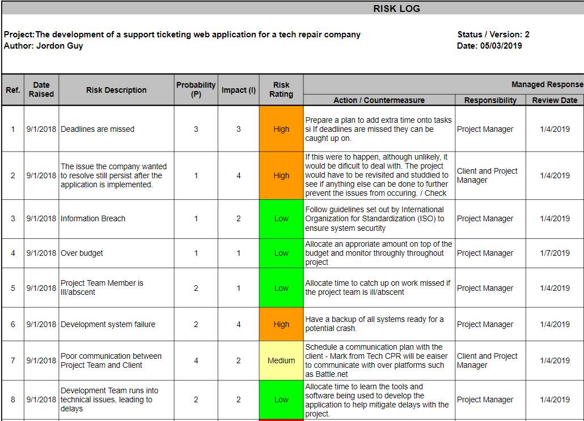

Figure 2 - **Risk Management Register version 2**

1st Meeting

Requirements from Meeting with Mark Wood At Tech CPR 05/10/2018

* Project Deliverable: A ticketing system for the Tech CPR website for their ‘subscribed’ clientele
* A back end that has ‘Admins’ and ‘Support’ user roles
* A front end that allows clients to sign in and submit support tickets, these support tickets will notify the ‘Support’ staff via email that a ticket has been submitted or updated.
* Admins create, and manage users. The user will NOT sign up themselves this services is for ‘subscribed’ clientele.
* The Users will be allowed to post a ticket consisting of text and images that are attached to show their problem in detail.
* When a ‘Support’ role user replies to a Users post an email is sent to the original poster to notify them the ticket has been reviewed and replied to.
* Posts will only be seen by the ‘Support’ staff and the original poster (posts aren’t public)

Figure 3 - **Meeting with Mark Wood of Tech CPR**

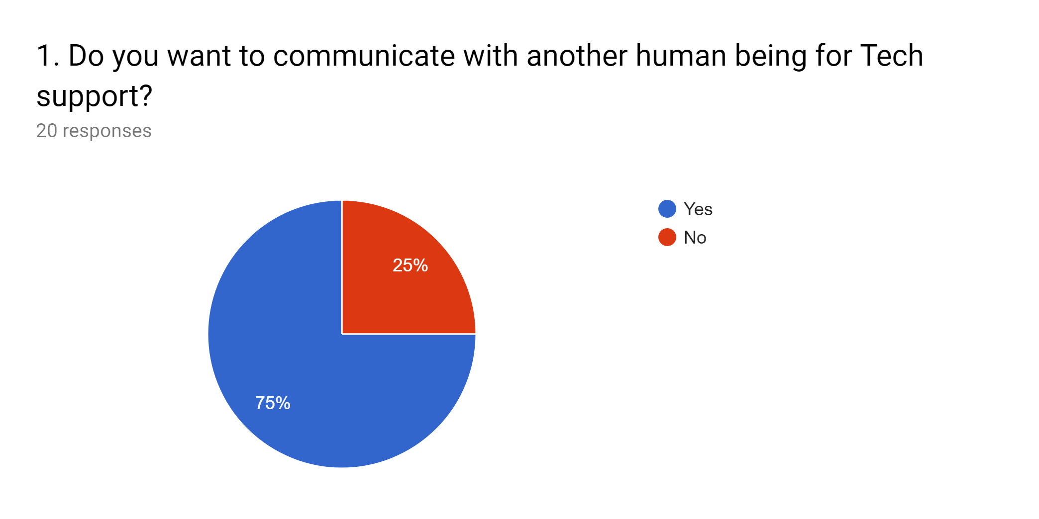

Figure 4 - **Survey Question 1**

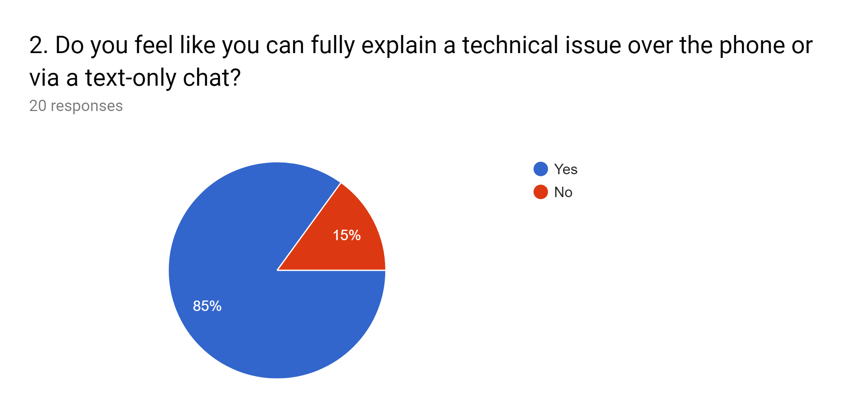

Figure 5 - **Survey Question 2**

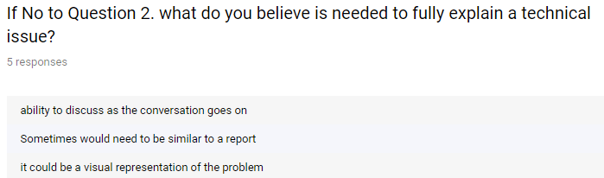

Figure 6 - **Survey Question 2.1**

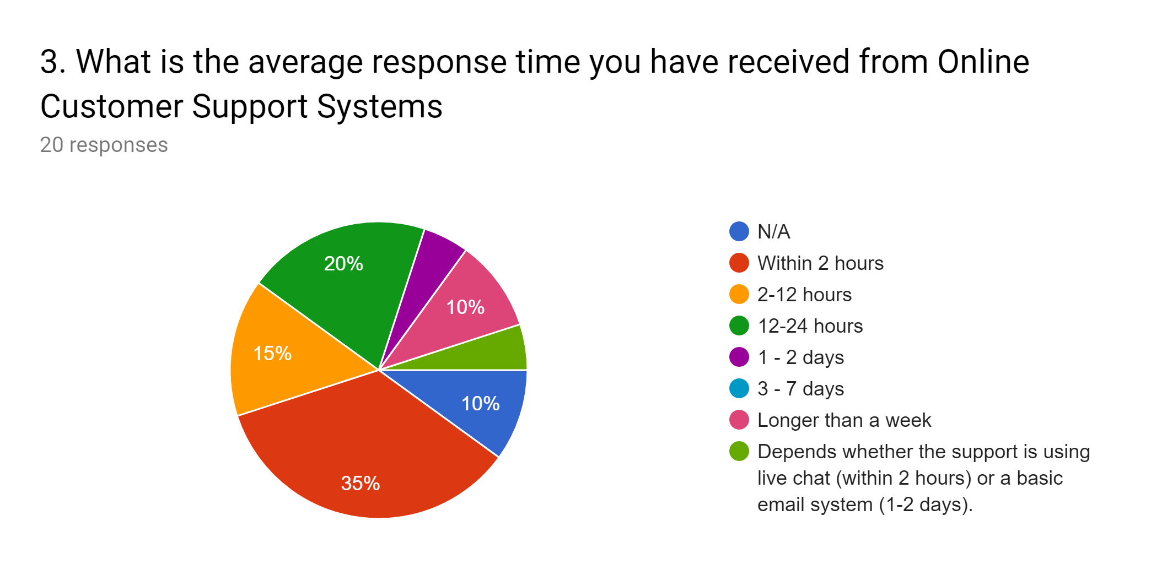

Figure 7 - **Survey Question 3**

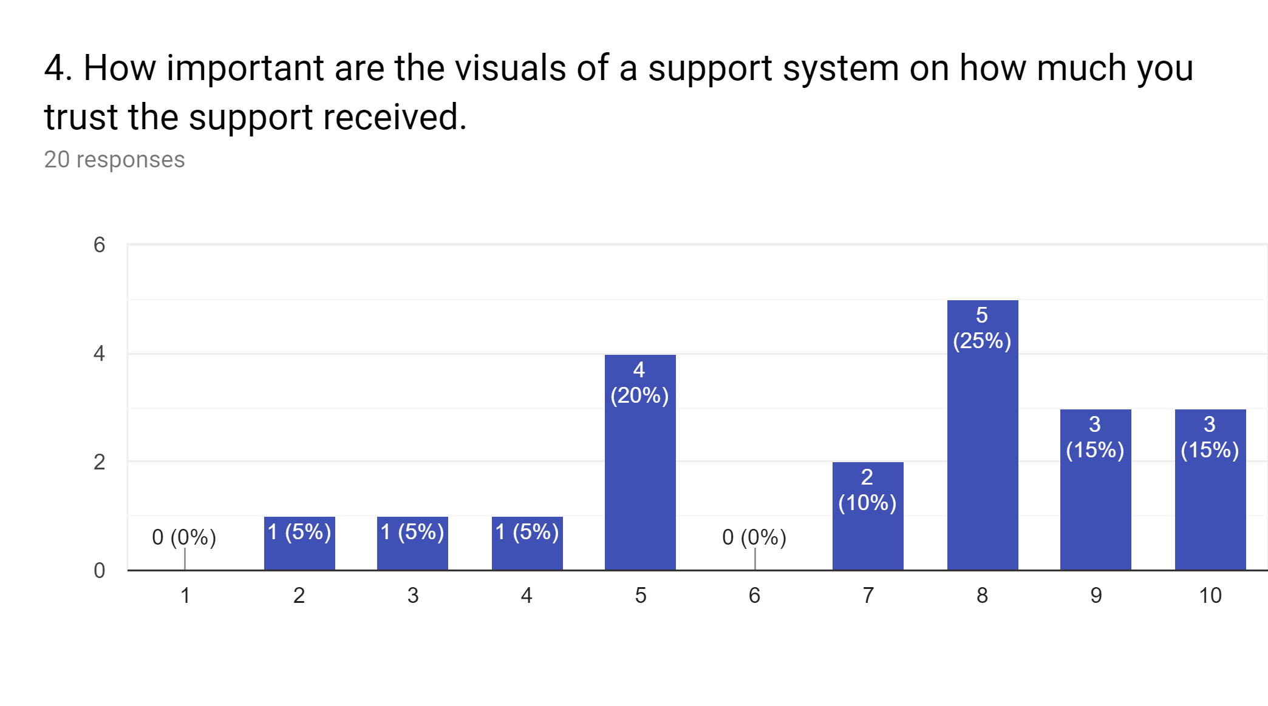

Figure 8 - **Survey Question 4**

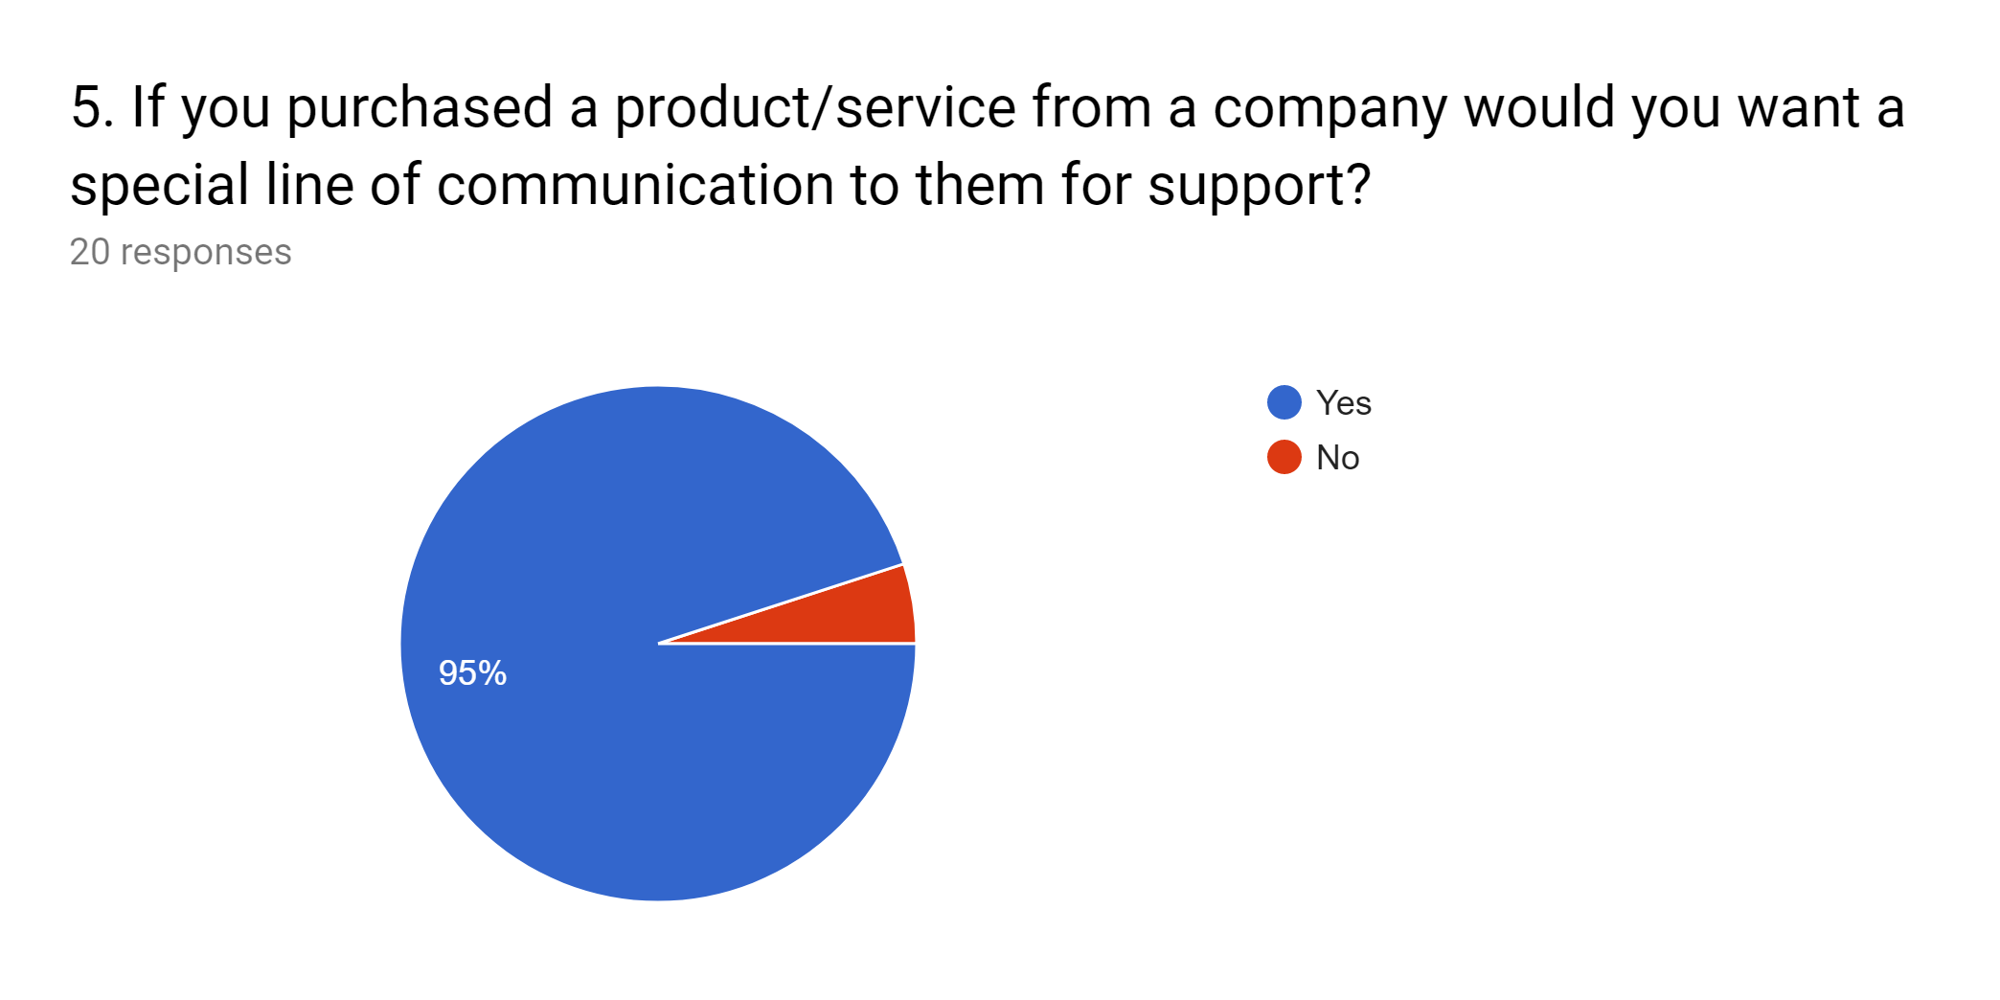

Figure 9 - **Survey Question 5**

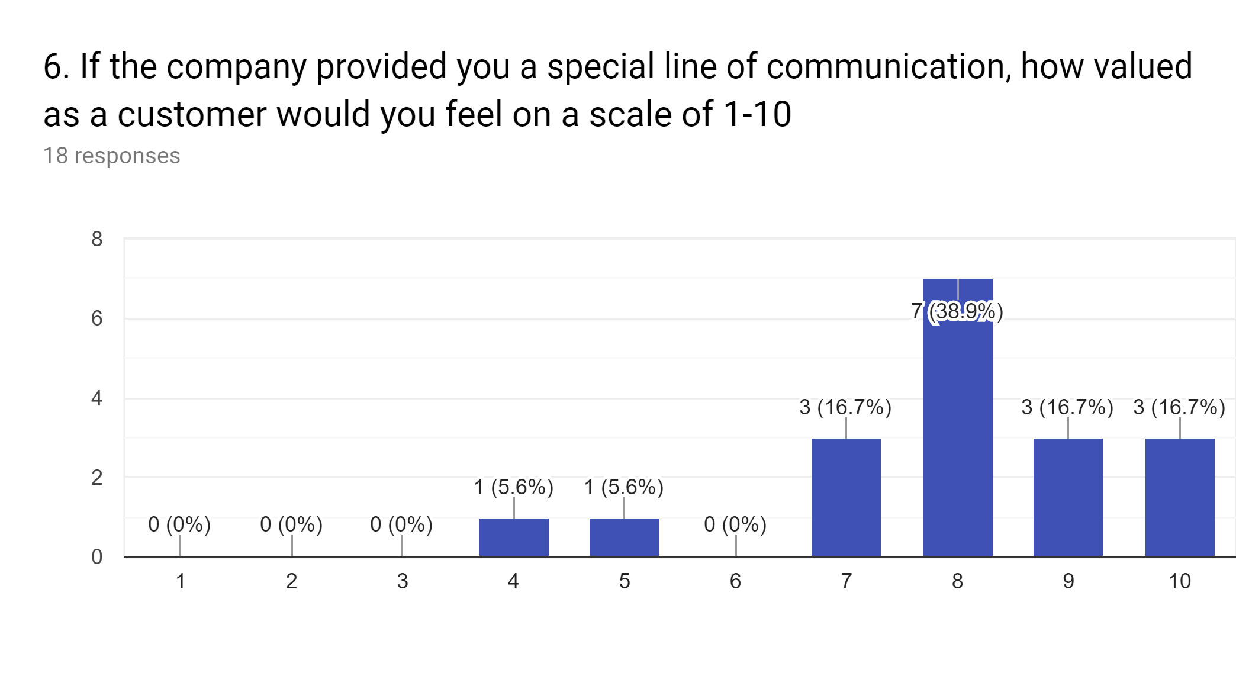

Figure 10 - **Survey Question 6**

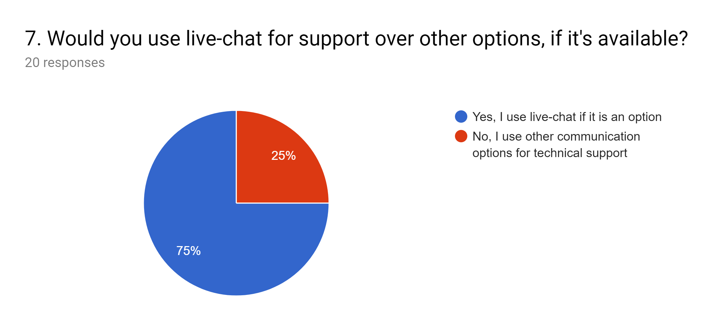

Figure 11 - **Survey Question 7**

## Appendix B - Design

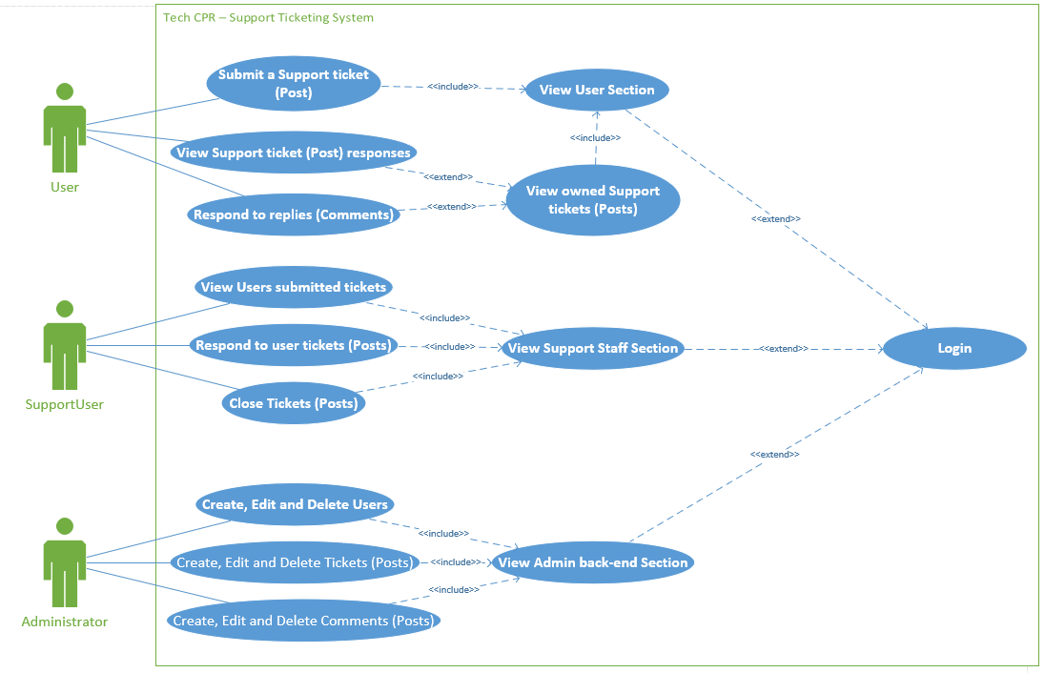

Figure 12 - **Use Case**



Figure 13 - **Tech CPR Website Header**

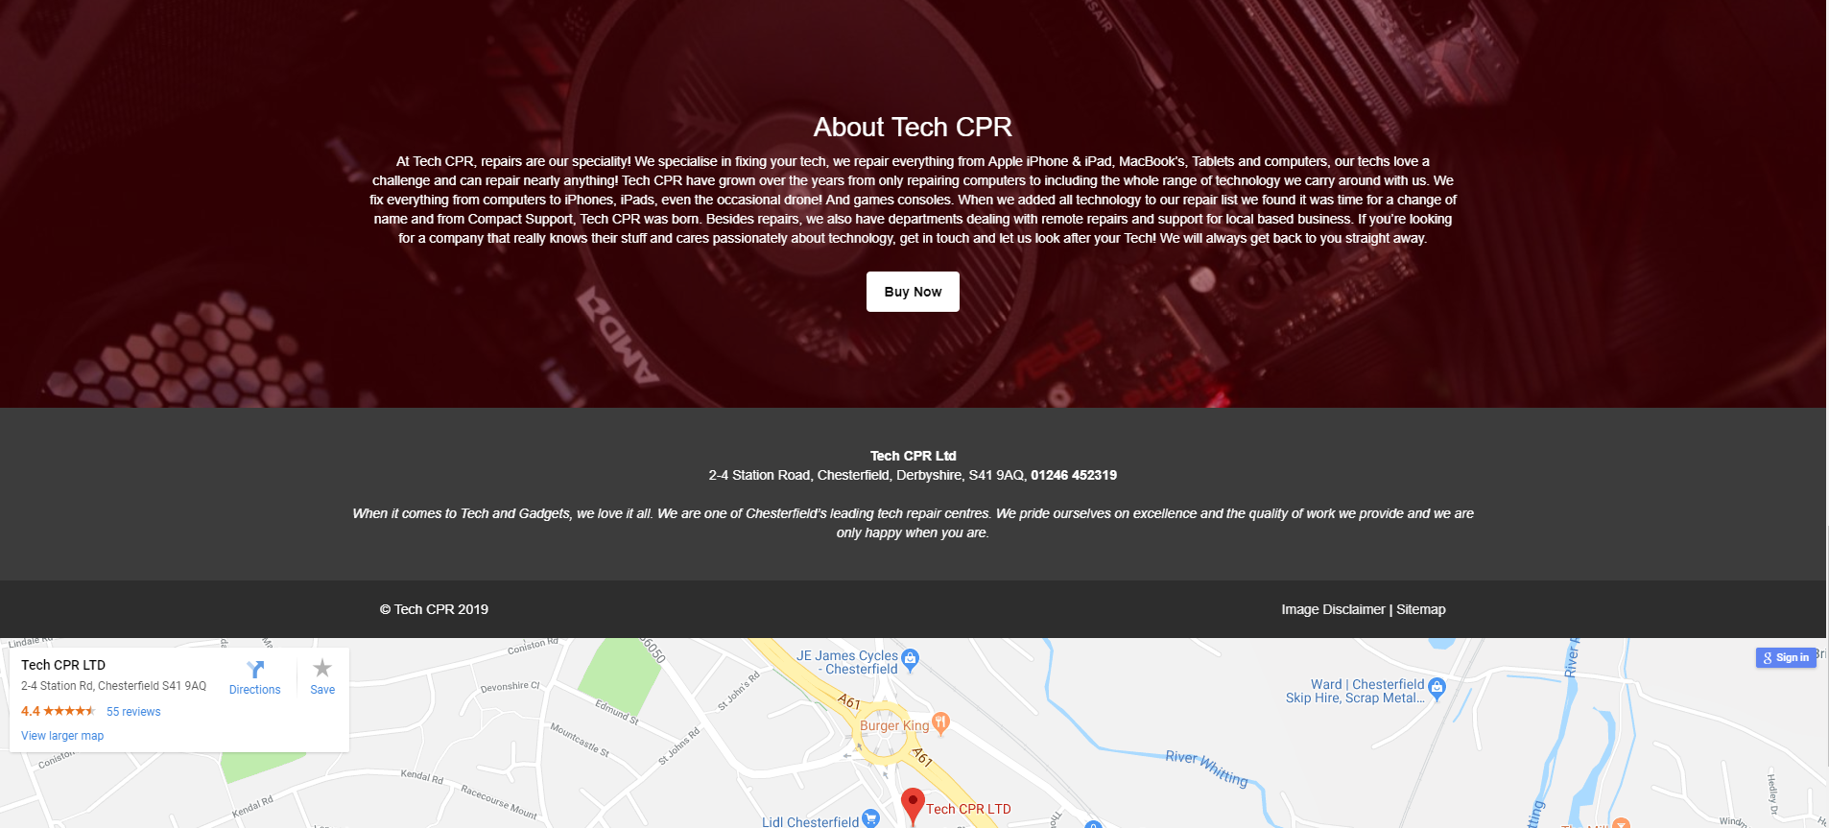

Figure 14 - **Tech CPR Website Footer**

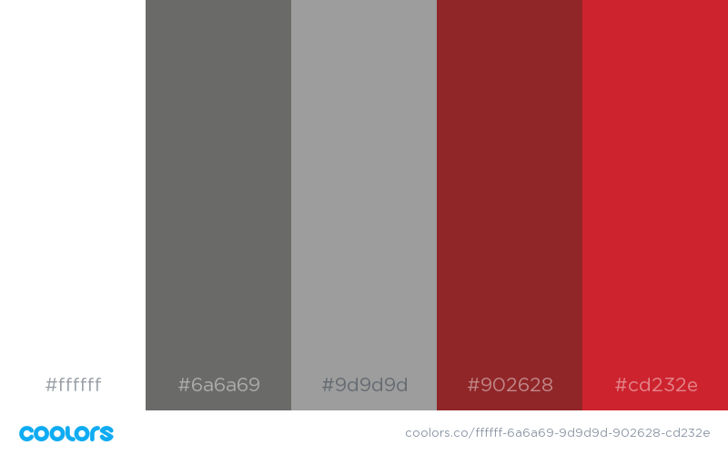

Figure 15 - **Tech CPR Support System Website Colour Scheme sampled from the Tech CPR Website**

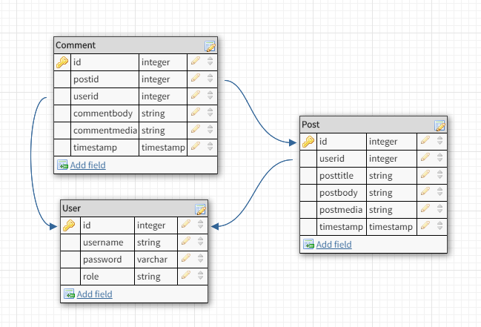

Figure 16 - **Support System Initial Database design**

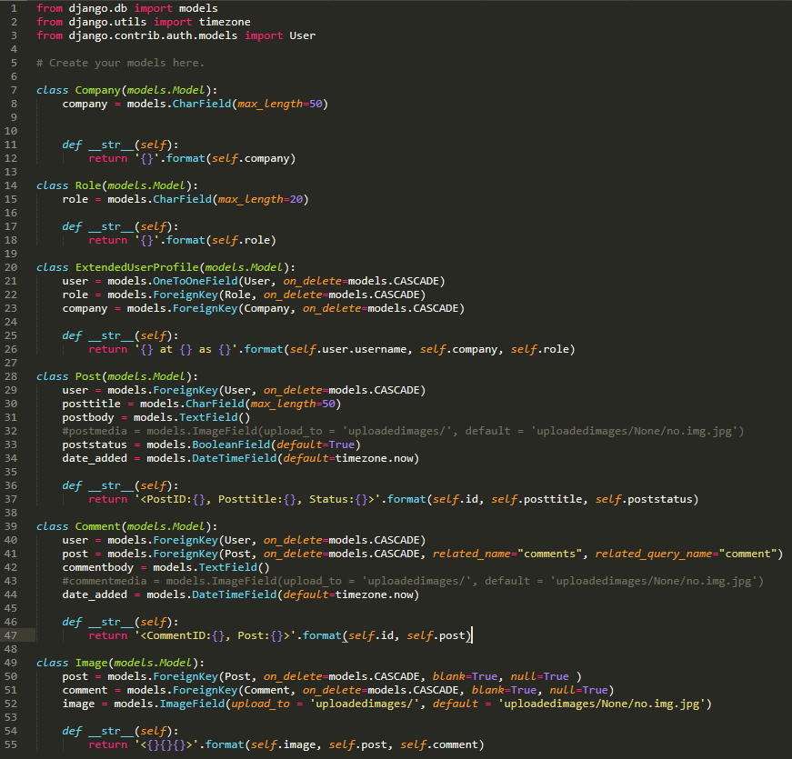

Figure 17 - **Django Model of the database.**

## Appendix C - Sprint 1

**SPRINT 1 Documentation.**

**Pre Sprint Planning - 08/03/2019**

Meeting Minutes - Scrum Master, Product Owner and Team Member Jordon Present.

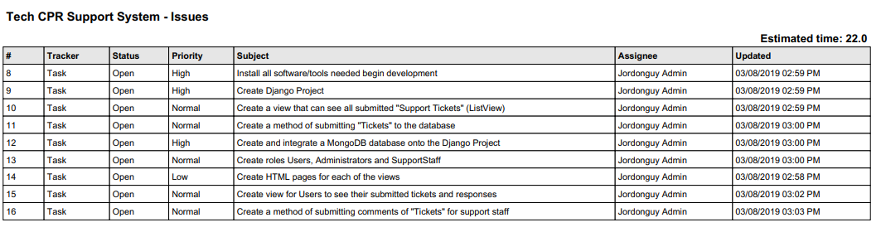

Figure 1 - Task List

These are the issues/Tasks assigned for this sprint, they all work towards the Sprint Goal of creating a basic functioning prototype.

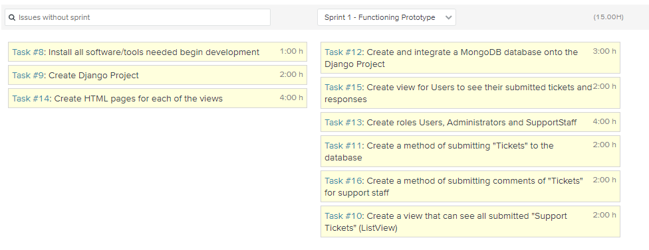

This is the task/issues separated into nonspecific and Sprint specific.

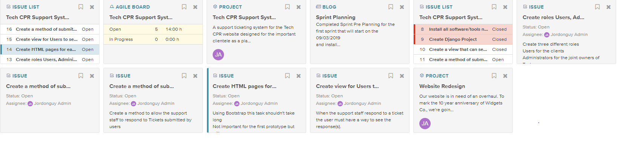

**Sprint Planning Board.**

The sprint will start officially on the 9th of March 2019 and last for 1 week.

**Sprint Start Day 1- 09/03/2019**

**Scrum Meeting 1 -** Scrum Master, Product Owner and Team Member Jordon present.

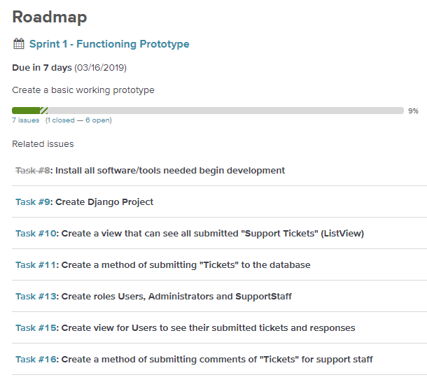

**Jordon** **09/03/2019 11:52 AM**: all tools and software has been installed so the development of the prototype can start and other tasks can begin, the first task of today is to create a django project and get its basic plugins working. By the end of today I plan on creating the project and change the database from Django’s default SQLite to a MongoDB.

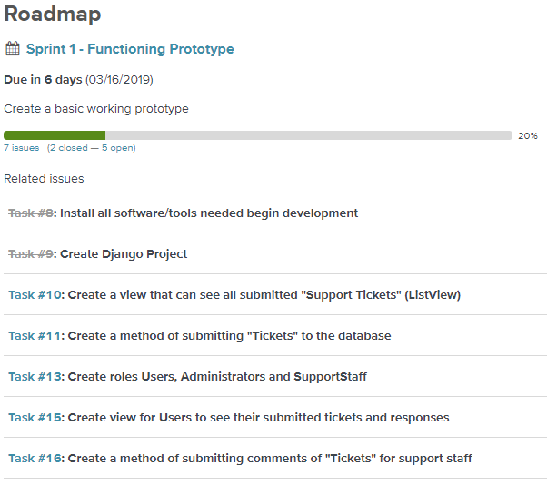

**End 09/03/2019 -** Task 9 completed and closed.

**Sprint 1 Day 2 - 10/03/2019**

**Scrum Meeting 2 -** Scrum Master, Product Owner and Team Member Jordon present.

**Jordon 10/03/2019 13:27 AM**:Create the models for the database to be migrated in django to generate the tables in the SQLite db. The users table can be done using the auto generated table by django.



This is the database design for application, A user can make many Posts, and Comments. A comment belongs to one post and one user.

**END 10/03/2019:** Django database models started.

**Sprint 1 Day 3 - 11/03/2019**

**Scrum Meeting 3 -** Scrum Master, Product Owner and Team Member Jordon present.

**Jordon 11/03/2019 14:46 PM**: Unable to create database models in Django today, development team is absent/busy….

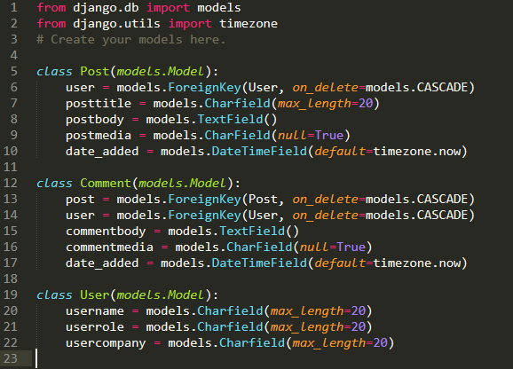

Version 1 - Django Models

**Sprint 1 Day 4 - 12/03/2019**

**Scrum Meeting 4 -** Scrum Master, Product Owner and Team Member Jordon present.

**Jordon 12/03/2019** : Going to Refine Database Models before making migrations to generate the database tables.

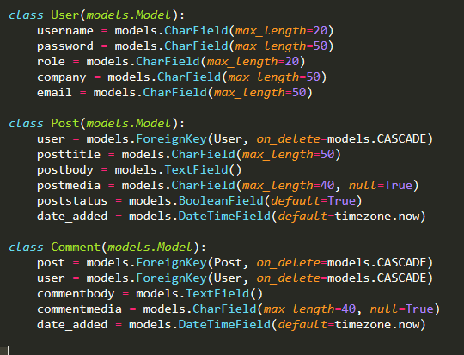

Refined Model

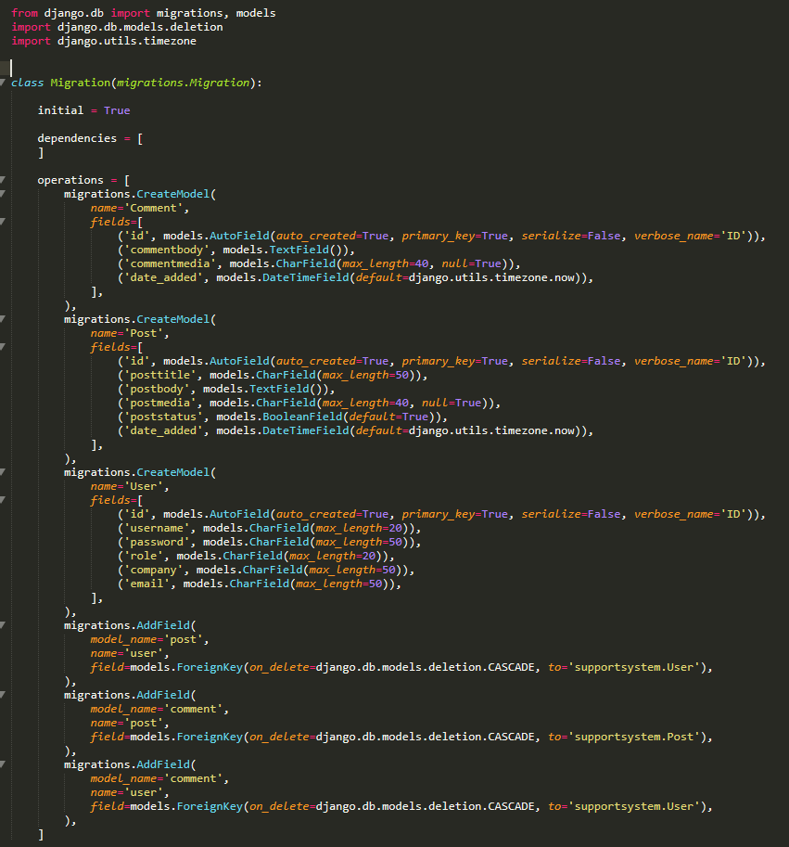

Generated Models/Tables to be migrated to create the database.

**END 12/03/2019 - Created the database models**

**Sprint 1 Day 5 - 13/03/2019**

**Scrum Meeting 5 -** Scrum Master, Product Owner and Team Member Jordon present.

**Jordon:** Migrated the database creating the tables in the SQLite database, Also inputted test data to validate.

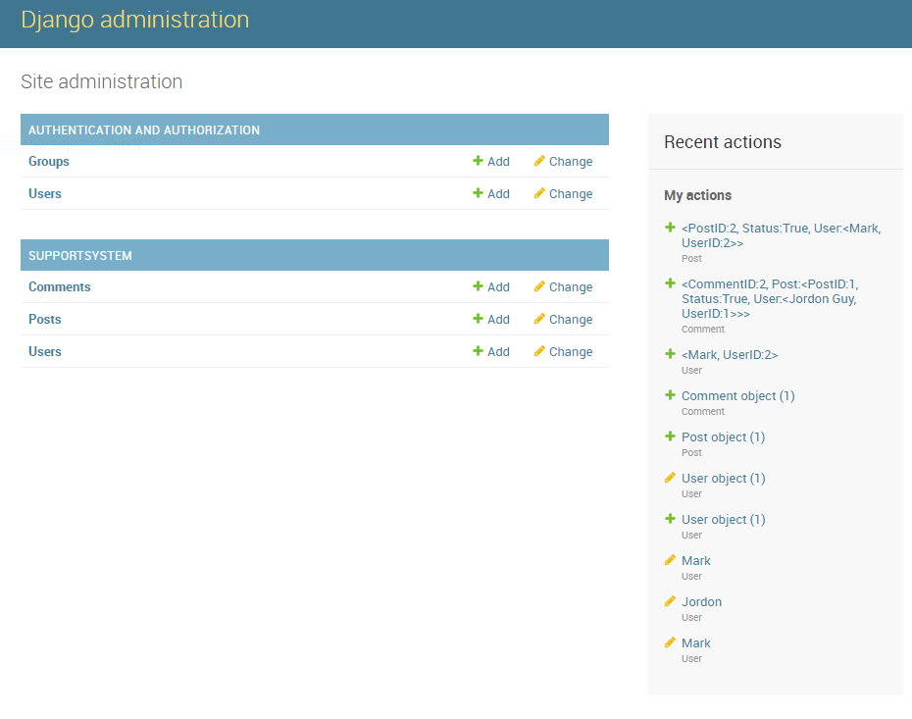

**END 13/03/2019 - Databases created and tested**

**Sprint 1 Day 6 - 14/03/2019**

**Scrum Meeting 6 -** Scrum Master, Product Owner and Team Member Jordon present.

**Jordon:** create ListView to view all posts in the database.

**END 14/03/2019 - ListView created, ran into technical difficulties leading to delays**

**Sprint 1 Day 7 - 15/03/2019**

**Scrum Meeting 7 -** Scrum Master, Product Owner and Team Member Jordon present.

**Jordon:** After technical issues yesterday the sprint is behind schedule and needs more time to be completed. User model created needs to be changed and a one to one relationship between the User model and the Auth_User model created by Django needs to be created to fix the login system.

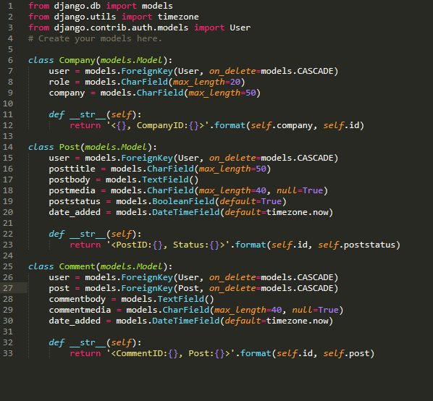

**Revisited the Models.py and created more refined models/tables for the database utilising the built User table of Django to correct the login system.**

**END 15/03/2019 - Sprint is going past due date, not enough time was allocated to fix technical issues and to learn/build skills in Python and Django.**

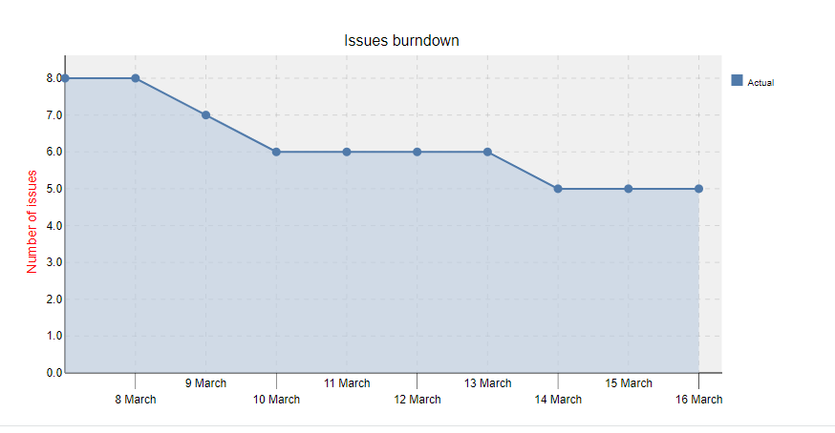

**The end result of the first sprint is a crude prototype of the final deliverable.**

**It has sign-up, Login, Logout functionality and a way to view all Posts submitted to the database.**

**This is a strong start for the first Sprint but needed to end at a better point.**

**Sprint 2 will focus heavily on the functionality with some for the sites visuals.**



**END Database Model**

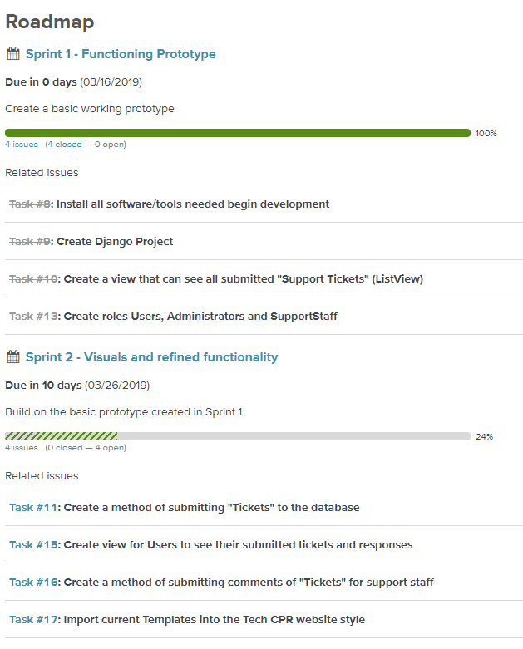

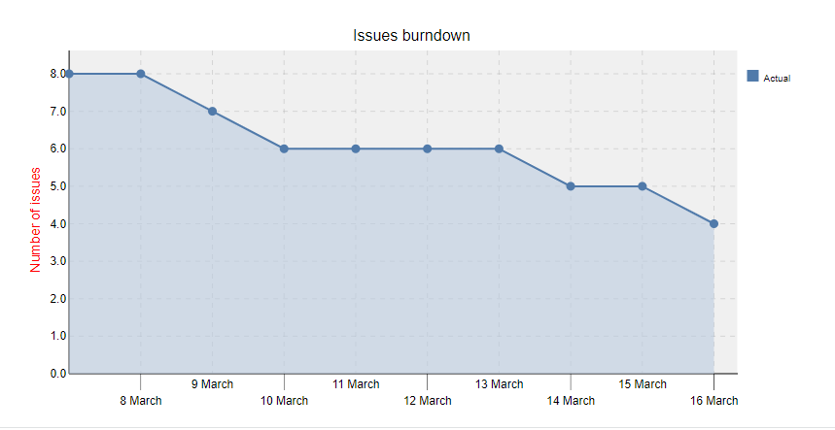

**RoadMap Changes, Sprint 1 closed and tasks moved to Sprint 2 that is due to start in a few days.**

**Sprint 1 End Documentation**

**Django Admin**



Django Backend allowing the admins to create, edit and delete entries in each of the tables within the SQLite database

**Index Page**



Default index page that the users will first see, this is a logged in view for the User “Jordon”



This is the logged out view

**Add Post Page**



This is where the users can add posts to the database, currently it can be accessed without being logged in which needs to be addressed before publication.

The Add Post form doesn’t validate correctly and a needs to be looked at again to get working.

**View Posts Page**



This is the view posts page, currently it displays all posts regardless of the user logged in, it also can be accessed without being logged in which needs to be addressed.

Each of the posts are displayed, but it is currently missing a few bits of information from the company table, the development team cannot resolve this issue without further research. Its need to pull information from a foreign key for each of the posts but currently doesn’t function correctly.

**Login Page**



The web application allows users to login and logout using the auth_user table generated by Django, this feature fully works.

Figure 18 - **SPRINT 1 Documentation.**

## Appendix D - Sprint 2

**SPRINT 2 Documentation.**

**Pre Sprint 2 Planning - 17/03/2019**

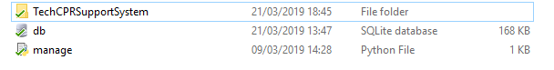

Figure 19 - **Django Project Default Files.**

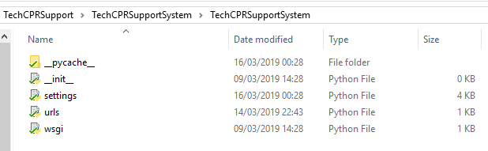

Figure 20 - **Django Project Default Files.**

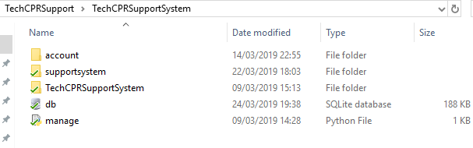

Figure 21 - **Django App folders.**

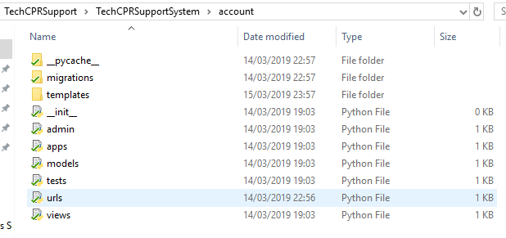

Figure 22 - **Django App Auto Generated Files.**

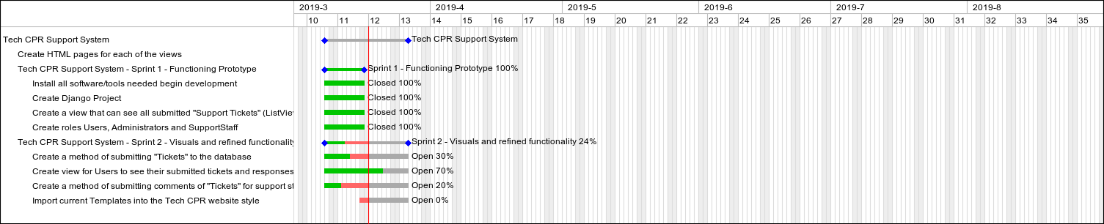

Sprint Gantt Chart - Tasks from Sprint 1 that wasn’t completed within the time limit were moved to Sprint 2

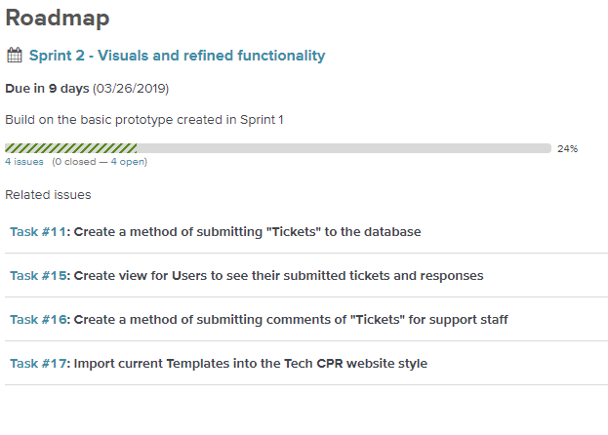

These are the issues/Tasks assigned for this sprint, they all work towards the Sprint Goal of refining the prototypes functionality and visuals. Some of the tasks were partially completed from the previous sprint

**Sprint 2 Planning Board.**

The sprint will start officially on the 10th of March 2019 and last for 1 week.

**Sprint 2 Start Day 1- 19/03/2019**

**Scrum Meeting 1 -** Scrum Master, Product Owner and Team Member Jordon present.

**Jordon:** Need to learn some Django on how it uses foreign keys in models and how to use child data.

**END 19/03/2019 -** built skills in Django to further the development of the web application.

**Sprint 2 Start Day 2 - 20/03/2019**

**Scrum Meeting 2 -** Scrum Master, Product Owner and Team Member Jordon present.

**Jordon:** Fully researched into how to fix the issue, a ForeignKey was used instead of a OneToOneField creating issues when trying to call the child information from the database.

**END 20/03/2019 -** Corrected the model/database tables to resolve the issue.

**Sprint 2 Start Day 3 - 21/03/2019**

**Scrum Meeting 3 -** Scrum Master, Product Owner and Team Member Jordon present.

**Jordon:** Started to fix just sorting the issue out at its most simple level first and building it up. So i have removed the image upload and will implement it later when I have resolve the basic issue.

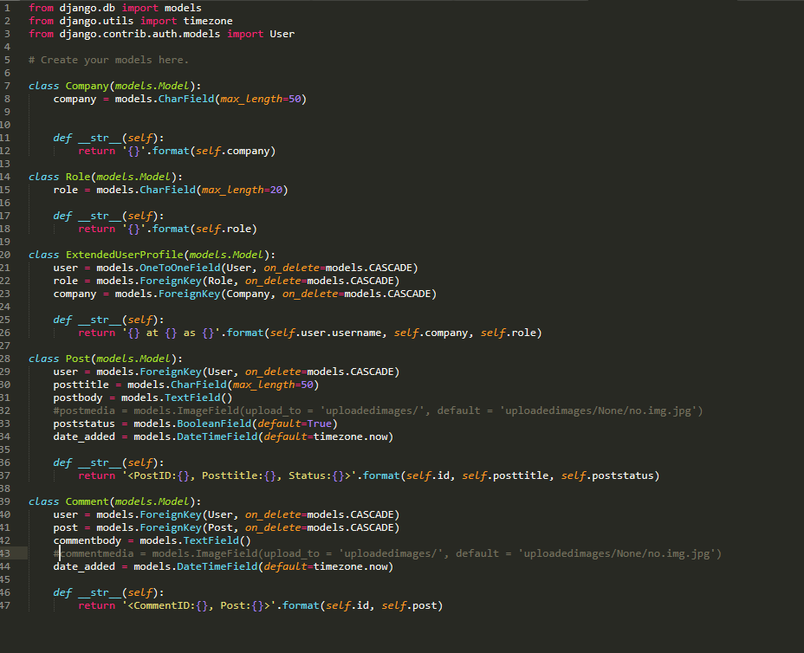

**This is the new model.py file, new models/tables in the database have been made to extend the auth_user table created by default by Django. This should resolve the issue of calling child data.**

**The PostMedia and CommentMedia have been disabled to allow the resolution of the POST error as the ImageField was creating problems and not allowing the new post to be saved to the database.**

**END 21/03/2019 - Close to a solution, needs some changes.**

**Sprint 2 Start Day 4 - 22/03/2019**

**Scrum Meeting 4 -** Scrum Master, Product Owner and Team Member Jordon present.

**Jordon:** Completed a method of submitting new Posts (Tickets) to the database but still need to work on the ImageField field in the database.

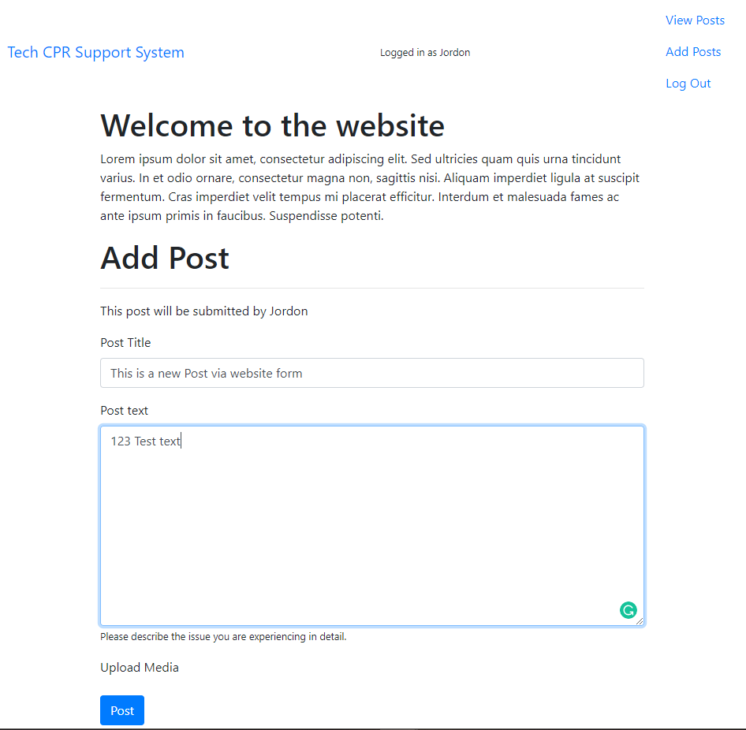

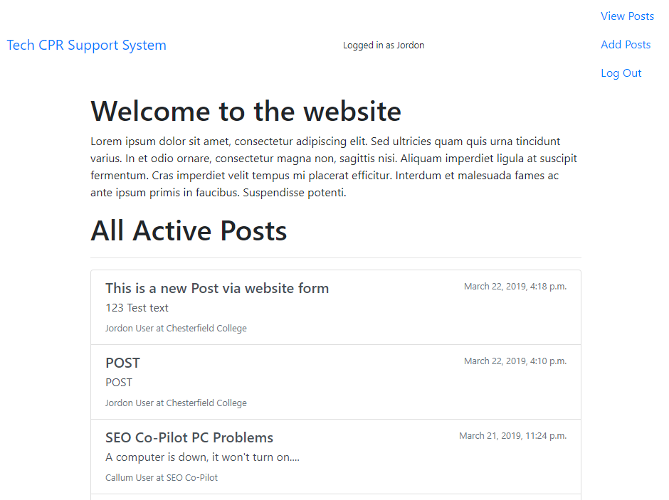

Changed from creating a form from scratch to FormModels where it is generated from the Model it is going to post to. Getting the currently logged in user was painful.

**END 21/03/2019 - Can now post new tickets to the database and it is displayed correctly. Also only show active posts that haven’t been closed on the ViewPosts page.**

**Sprint 2 Start Day 5 - 23/03/2019**

**Scrum Meeting 5 -** Scrum Master, Product Owner and Team Member Jordon present.

**Jordon:** Styled the html documents to better match the Tech CPR website. + added the Tech CPR favicon to the website to match.

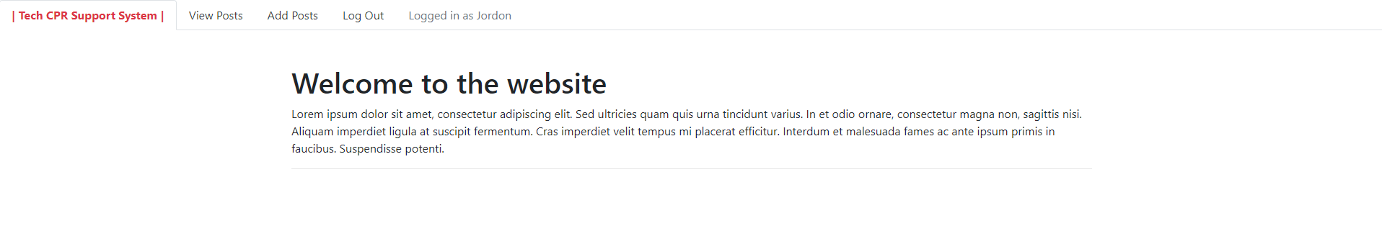

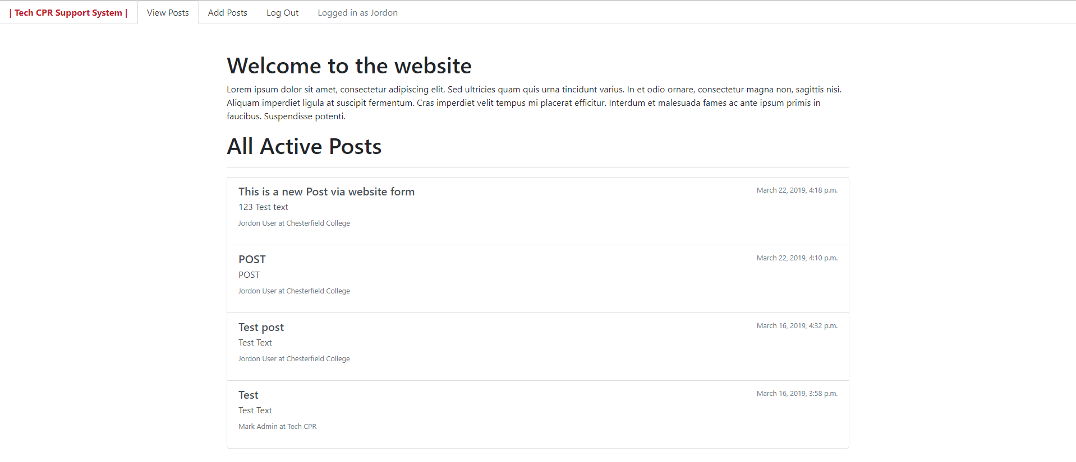





**END 23/03/2019:** The new html style fits the Tech CPR theme and will be a better fit for the Tech CPR website.

**Sprint 2 Start Day 6 - 24/03/2019**

**Scrum Meeting 6 -** Scrum Master, Product Owner and Team Member Jordon present.

**Jordon:** Researched into Django class based views, more specifically DetailView and Generic Views to create a web page to view a single Post with comments and a web page to view all posts from a single user.

**END 24/03/2019:**  Started to create class based views for the generic view and DetailView, Web pages were created to house these new Views

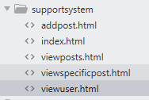

**Sprint 2 Start Day 7 Final - 25/03/2019**

**Scrum Meeting 7 -** Scrum Master, Product Owner and Team Member Jordon present.

**Jordon:** I know how to write the python for the class based views so today I will write the backend and implement them onto the web pages created yesterday.

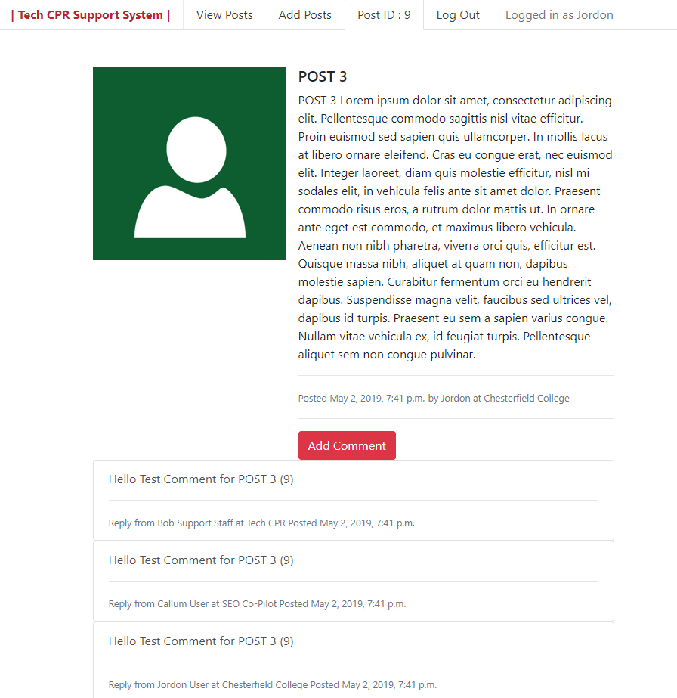

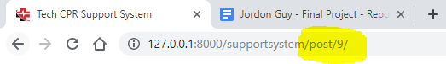

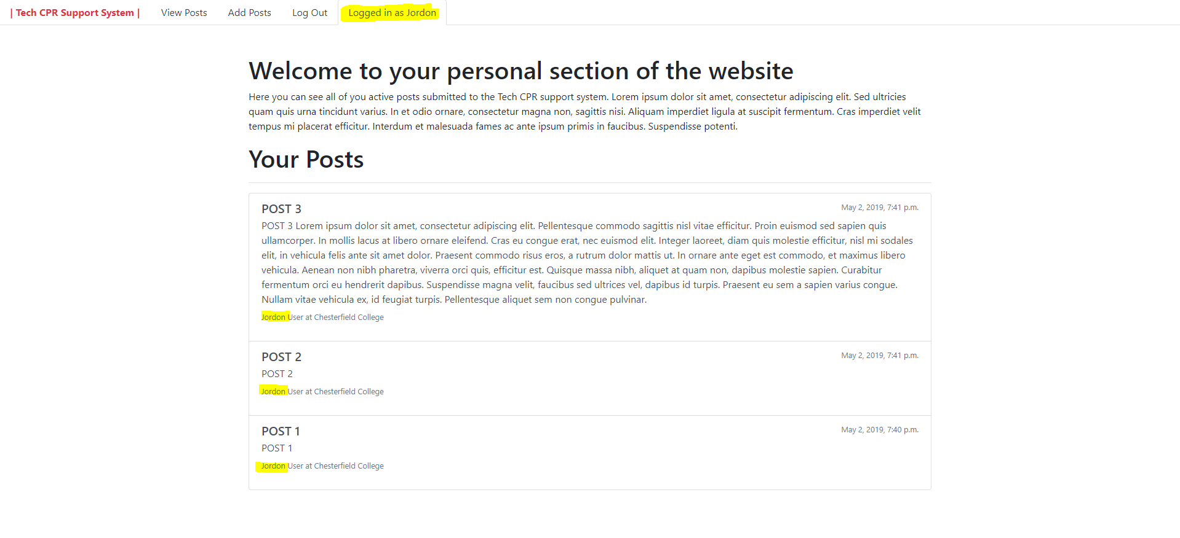

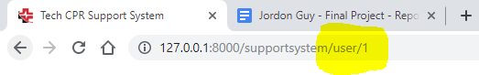

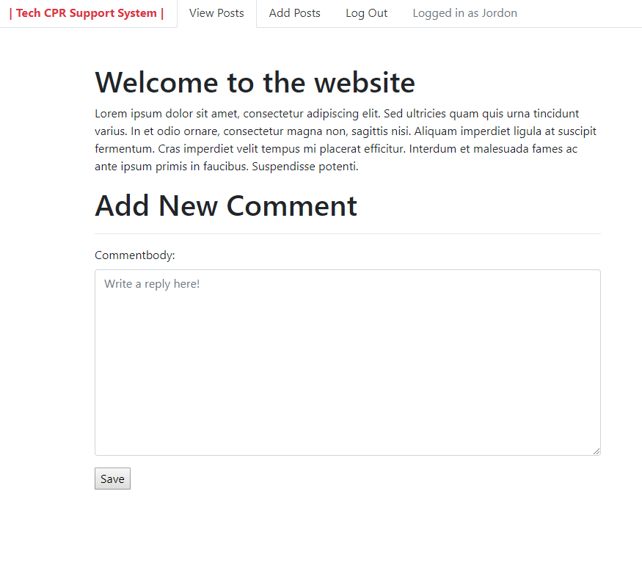

This add comment page doesn’t function correctly currently as issues arose around Class based views, a different solution will have to be researched.

**END 25/03/2019:** These two extra web pages allow a user to view a specific Post with all related Comments, and a view to see all Posts from a specific user.

**SPRINT END**

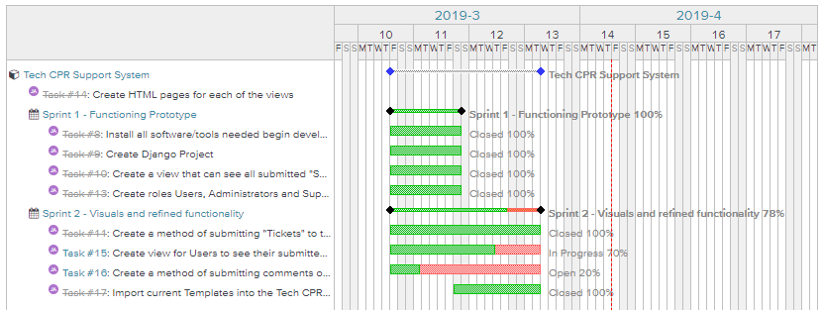

At the end of Sprint many tasks it had assigned to it completed with some exceptions. The development team ran into issues that were difficult to resolve, because of Django’s open-source nature meaning there isn’t any professional assistance available and all resources are created by the community. This coupled with Django having multiple versions makes finding solutions to problems more difficult.

**Figure 23 - Sprint 2 Documentation**

## Appendix E - Extra Development

**Figure 24 - Extra Development Documentation**

Figure 25 - forms.py

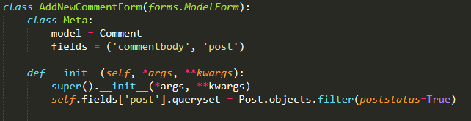

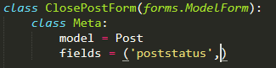

Figure 26 - views.py

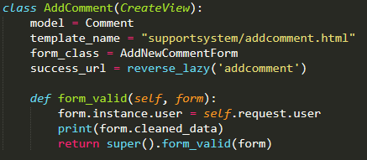

Figure 27 - urls.py

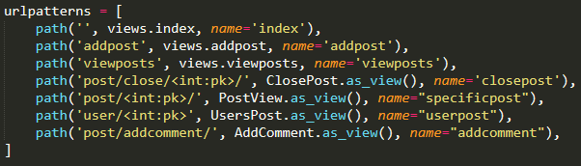

Figure 28 - addcomment.html

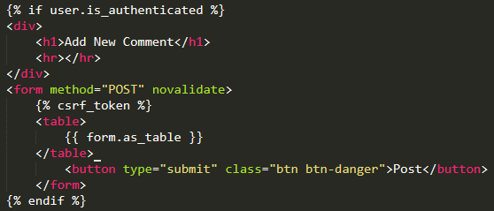

Figure 29 - Add Comment Form HTML Render

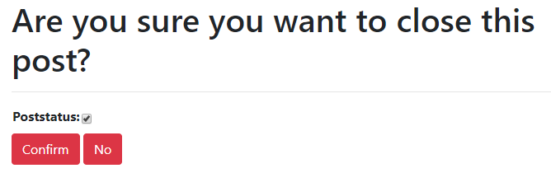

Figure 30 - Close Post Form HTML Render

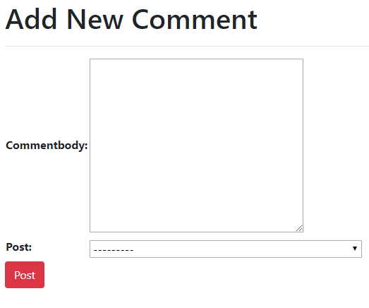

## Appendix F - Database Normalisation

**UNF**

|  |  |
| --- | --- |
|  | Post ID |
|  | Post Title |
|  | Post Text |
|  | Post Status |
|  | Post_User |
|  | Date_Added |
|  | Comment ID |
|  | Comment Text |
|  | Comment_Post |
|  | User ID |
|  | Role |
|  | Company |
|  | First Name |
|  | Last Name |
|  | Email |
|  | Staff Status |

**1NF**

|  |  |
| --- | --- |
| PK | Post ID |
|  | Post Title |
|  | Post Text |
|  | Post Status |
|  | Date_Added |
| FK | Post_User |

|  |  |
| --- | --- |
| PK | Comment ID |
|  | Comment Text |
|  | Date_Added |
| FK | Comment_Post |
| FK | Comment_User |

|  |  |
| --- | --- |
| PK | User ID |
|  | Role |
|  | Company |
|  | First Name |
|  | Last Name |
|  | Email |
|  | Staff Status |

**2NF**

|  |  |
| --- | --- |
| PK | Post ID |
|  | Post Title |
|  | Post Text |
|  | Post Status |
|  | Date_Added |
| FK | Post_User |

|  |  |
| --- | --- |
| PK | Comment ID |
|  | Comment Text |
|  | Date_Added |
| FK | Comment_Post |
| FK | Comment_User |

|  |  |
| --- | --- |
| PK | User ID |
|  | Role |
|  | Company |
|  | First Name |
|  | Last Name |
|  | Email |
|  | Staff Status |

**3NF**

|  |  |
| --- | --- |
| PK | Post ID |
|  | Post Title |
|  | Post Text |
|  | Post Status |
|  | Date_Added |
| FK | Post_User |

|  |  |
| --- | --- |
| PK | Comment ID |
|  | Comment Text |
|  | Date_Added |
| FK | Comment_Post |
| FK | Comment_User |

|  |  |
| --- | --- |
| PK | User ID |
|  | First Name |
|  | Last Name |
|  | Email |
|  | Role |
|  | Staff Status |

|  |  |
| --- | --- |
| PK | Company |

## Appendix G - Wireframes

Wireframes were created to outline how each of the web pages should look like, each of these wireframes are starting points that could be changed during the development of the application but will consist of each of the functional elements.

**User Section**

**Login Page**

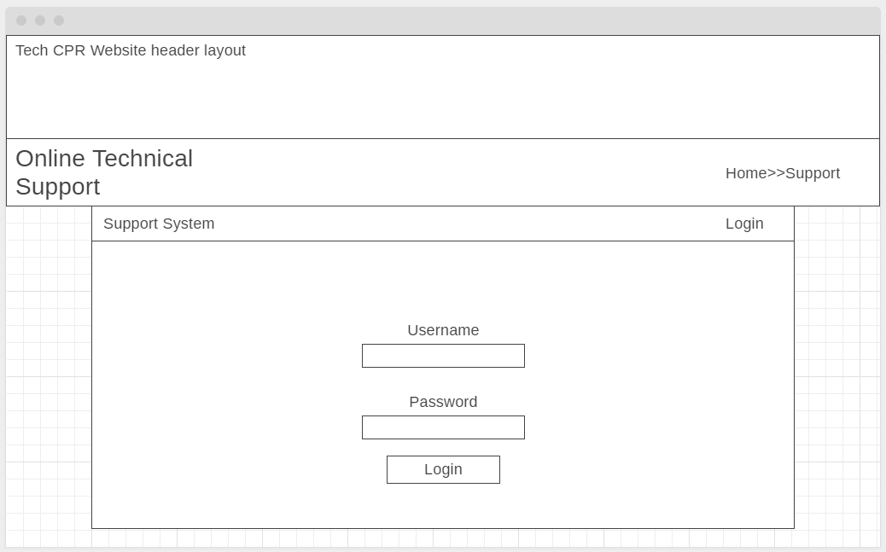

This is a simple Login page where the user will input their username and password to login, Support staff and Admins will have a different login page within the Django out of the box backend.

**Add Post Page**

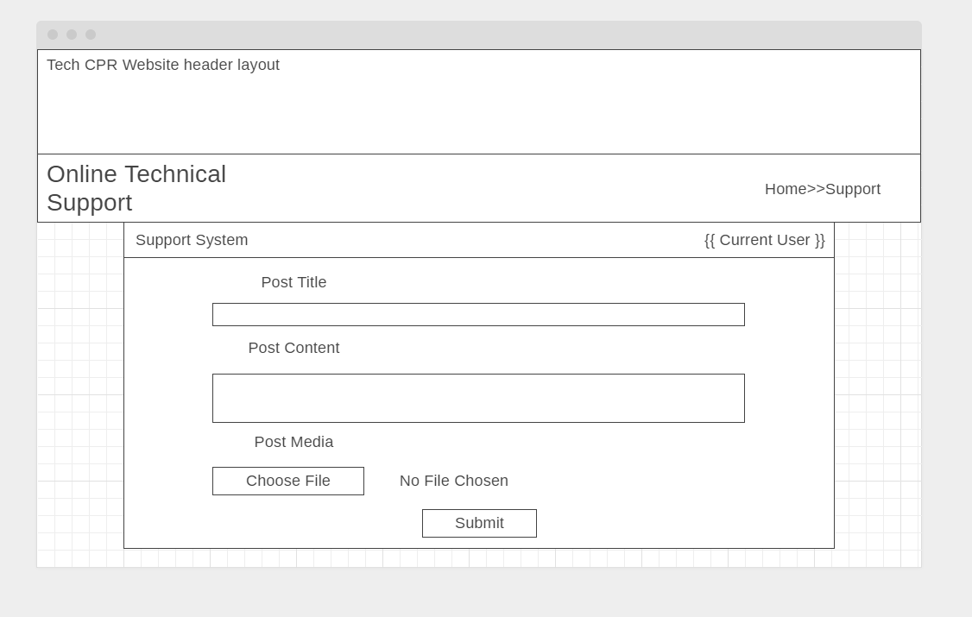

This page will allow the user to submit a new post to the database, the “{{ }}” is where the currently logged in user will appear such as “Jordon” etc.

**User View Post Page**

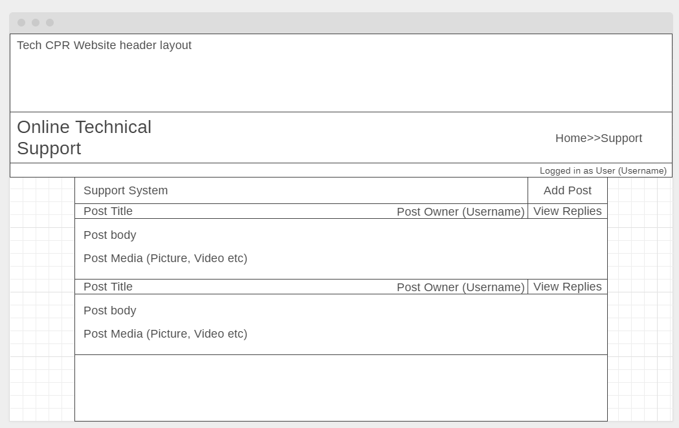

This web page will display all of the posts that the user owns as they will not need to see other users support tickets.

**Support Section**

**Support Staff View Posts**

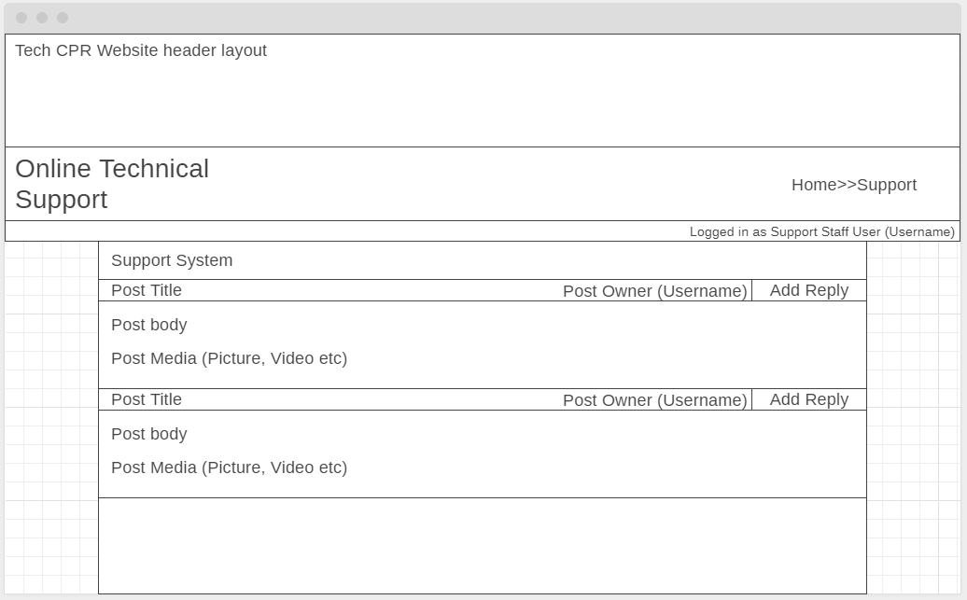

The support staff will be able to see the posts of all users, allowing them to select and add replies to them

**Support Staff Add Reply**

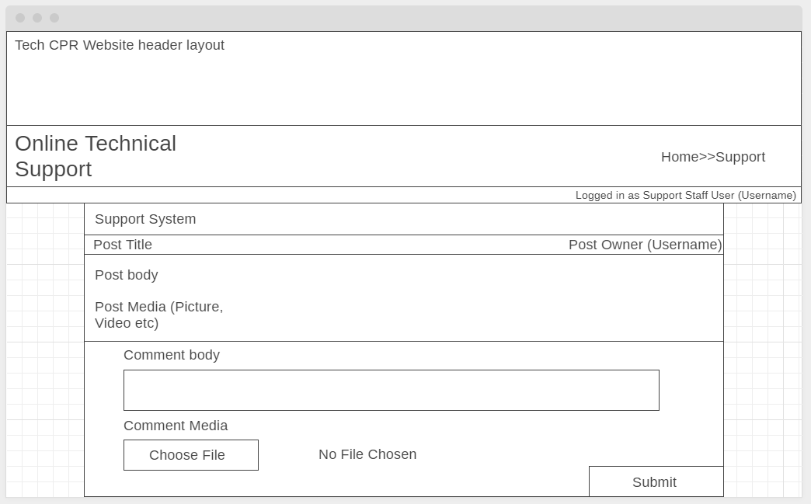

This web form is where the support staff will add replies to posts, allowing them to add text and some media.

**Support Staff View Replies**

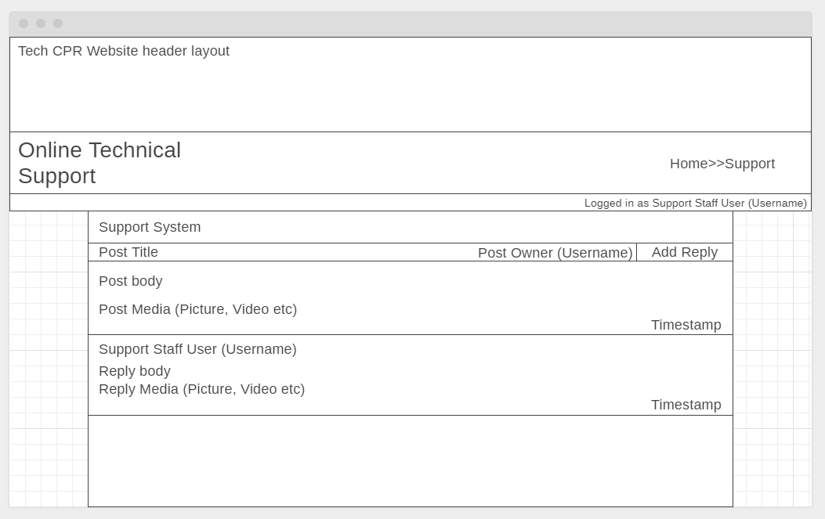

The new replies added to posts will be seen below the original post

## Appendix H - Functionality Test Plans

**Login System Test Plan**

|  |  |  |  |  |
| --- | --- | --- | --- | --- |
| **Conditions** | **Rule 1** | **Rule 2** | **Rule 3** | **Rule 4** |
| Username (A/B) | B | B | A | A |
| Password (A/B) | **B** | A | B | A |
| Output (C/D) |  |  |  |  |

*Legend:*

*A - Correct Username/Password*

*B - Incorrect Username/Password*

*C - Validation Error Displays*

*D - User is Logged In*

**Viewing All Active Posts**

|  |  |  |
| --- | --- | --- |
| **Conditions** | **Rule 1** | **Rule 2** |
| User (A/B) | A | B |
| Output (C/D) |  |  |

*Legend:*

*A - User is logged in*

*B - No User is logged in*

*C - All Active Posts are displayed.*

*D - Nothing is displayed and the navigation bar only shows the login button.*

**Database Testing (Using Back-end Admin Section)**

**Creating a new User**

|  |  |  |  |  |
| --- | --- | --- | --- | --- |
| **Conditions** | **Rule 1** | **Rule 2** | **Rule 3** | **Rule 4** |
| Username (A/B) | A | A | B | B |
| Password + Password Confirmation (C/D) | C | D | C | D |
| Output (E/F) |  |  |  |  |

*Legend:*

*A - Username Null*

*B - Username Not Null*

*C - Password meets the conditions but doesn’t match*

*D - Password meets the conditions but does match*

*E - A new user is created*

*F - Errors display*

**Removing a User*.***

|  |  |  |
| --- | --- | --- |
| **Conditions** | **Rule 1** | **Rule 2** |
| User (A/B) | A | B |
| Output (C/D) |  |  |

*Legend:*

*A - User has Posts*

*B - Posts has Comments*

*C - User + Posts are deleted*

*D - User + Post + Comments are deleted*

**Removing a post**

|  |  |  |
| --- | --- | --- |
| **Conditions** | **Rule 1** | **Rule 2** |
| Post (A/B) | A | B |
| Output (C/D) |  |  |

*Legend:*

*A - Post has no Comments*

*B - Post has related Comments*

*C - Post is deleted from the database*

*D - Post is deleted along with all related Comments*

**Removing a Comment*.***

|  |  |  |
| --- | --- | --- |
| **Conditions** | **Rule 1** | **Rule 2** |
| User (A) | A | A |
| Output (C/D) |  |  |

*Legend:*

*A - Comment belongs to a Post*

*C - Comment is removed*

*D - Comment + Post is removed*

**Submitting a New Post**

|  |  |  |  |  |
| --- | --- | --- | --- | --- |
| **Conditions** | **Rule 1** | **Rule 2** | **Rule 3** | **Rule 4** |
| Post Title (A/B) | A | A | B | B |
| Post Text (A/B) | A | B | A | B |
| Output (C/D) |  |  |  |  |

*Legend:*

*A - Post Title/Body Null*

*B - Post Title/Body Not Null*

*C - Validation Errors Are Displayed*

*D - New Post is submitted to the database*

**Adding Comments**

|  |  |  |  |  |
| --- | --- | --- | --- | --- |
| **Conditions** | **Rule 1** | **Rule 2** | **Rule 3** | **Rule 4** |
| Comment body (A/B) | A | A | B | B |
| User (C/D | C | D | C | D |
| Output (E/F/G) |  |  |  |  |

*Legend:*

*A - Comment body Null*

*B - Comment body Not Null*

*C - Logged in*

*D - Not logged in*

*E - Validation Errors Are Displayed*

*F - New Post is submitted to the database*

*G - Form isn’t displayed*

## Appendix I - Usability Survey Results

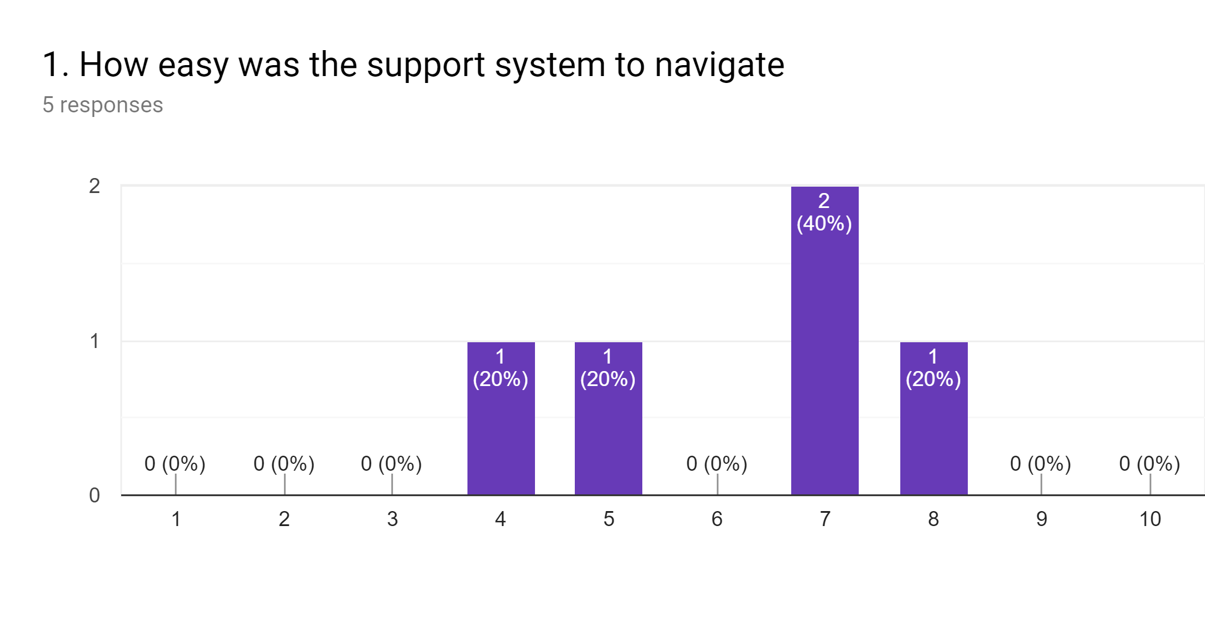

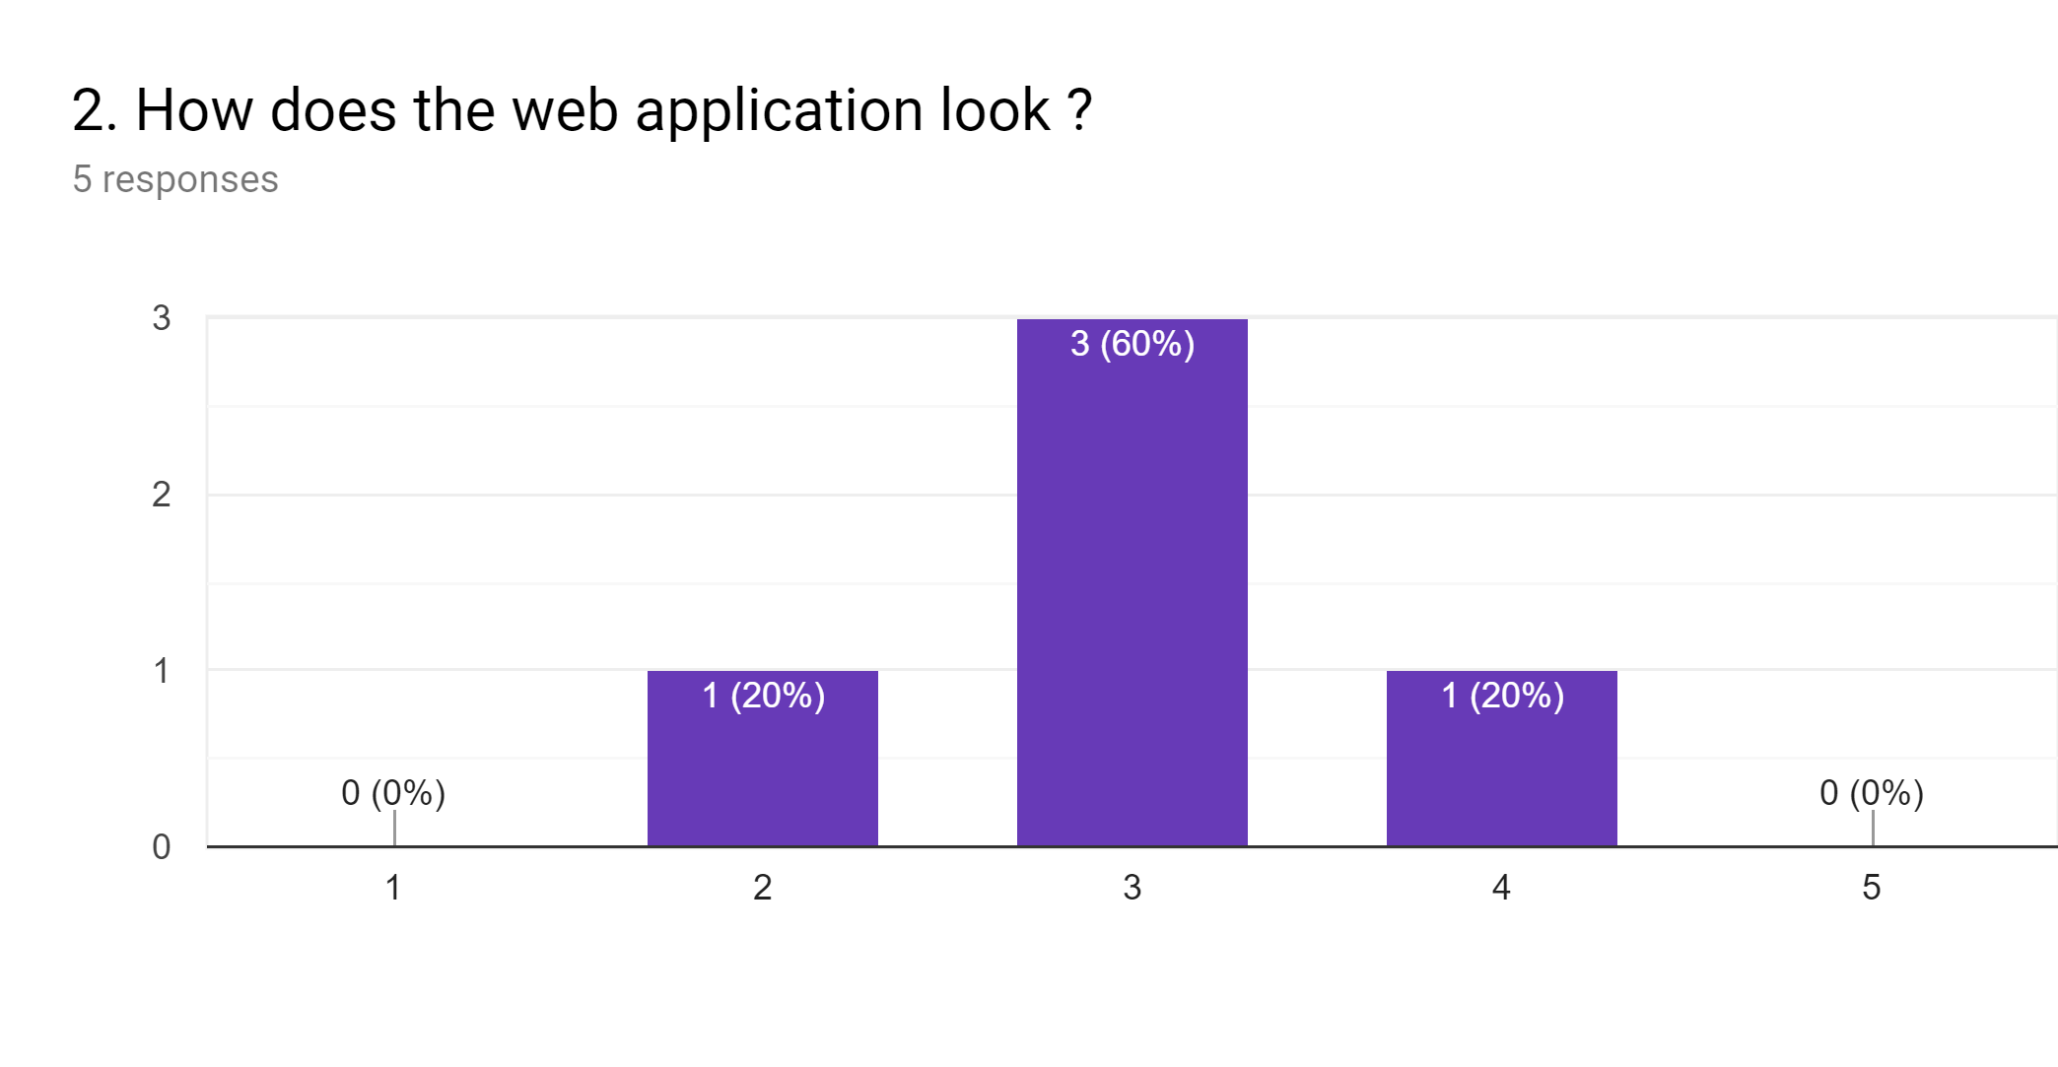

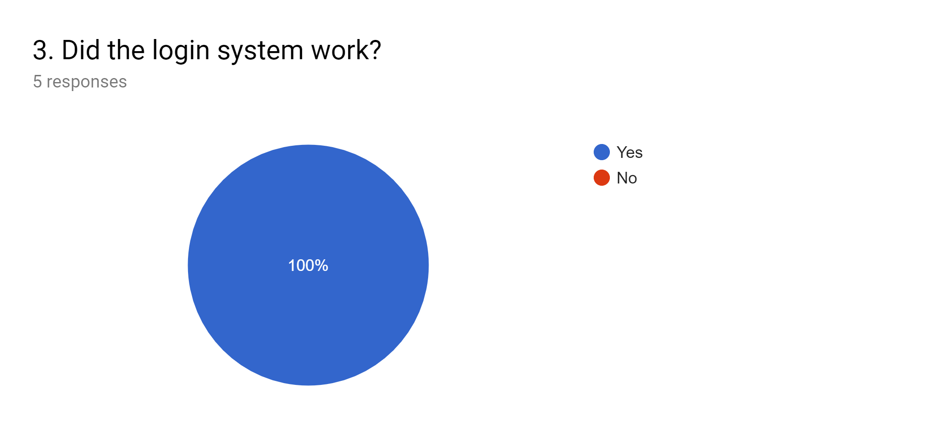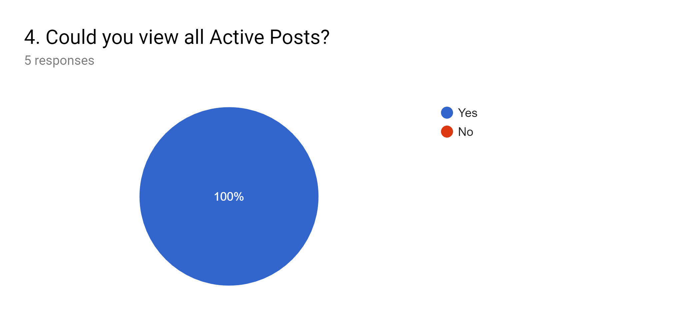

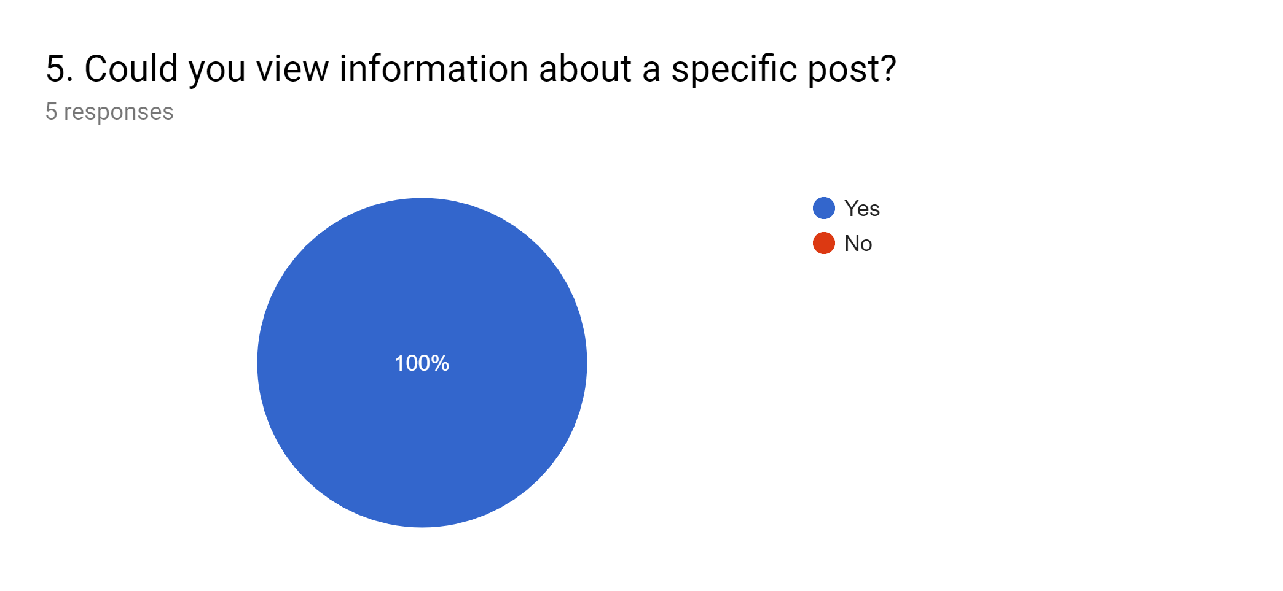

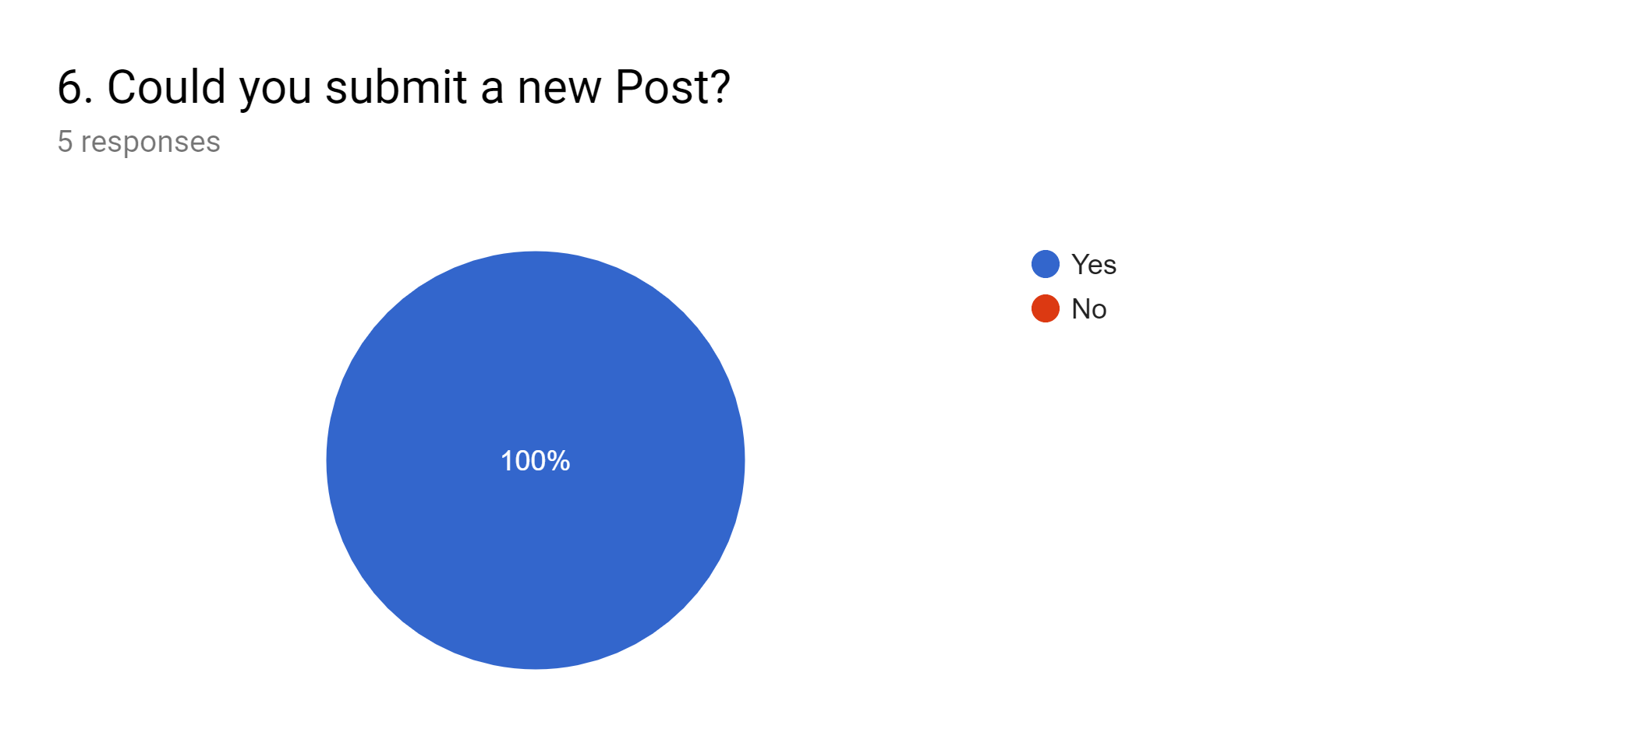

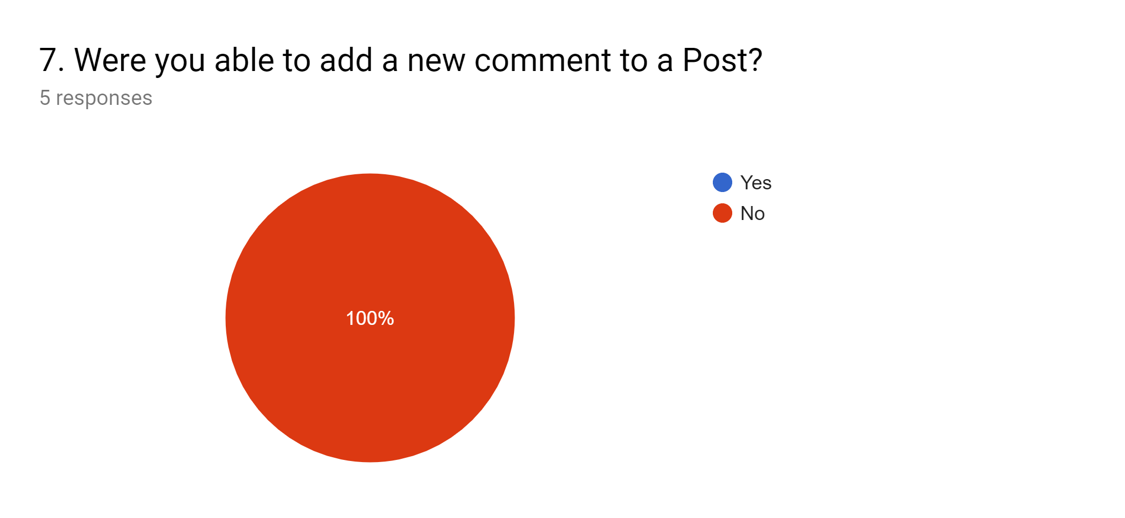

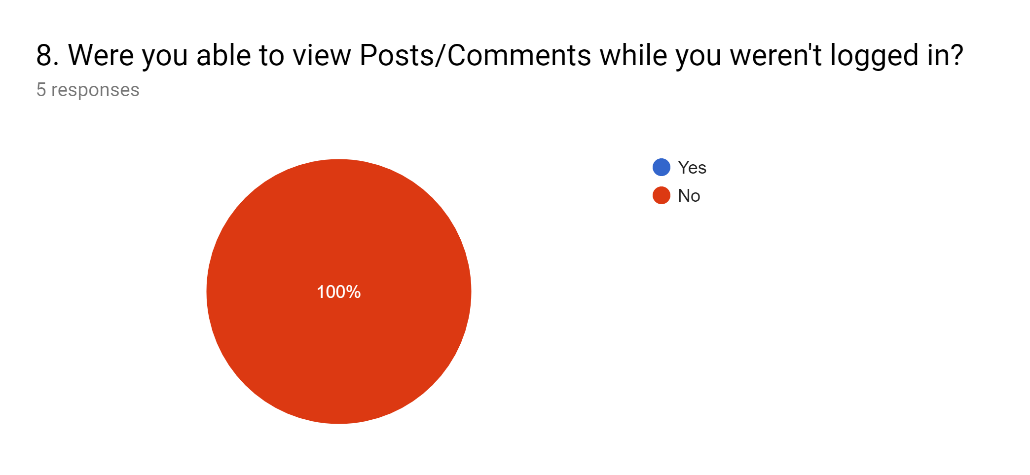

**PROJECT SPECIFICATION**

**PROJECT DEFINITION**

Student: *Jordon Douglas Guy*

Date: 15 October 2018

Supervisor: *Steven Lambert (Tutor)*

Level of Project: BSc (Hons) *Computer Software Development*

Title of Project: *The development of a support ticketing web application for a tech repair company*

Type of Project: Application

**ELABORATION**

*Tech CPR a tech repair company that deals with both individuals and businesses wants a support ticketing system for their website (https://techcpr.co.uk) that allows their business clientele a place to submit tickets detailing issues they are having with the system(s) that Tech CPR installed so that the support staff will be notified and and be able to respond quickly.*

*The aim of this project is to plan and develop a support ticket web application that can be used by Tech CPR’s ‘subscribed’ clientele to quickly contact the Tech CPR support staff to easily resolve any issues they may be experiencing with the system(s) Tech CPR implemented for them. The clientele will be able to submit posts to the support ticketing system, these posts will be stored within a database; and allow the user to submit text and other media such as images, videos and files allowing them to clearly outline the problem, when the post is submitted the support staff at Tech CPR will be notified encouraging a hasty response. The joint-owners of Tech CPR will be able to manage the web application; administering users, posts and roles with full access to the database within the web applications backend.*

*This project will include an investigation into IT project management that will identify a suitable project management methodology for the project undertaken, During the investigation an in depth analysis of support ticketing systems in commercial-use will be done to determine the key features of a support ticketing system the advantages and disadvantages of each feature and how each system was planned and developed.*

*The computer software development degree awarded by Sheffield Hallam has allowed a large degree of flexibility for the Professional project module. This project is relevant to the computing route, as it will require in-depth knowledge and application of HTML5, Javascript and Python to create a web application. This application will require knowledge of key aspects(modules) of the course such advanced datastores as the application will interact with a database backend.*

**PROJECT ETHICS & RISKS**

*While undertaking this project for Tech CPR risks and ethical issues will be considered while researching, developing and publishing the project deliverable. An issue identified is the recent law changes to the customer information regulation GDPR, as it changes how businesses must handle customer information.*

*A risk identified is the security of Tech CPR’s information/website, to mitigate this risk the web application will be developed and tested in a secure environment separated from the Tech CPR computer infrastructure.*

*When selecting tools and software to develop the web application the restrictions and licenses will be followed, this consideration may impact the tools and software used to develop the final deliverable but shouldn’t impact the quality of the final product.*

**PROJECT OBJECTIVES**

The student is required to:

1. *Research into project management methodologies and choose the most appropriate for the project undertaken.*
2. *Review literature on others who have undertaken similar projects and how they approached the issue and their critical analysis of how it was resolved.*
3. *Investigate into other similar ticketing systems in commercial-use for companies of the same nature as Tech CPR and outline their features; determine the advantages and disadvantages of each of the systems; and how each of the systems were developed and built (Software and Tools).*
4. *Research into tools and softwares that could be used to develop the web application (Python, Javascript, MonogoDB etc.), collaborate a suitable set of tools to develop the project deliverable and build skills into each of them.*
5. *From the research undertaken into similar projects create and use a suitable plan on how to design and develop the web application.*
6. *Develop a test plan for the web application to ensure the final product is up-to Tech CPR’s requirements and standard.*
7. *Create screen mockups, and use-case diagrams for the web application to present to Tech CPR*
8. *Get Tech CPRs approval of the design and development plan, if not resolve any issues they may have.*
9. *Develop the web application using the approved design and development plan using the suitable set of tools and software decided on.*
10. *Test the web application using the test plan*
11. *Present/walkthrough of the project to the marking board*
12. *Implement the web application on the Tech CPR website and train the users.*
13. *Write a final report detailing how and why the project was undertaken, critically evaluating all decision mades, the methodology used and the successes and failures of the developed system.*

**PROJECT DELIVERABLE**

*The deliverable for this project will be a ticketing system within the current website of Tech CPR that allows the ‘subscribed’ clientele and the support staff of Tech CPR a convenient secure way to communicate any issues the client is experiencing.*

**TASK PLAN**

|  |  |  |
| --- | --- | --- |
| *Task* | | *Milestone Date* |
| *1.* | *Research into project management methodologies and choose the most appropriate for the project.*   * *Select suitable project management methodology examples PRINCE2, Agile, Waterfall etc* * *Follow chosen project management methodology* | *25/10/18* |
| *2.* | *Review literature on others who have undertaken similar projects and how they approached the issue and their critical analysis of how it was resolved.*   * *Collect relevant and reliable literature from different sources (Books, Journal and credible internet sources etc.)* * *review useful information from each and reflect on how it could be applied to the project undertaken.* | *02/11/18* |
| *3.* | *Investigate into other similar ticketing systems in commercial-use for companies of the same nature as Tech CPR and outline their features; determine the advantages and disadvantages of each of the systems; and how each of the systems were developed and built (Software and Tools).* | *09/11/18* |
| *4.* | *Research into tools and softwares that could be used to develop the web application (Python, Javascript, MonogoDB etc.), collaborate a suitable set of tools to develop the project deliverable and build skills into each of them.*   * *select appropriate tools and software* * *review restrictions and licenses for academic work and commercial-use* * *build skills into each of the tools and softwares chosen* | *16/11/18* |
| *5.* | *From the research undertaken into similar projects create and use a suitable plan on how to design and develop the web application.* | *22/11/18* |
| *6.* | *Develop a test plan for the web application to ensure the final product is up-to Tech CPR’s requirements and standard.* | *26/11/18* |
| *7.* | *Create screen mockups, and use-case diagrams for the web application to present to Tech CPR.*   * *create sketches of screen designs* * *present sketches to Tech CPR and get feedback* * *use feedback to create final screen design* * *create draft use-case diagram from information obtained from Tech CPR* * *present use-case to Tech CPR and get feedback* * *create final use-case diagram to follow when developing the web application* | *30/11/18* |
| *8.* | *Get Tech CPRs approval of the design and development plan, if not resolve any issues they may have.*   * *present Tech CPR with the design and development plan in a meeting, resolve any minor issues* * *When approved begin the development of the web application* | *03/12/18* |
| *9.* | *Develop the web application using the approved design and development plan using the suitable set of tools and software decided on.* | *16/01/19* |
| *10.* | *Test the web application*   * *Run developed application against test plan operation* * *fix any issues or bugs found* | *20/01/19* |
| *11.* | *Present/walkthrough of the project to the joint-owners of Tech CPR.* | *25/01/19* |
| *12.* | *Implement the web application on the Tech CPR website.* | *15/02/19* |
| *13.* | *Write a final report detailing how and why the project was undertaken, critically evaluating all decision mades, the methodology used and the successes and failures of the developed system.* | *25/03/19* |
| *14.* | *Write a critical reflection on the project.* | *21/04/19* |

**ETHICS CHECKLIST**

***Human participants***

|  |  |  |  |
| --- | --- | --- | --- |
| ***Question*** | | | ***Yes/No*** |
| 1. | Does the project involve human participants? This includes surveys, questionnaires, observing behaviour, testing etc.  *If YES, then please go to Questions 2 to 5.*  *If NO, please go to Question 6.* | | Yes |
| 2.  *Note* | Will any of the participants be vulnerable?  *‘Vulnerable’ means those who may not fully understand the research, or the consequences of taking part. They include:*   * *children (i.e. under 18)* * *people with learning disabilities or physical disabilities (visible or not)* * *people who may be limited by age or illness*   *If YES, then please go to Question 2a*  *If NO, please go to Question 3* | | No |
|  | 2a | Will you ever be alone (i.e. not overseen) with any vulnerable participants during the course of the research?  *If YES, then please go to Question 2b*  *If NO, please go to Question 2c.* |  |
|  | 2b  *Note* | If you will be alone (i.e. not overseen) with any vulnerable participants during the course of the research, do you need to apply for a Disclosure and Barring Service (DBS) check?  *If you need a DBS check, you may be liable for the cost of the application. More details regarding DBS checks can be found at*  [*https://www.gov.uk/dbs-update-service*](https://www.gov.uk/dbs-update-service)  *GO TO Question 3.* |  |
|  | 2c  *Note* | If you will NOT be alone (i.e. you will be overseen) with any vulnerable participants during the course of the research, does your overseer have a DBS Check?  *If your overseer does NOT have a DBS check, you may need to apply for a DBS check yourself. You may be liable for the cost of the DBS application. More details regarding DBS checks can be found at*  [*https://www.gov.uk/dbs-update-service*](https://www.gov.uk/dbs-update-service)  *GO TO Question 3.* |  |
| 3.  *Note* | Will any participants be at risk of any physical or emotional harm by taking part in your project?  *Harm may be caused by:*   * *distressing or intrusive interview questions* * *uncomfortable procedures involving the participant,* * *invasion of privacy,* * *topics relating to highly personal information or to illegal activity etc.* | | No |
| 4. | Will anyone be taking part without giving their informed consent? (e.g. research involving covert study, or where subjects have not fully understood the research.) | | No |
| 5. | Will any part of the project allow the identification of any individual who has not given their express consent to be identified? | | No |
| *Note* | *If you answered YES to any of questions 2 – 5, then you MUST address these ethical issues in your Project Specification, ensure that you take all reasonable steps to avoid/mitigate these issues during the execution of your project, and explain your actions in your Critical Reflection.* | |  |

***OTHER participants***

|  |  |  |
| --- | --- | --- |
| ***Question*** | | ***Yes/No*** |
| 6. | Does the project involve the use of live animals? |  |
| *Note* | *If you answered YES to Question 6, then the project proposal must be submitted to the FREC for approval unless it falls into a category/ programme of research that has already received category approval.* | *No* |
| 7. *Note* | Does the project involve the NHS?  *For NHS research, this includes:*   * *any service evaluation work* * *work concerning NHS patients (tissues, organs, personal information or data)* * *NHS staff, volunteers, or carers* * *NHS premises or facilities* |  |
|  | *If you answered YES to Question 7, then your project proposal MUST be submitted Project Module Ethics Committee for review, and may be referred to the Faculty Research Ethics Committee and/or to an NHS Research Ethics Committee. For further details on NHS Research Ethics Service, please refer to* [*http://www.hra.nhs.uk/about-the-hra/our-committees/res/*](http://www.hra.nhs.uk/about-the-hra/our-committees/res/) | *No* |
| 8. | Does the project require approval from any other external ethics committee? |  |
| *Note* | *If you answered YES to Question 8, then the project proposal must be submitted to the relevant external body. For further advice, please contact the Faculty Research Ethics Committee* | *No* |

***Organisations***

|  |  |  |
| --- | --- | --- |
| ***Question*** | | ***Yes/No*** |
| 9. | Will the project involve working with or within an organisation?  *'Organisation' includes (but is not limited to):*   * *business* * *charity / volunteer organisation* * *government department* * *international agency* * *sports/social club*   *If YES, then please go to Question 10*  *If NO, please go to Question 12* | Yes |
| 10.  *Note* | Do you have granted access (permission) to conduct the project from the organisation?  *If YES, please show evidence to your supervisor and include this evidence in the Appendix of your Final Report. go to Question 12.*  *If NO, go to Question 11.* | Yes |
| 11. | Do you not have permission because:   1. you have not yet asked; 2. you have asked and not yet received and answer; 3. you have asked and been refused access. | A / B / C |
| *Note* | *You will only be able to start this aspect of the project when you have been granted access/permission.* |  |
| 12.  *Note* | Will covert research be part of the project?  *‘Covert research’ refers to research that is conducted without the knowledge of participants.*  *If you answered YES to Question 12, then your project proposal MUST be submitted Project Module Ethics Committee for review, and may be referred to the Faculty Research Ethics Committee* | No |

***Products and artefacts***

|  |  |  |
| --- | --- | --- |
| ***Question*** | | ***Yes/No*** |
| 13  *Note* | Does the project require the reproduction (beyond normal academic quotations) of materials authored by a source other than yourself?  *Materials includes (but is not limited to):*   * *books / e-books* * *journals* * *websites* * *newspaper / magazine articles* * *films / broadcasts /photographs / artworks / images / diagrams* * *designs / products* * *computer programmes / code / databases, networks* * *processes*   *If YES, please go to Question 14*  *If NO, please read the Declaration at the end of the checklist* | No |
| 14.  *Note* | Are all the materials you intend to reproduce in the public domain?  *‘In the public domain’ does not mean the same thing as ‘publicly accessible’.*   * *Information which is 'in the public domain' is no longer protected by copyright (i.e. copyright has either expired or been waived) and can be used without permission.* * *Information which is 'publicly accessible' (e.g. TV broadcasts, websites, artworks, newspapers) is available for anyone to consult/view. It is still protected by copyright even if there is no copyright notice. In UK law, copyright protection is automatic and does not require a copyright statement, although it is always good practice to provide one. It is necessary to check the terms and conditions of use to find out exactly how the material may be reused etc.*   *If YES, please read the Declaration at the end of the checklist.*  *If NO, please go to Question 15.* |  |
| 15.  *Note* | Will you be reproducing more than 5% (or one chapter) of an individual source?  *You are allowed to copy/reproduce up to 5% of a source (or one chapter) for your own personal research usage without explicit permission. Please see* [*http://libguides.shu.ac.uk/copyright*](http://libguides.shu.ac.uk/copyright) *for further information.*  *If YES, please go to Question 16*  *If NO, please read the Declaration at the end of the checklist* |  |
| 16. | Do you have explicit permission to use these materials?  *If YES, please show any explicit evidence to your supervisor and include in the Appendix of your Final Report. Please read the declaration at the end of the checklist.*  *If NO, please go to Question 17.* |  |
| 17. | If you do not have explicit permission, is it because:  A. you have not yet asked permission;  B. you have asked and not yet received and answer;  C. you have asked and been refused access. | A / B / C |
| *Note* | *You will not be allowed to use the material until you have been granted permission to use it.* |  |

**Mark an Owner at Tech CPR gave the project team permission to undertake this project, since then communication between the client and the project team ceased because the client stopped responding while the application was being developed. This has been reflected in the report.**

**Due to this Tech CPR has been used as a Case Study for the project, at this point it is unknown why the client stopped responding and the project deliverable has just been developed to fulfill the case study.**

**|!IMPORTANT!|**

**All Code and Files Available to view at (**[**https://drive.google.com/drive/folders/1Eo2qC-ilyAiJ7T8E0_rzcR95z7gnfFKx?usp=sharing**](https://drive.google.com/drive/folders/1Eo2qC-ilyAiJ7T8E0_rzcR95z7gnfFKx?usp=sharing)**)**

**|!IMPORTANT!|**